Pembroke Country Club |  |  | Friday, October 17th 2014
Hanover Youth Hockey Golf Tournament
Pembroke Country Club  94 W. Elm Street  Pembroke, MA 02359  Pro-Shop Phone:  (781) 829-2273  Office Phone:  (781) 829-2285  Friday, Oct. 17, 2014  Cost: $125 per player  Registration 12:30 PM  Enjoy a complete program of special events, 18 holes of golf (including cart), dinner, door prizes for each player and an exciting awards banquet...  All for just $125 / player  - Putting challenge on the practice green  - Closest to the pin challenge  Don’t golf??  Join us for dinner and dancing for only $35! We will also have a silent auction and fun raffles. |  | 4 Man Scramble  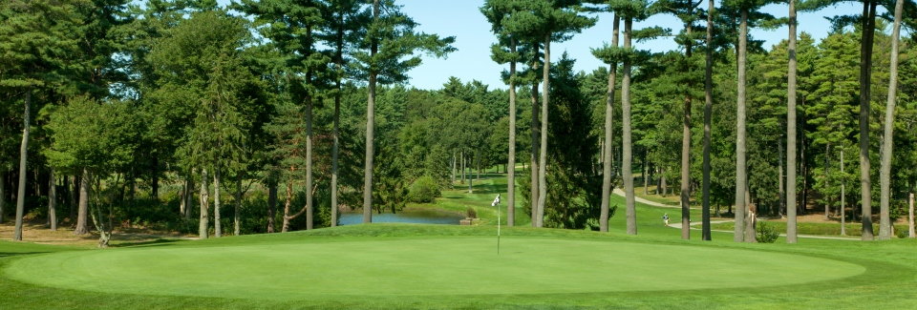  This year’s event will be held Friday October 17th 2014 at the well-manicured Pembroke Country Club in Pembroke, MA.  Registration begins at 12:30 PM, with a 1:30 PM shot-gun start.  The cost for this event is only $125. This price includes entry into all events, 18 holes of golf, riding cart, dinner and various prizes.  To help us properly plan for this event, please pre-register by contacting Joanna Dyer at joannaslp@yahoo.com    Golf attire is required. Collared shirts must be worn. No steel spikes are allowed on the course.
Player Information
Player 1
Name: ___________________________________
Address: __________________________________
City: _____________________________________
State: _______________ Zip: _________________
Tel: ______________________________________
E-mail: ___________________________________

Player 2
Name: ___________________________________
Address: __________________________________
City: _____________________________________
State: _______________ Zip: _________________
Tel: ______________________________________
E-mail: ___________________________________

Player 3
Name: ___________________________________
Address: __________________________________
City: _____________________________________
State: _______________ Zip: _________________
Tel: ______________________________________
E-mail: ___________________________________

Player 4
Name: ___________________________________
Address: __________________________________
City: _____________________________________
State: _______________ Zip: _________________
Tel: ______________________________________
E-mail: ___________________________________


Sponsorship Opportunities/Benefits

We invite you to sponsor our Golf Classic. Sponsorship levels are outlined below.
All sponsors will be acknowledged at event, on website with company link & opportunity to place collateral in goodie bags. Please check level that applies, complete information and return by September 1, 2014 to HYHA PO Box 591, Hanover, MA 02339

Platinum Sponsor $2,500
Company banner at event; hole sponsorship
recognition; signage at awards dinner; preferential tee; two foursomes

Gold Sponsor $1,500
Signage on golf carts; hole sponsorship recognition; signage at awards dinner; 1 foursome

Bronze Sponsor $500
Signage at awards dinner; 2 tickets to dinner

Dinner Sponsor $250
Company name/logo on table tent cards at every table during dinner; 2 dinner tickets

Beverage Cart Sponsor $250
Sponsor recognition posted on cart; 2 tickets to dinner

Hole Sponsor $100
Sponsor recognition posted at tee.

Foursome Golf $500

Individual Golf $125

Name: __________________________________
Address: ________________________________
City: ____________________________________
State: ___________ Zip: ____________________

