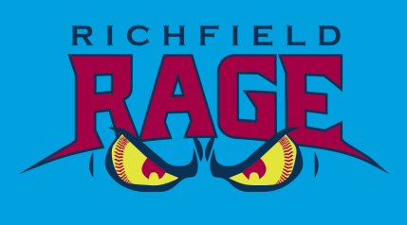
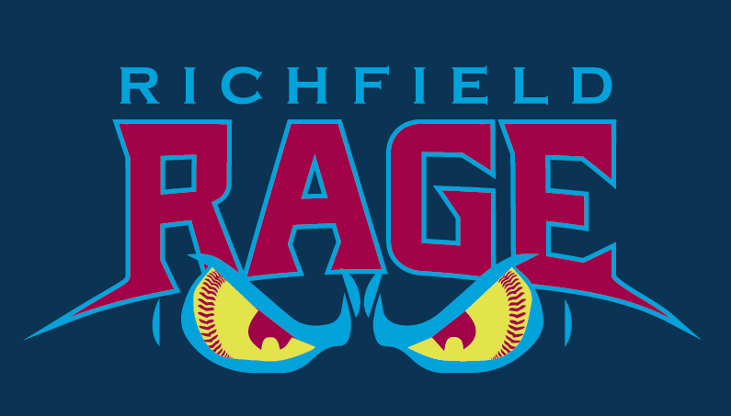
SOFTBALL WORKOUT REGISTRATION FORM
Better Athletes - Better People
Player Name  Click here to enter text. |  |  | DOB: (MM/DD/YY)  Click here to enter text. | Age: (current)  Click here to enter text. | Player Tryout Number  Staff Use Only
Date Paid: | Workout fee Paid with check #: |  | School  Click here to enter text. | Grade in 2016 Click here to enter text. | Location:  Heritage Park (lower fields)
Street Address:  Click here to enter text. |  | City/ZIP:  Click here to enter text. |  |  | Pitcher and/or Catcher  Choose an item.
Parent Name:  Click here to enter text. |  | Email Address:  Click here to enter text. |  |  | Phone:  Click here to enter text.
Parent Name:  Click here to enter text. |  | Email Address:  Click here to enter text. |  |  | Phone:  Click here to enter text.
*Pre-register by emailing this completed form to either rybsagirlsdirector15@gmail.com

Softball Skills Assessment for Tryouts will include:
Infield Skills | Mechanics | Range | Strength |  | Accuracy |  | Catching
Outfield Skills | Mechanics | Range | Strength |  | Accuracy |  | Catching
Pitching** | Mechanics | Velocity | Control |  | Fastball |  | Change Up
Catching** | Blocking | Arm | Accuracy |  | Feet |  | Receiving
Hitting Skills | Mechanics | Power | Contact |  | Head-Eyes |  | Bunting
Overall | Effort | Coachability |  |  | Grit
Raw Athletic | 5-10-5 | Vertical Jump |  | 30 Yrd Dash |  | Power Ball

**Teams need these specialized positions and we encourage everyone to do these assessments but they are not required
The Richfield Lady RAGE are pleased to offer workout opportunities to local youth who wish to have fun, train and compete in softball tournaments. RYBSA and the Lady RAGE have partnered with Positive Coaching Alliance (PCA) to “Honor the Game” and bring healthy experiences for ball players and their families. Better Athletes - Better People are born out of our joint commitment to offering a Developmental Zone for players to grow and learn the game.
Age groups 9, 10, 11 & 12 as of Jan 1, 2016 are encouraged to attend.
Families will have access to the Coaches MatrixTM Player Feedback Form (workout report card) after workouts have been completed and teams have been set. This will provide insight into how coaches have evaluated the player during the workout.

