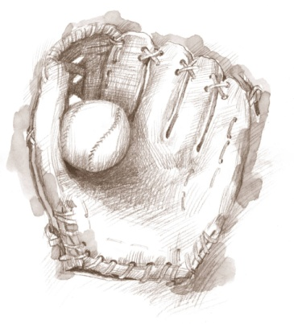 **Coach Mac Baseball Camps**

**At Murray State**

**2012 Winter Camp**

**Camp:** For 1st through 8th grade students.

**Staff:** MSU coaching staff

**Facilities:** Racer Arena-North Gym (Carr Health Building), Murray State

**Cost:** $50.00 per camp **OR** $75 for both camps

**Camp 1 Date:** Wednesday, December 19th 4:00 p.m. - 7:00 p.m. **Check-In**: Will start at 3:00 p.m.

**Camp 2 Date:** Thursday, December 20th 9:00 a.m. - 12:00 p.m.

**Check-In:** Will start at 8:00 am

**Please Contact**: Dan Skirka at 270-809-3475 or [dskirka@murraystate.edu](mailto:dskirka@murraystate.edu)

C:\Documents and Settings\daniel.skirka\Local Settings\Temporary Internet Files\Content.IE5\LUOD1QS5\MC900364360[1].wmfOR VISIT: [www.goracers.com](http://www.goracers.com)