How To Grip And Throw A Four Seam Fastball
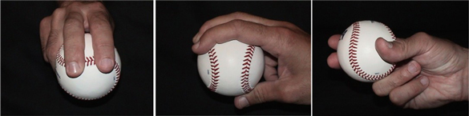
Four-seam fastball
To grip the four seam fastball, place your index and middle fingertips directly on the perpendicular seam of the baseball. The "horseshoe seam" should face into your ring finger of your throwing hand (as shown in the picture on the left). I call it the horseshoe seam simply because the seam itself looks like the shape of a horseshoe.
Next, place your thumb directly beneath the baseball, resting on the smooth leather (as shown in the picture on the right). Ideally, you should rest your thumb in the center of the horseshoe seam on the bottom part of the baseball.
Grip this pitch softly, like an egg, in your fingertips. There should be a "gap" or space between the ball and your palm (as shown in the middle picture). This is the key to throwing a good, hard four-seam fastball with maximal backspin and velocity: A loose grip minimizes "friction" between your hand and the baseball. The less friction, of course, the quicker the baseball can leave your hand.
Does a four-seam fastball rise?
"No," says Bill James, author of the The Neyer/James Guide to Pitchers. "A fastball can't rise unless it's thrown underhand. But if you throw the fastball overhand with enough force, it will appear to rise because it's not dropping as much as the batter's brain thinks it should."

How To Grip And Throw A Two Seam Fastball
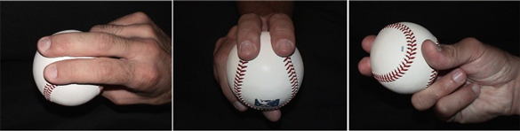
Two seam fastball
A two seam fastball, much like a sinker or cutter (cut fastball), is gripped slightly tighter and deeper in the throwing-hand than the four-seam fastball. This pitch generally is thought of as a "movement pitch" (as opposed to the four-seam fastball, which is primarily thought of as a "straight pitch").
When throwing a two-seam fastball, your index and middle fingers are placed directly on top of the narrow seams of the baseball (as shown in the picture on the left).
Next, place your thumb directly on the bottom side of the baseball and on the smooth leather in between the narrow seams (as shown in the picture on the right).
Again, a two seamer is gripped a little firmer than the four seamer. A firm grip causes friction, which causes the baseball to change direction, usually "backing up" - or running in - to the throwing hand side of the plate. It also slightly reduces the speed of the pitch, which is why most two-seamers register about 1 to 3 mph slower than four-seam fastballs.
One thing I did with this pitch in college and in professional baseball was to always throw my two-seam fastball to the throwing-hand side of the plate and my four seam fastball to the glove-hand side of the plate. In other words, because I'm a righty, I'd throw two-seamers inside to right-handed batters and four-seamers away. I always liked how the feel of the grip of the two-seamer in my glove (when I was in my pre-pitch stance) let me know on a sub-conscious level that I was going inside on guy.

How To Grip And Throw A Three Finger Changeup
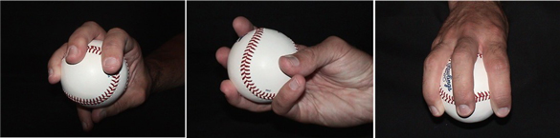
Three finger changeup
A three-finger changeup is a good off-speed pitch for younger baseball pitchers – and for those who do not have big hands.
To throw an effective three-finger changeup, center your ring, middle, and index fingers on top of the baseball (as shown in the third picture at right). Your thumb and pinky finger should be placed on the smooth leather directly underneath the baseball (as shown in the middle picture).
A lot of pitchers that I work with like to "touch" their pinky and thumb when gripping this pitch (as shown in the middle picture). It helps to develop a good "feel" for the pitch, which is important since the changeup is a finesse pitch.
OK, now that you've got your grip, hold the baseball deep in the palm of your hand to maximize friction and to "de-centralize" the force of the baseball when the pitch is released. This helps take speed off of the pitch. Throw it like you would a fastball: Same mechanics. Same arm speed. Same everything.
One way to develop "fastball mechanics" but changeup speed is to practice throwing your changeup as you long toss (throwing beyond 90 feet). Alternate fastballs and changeups at 90-or-more feet for about 20 throws a couple of times a week.
Note: Advanced pitchers can experiment with "turning the ball over" to create even more movement on the pitch. To do this, pronate your throwing hand (turn it over as if you were giving your catcher a "thumbs down" hand signal) as you throw the pitch.

How To Grip And Throw A Circle Changeup
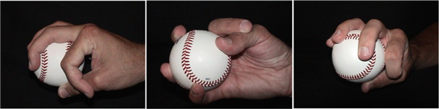
Circle changeup
The circle changeup and the four-seam fastball are what got me to professional baseball. They're both great pitches.
To throw a circle changeup make - quite literally - a circle or an "OK" gesture with your throwing hand (using your thumb and index fingers). You then center the baseball between your three other fingers (as shown in the middle picture above right). The baseball should be tucked comfortably against the circle.
Throw this pitch with the same arm speed and body mechanics as a fastball, only slightly turn the ball over by throwing the circle to the target. This is called pronating your hand. (Think about this as giving someone standing directly in front of you a "thumbs down" sign with your throwing hand.) This reduces speed and gives you that nice, fading movement to your throwing-arm side of the plate.
A great way to develop the "fastball mechanics" but changeup speed is to practice throwing your changeup as you long toss (throwing beyond 90 feet). Alternate fastballs and changeups at 90-or-more feet for about 20 throws a couple of times a week.

How To Grip And Throw A Palmball
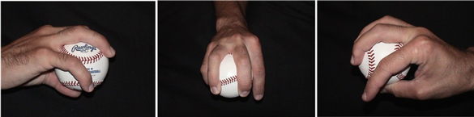
Palmball
The palmball (sometimes called a palm ball or four-finger changeup) is one of two or three variations of the changeup. It's an off-speed pitch.
A palmball is is gripped by essentially choking the baseball deep in your hand and wrapping all of your fingers around the baseball. It's essentially a four-fingered change-up where the baseball is centered in your hand between your middle and ring fingers.
The index and ring fingers are placed on either side of the baseball for balance, and the thumb is placed directly below the baseball. At its release point, try to turn the ball over a little to get more movement. The deeper the grip, the more friction that is created on the ball, which takes off velocity.
However, as with all off-speed pitches, the arm speed and mechanics of your pitching delivery have to be the same as your fastball.

