How to Email from the Website…

Below you’ll find directions to email from the website. Please let me know if you have any questions.

When you log in. Click on the Admin link in the upper right of the screen.

From the Menu above click the members Link. Here you’ll find a list, click on the Email Members

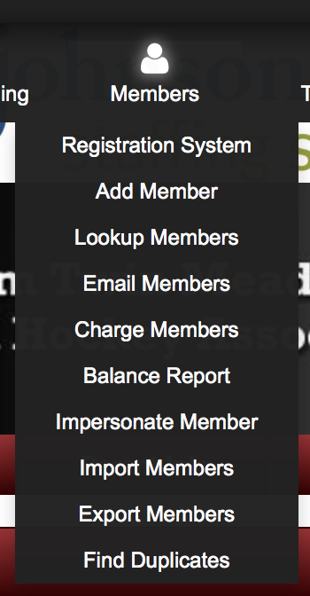

Once you click on the Email Members link you’ll see the screen below. From here you have the ability to choose which team you’d like to email. Notice that the whichever team is highlighted will receive the email.

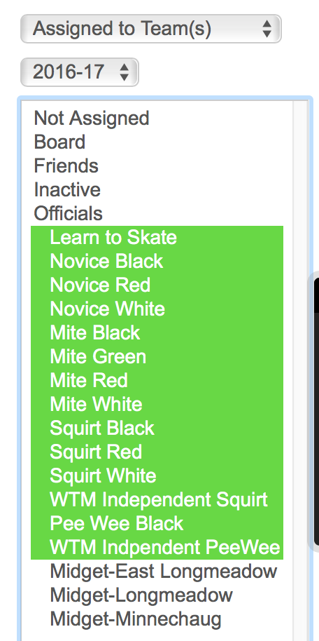

Once you highlight the teams you’d like to email. Scroll down and click on the Find Member Link.

Once you click on the Find members, the screen will refresh and you’ll see something similar to below. From here you’ll want to overwrite the “From” and choose the reply to email and enter the subject. If you have additional email addresses, you can enter them in the Add Addresses field.

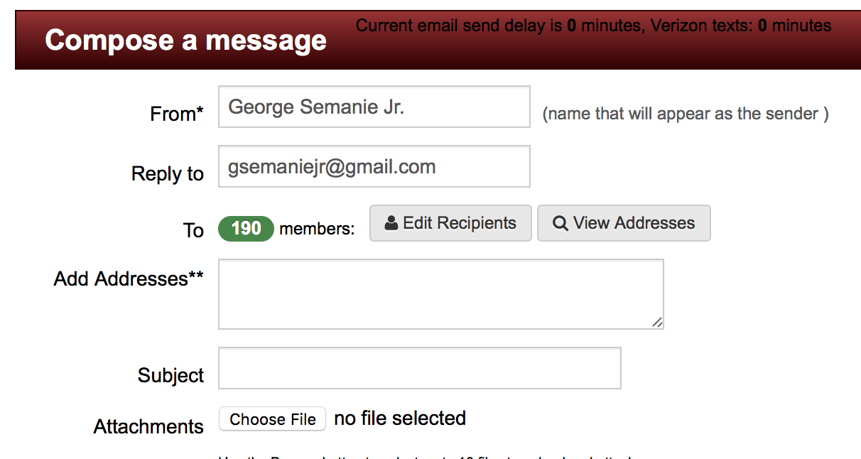

Insert the message here:

Once you have completed your email, you can choose one of two options. Send the email immediately, or schedule the email to be sent later. Note that the attachments will not be visible when sending a test email.

