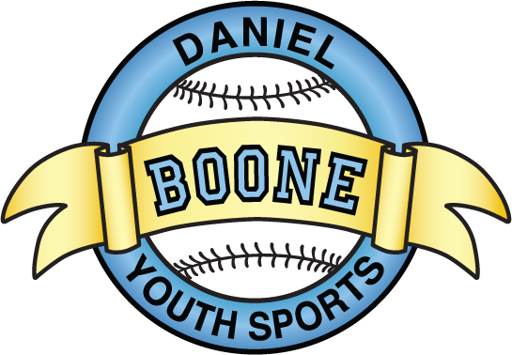
DBYS General Meeting Minutes
October 11, 2015
7:00pm at the Hill Road Complex Pavilion

- Meeting called to order: 7:02
- Agenda: approved by DW, MG
- Attendance: Kristi Schueler, Amee Hartman, Dan Welker, Dan Welker, Rick Schellinger, Pete Kelly, Matt Gonder, Joe Simplot, Bill Howells, Jay Hall
- Officers’ Reports:
- President’s Report (Eric Detweiller) – Field Hockey – there is excitement and interest
  - Girls in 2nd grade and up
  - Set curriculum to USA Field Hockey standards
- Vice President’s Report (Dan Brown) –
- Treasurer’s Report (Nan Tindall) -
    - Financials are attached
    - Comments: Budget approved (RS, MG)
- Secretary’s Minutes – reading waived JH, PK)
- Softball Director’s Report (Greg Whelan) –
  - Gator – no children under 18 allowed to drive
  - Shut off for the season
- Baseball Director’s Report (Tom Curley) – Winter workouts at PlayBall
  - Winter Workouts $80.00 per player
  - Will start late January / early February
- Logistics Coordinator’s Report (Lori Pence) –
- Buddy Ball Report (Traci Huddleson) -
- League Representative’s Report (Randy Yenser) –
  - Township approved painting of dugouts
  - Diamond league team tryouts completed
- Old Business:
  - Updates on MS Fields
    - Outside organizations using fields
    - Schedules are due March 31st
    - Fall Baseball
      - Possibility of moving away from Berks league (less travel, easier schedules)
      - Snack bar items not being recorded
      - DBCA merger Update
      - Need additional parent volunteer
      - Need additional board member
      - Meeting 10/18/15

    - Travel Baseball Tournament Coach Nominations
    - Diamond Team – Eric Detweiler nominated and accepted (LP, TH)
    - 12U – Jay Hall nominated and accepted (ED, TC)
    - 11U – Open
    - 10U – AL Hughes previously nominated, Pete High – Not in attendance (AH, JS)
    - 9U – Pete Kelly – nominated and accepted (TC, ED)
    - 8U – Brett Scarbinsky – nominated and accepted previously
- New Business
  - Field aeration and seeding – 2 estimates by Spayds and T&D
  - Field Drainage issue
    - Brett Scarbinsky will get estimate – Spayds recommends a French drain around the infield
    - MS Batting cage approved for replacement
    - Potential capital improvements – Scoreboards, Pressbox
    - Next monthly meeting – October 11th at the Villa at 7pm
    - Financials are attached on next page

DBYS Financial Summary
as of 9/30/15
Description | Beg Balance |  | Change |  | Ending Balance
Cash Balances
Sovereign Bank - Checking | 57,644.53$ |  | (15,491.18)$ |  | 42,153.35$
Petty Cash - Treasurer | 1,040.00$ |  | -$ |  | 1,040.00$
Snack Stand Cash Boxes | 320.00$ |  | -$ |  | 320.00$
Total Cash Held | 59,004.53$ |  | (15,491.18)$ |  | 43,513.35$
Restricted Cash
TT Softball Funds Held | ----------------> |  | ----------------> |  | -$
InfernoTravel Funds Held | ----------------> |  | ----------------> |  | (905.79)$
Buddy Ball Funds Held | ----------------> |  | ----------------> |  | 1,244.48$
TT Baseball Funds Held | ----------------> |  | ----------------> |  | -$
DBCA Registration Fees | ----------------> |  | ----------------> |  | (130.00)$
Unrestricted Cash | ----------------> |  | ----------------> |  | 43,304.66$
Cash Inflows
Reg. Fee - Fall Ball |  |  | 585.00$
DBCA Reg. Fee |  |  | 780.00$
Spring Reg. Fee |  |  | 147.00$
Softball TT Fees |  |  | 440.00$
Spiritwear Sales |  |  | 139.00$
Snack Stand Proceeds |  |  | 1,348.00$
Sponsorship Income |  |  | 500.00$
Total Cash Collected |  |  | 3,939.00$
Cash Outflows
Snackstand Supplies |  |  | 888.16$
DBCA Fall Ball Reg. Fees |  |  | 2,990.00$
Field & Fencing Equipment |  | 905.61$ |  | mowing of fields
Rental Facility |  | 3,960.00$ |  | Holman - winter workouts
Trophies |  |  | 3,666.10$
Baseball Equipment |  |  | 53.00$
Fall Ball Uniforms |  |  | 2,789.25$
Fall Ball Umpire Fees |  |  | 1,950.00$
Softball Equipment |  |  | 359.28$
Softball Fall Ball Umpire Fees |  |  | 336.00$
Softball Fall Ball & TT uniforms |  |  | 882.50$
Softball Round Robin Fee |  | 400.00$ |  | Stonersville Flames
Misc. Expenses |  | 79.43$ |  | Board Meeting
Other Expenses |  | 170.85$ |  | CC & Bank Fees
Total Cash Paid |  |  | 19,430.18$
Net Monthly Change in Cash |  |  | (15,491.18)$
Payables
Total Payables |  |  | -$
DBYS Equity at Month End |  |  | 43,513.35

Meeting adjourned 7:43 (BH, JS)

