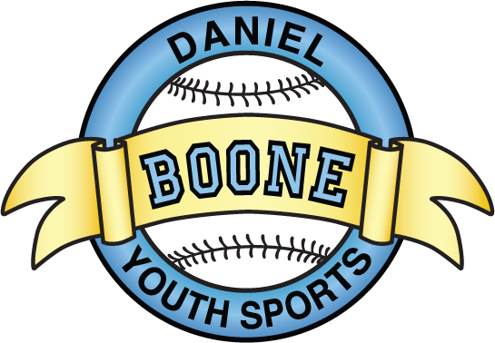
DBYS General Meeting Minutes
September 13, 2015
7:00pm at the Hill Road Complex Pavilion

- Meeting called to order: 7:01
- Agenda: approved by DW, MG
- Attendance: Al Hughes, Ron Tindall, Dan Welker, John Schueler, Rick Schellinger, Levi Peiffer, Luiz Munoz, Matt Gonder, Chris Cinege, Jason Linderman, Ralph Shafer, Brad Kriebel, Bill Howells, Brian Kazmorck, Brian Miller, Jay Hall
- Officers’ Reports:
- President’s Report (Eric Detweiller) – Fall Baseball in full swing
- Vice President’s Report (Dan Brown) –
- Treasurer’s Report (Nan Tindall) -
    - Financials are attached
    - Comments: Budget approved (MG, DW)
- Secretary’s Minutes – reading waived (JL, LP)
- Softball Director’s Report (Greg Whelan) – need field liner
- Baseball Director’s Report (Tom Curley) – Winter workouts at PlayBall
- Logistics Coordinator’s Report (Lori Pence) –
- Buddy Ball Report (Traci Huddleson) -
- League Representative’s Report (Randy Yenser) –
- Commissioners reports
- Old Business:
  - Updates on MS Fields
    - Lease with DB school district – have given permission for field use to outside travel teams
    - Dugouts on Hold
    - Diamond team
      - Tryouts September 27th and October 4th from 10am-12pm at MS Field 40
      - Previous coaches will be doing the evaluations
      - DBCA merger Update
      - Meeting September 20th
      - Township Fields – now are available for summer 2016
- New Business
  - Rule Change
    - Rookie – Possession Rule
      - Halfway through the season plays where the ball is hit to the outfield we will transition from ball being released by the outfielder to the play ends when the ball reaches the dirt of the infield or in the possession of the infielder – PASSED

    - Ball hitting machine is a dead ball and every player is awarded 1 base – PASSED
    - Minors
    - you can choose to play 4 outfielders without regard to the number of outfielders your opponent is playing - PASSED
    - League Wide
    - Call Ups - once teams are formed the board will submit a list of age eligible players available to be called up – Coaches must attempt to use all players on list prior to calling up a player for a second time - PASSED
    - Minors and Majors –
    - Hard stop of games at 2 hours and 15 minutes - PASSED
    - Pitchers are removed after 2nd mound visit in the same inning - PASSED
    - Pitchers pulled at a hard 65 pitch count in Minors and 75 pitch count in Majors- PASSED
    - Composite Bat Ban – DID NOT PASS
    - Suggested each team is permitted a head coach and only 1 assistant prior to selection of teams. – DID NOT PASS
    - Travel Baseball Tournament Coach Nominations
    - 12U – Open
    - 11U – Open
    - 10U – AL Hughes (LP, ED) accepted nomination
    - 9U – Open
    - 8U – Brett Scarbinsky (AL, LP) accepted nomination
    - Painting of Hill Rd dugouts
    - If less than $1500.00 we will proceed with painting of all 6 Hill Rd Dugouts
    - Next monthly meeting – October 11th at the Villa at 7pm
    - Financials are attached on next page

DBYS Financial Summary
as of 8/31/15
Description | Beg Balance |  | Change |  | Ending Balance
Cash Balances
Sovereign Bank - Checking | 53,337.31$ |  | 4,307.22$ |  | 57,644.53$
Petty Cash - Treasurer | 1,040.00$ |  | -$ |  | 1,040.00$
Snack Stand Cash Boxes | 320.00$ |  | -$ |  | 320.00$
Total Cash Held | 54,697.31$ |  | 4,307.22$ |  | 59,004.53$
Restricted Cash
TT Softball Funds Held | ----------------> |  | ----------------> |  | -$
InfernoTravel Funds Held | ----------------> |  | ----------------> |  | (905.79)$
Buddy Ball Funds Held | ----------------> |  | ----------------> |  | 1,244.48$
TT Baseball Funds Held | ----------------> |  | ----------------> |  | -$
DBCA Registration Fees | ----------------> |  | ----------------> |  | 1,690.00$
Unrestricted Cash | ----------------> |  | ----------------> |  | 56,975.84$
Cash Inflows
Reg. Fee - Fall Ball |  |  | 5,145.00$
Spiritwear Sales |  |  | 135.00$
Unused Softball Umpire Fees |  |  | 21.00$
DBCA Fall Ball Reg. Fees |  |  | 1,300.00$
Total Cash Collected |  |  | 6,601.00$
Cash Outflows
Maintenance & Repairs |  | 14.92$ |  | Repair broken window
Field & Fencing Equipment |  | 688.92$ |  | mowing of fields
Inferno Expense |  | 767.00$ |  | Fall Ball & Round Robin Fees
Web Fees |  | 450.00$ |  | League Athletics Hosting Fee
Fall Ball League Fee - Baseball |  |  | 100.00$
Misc. Expenses |  | 40.00$ |  | Board Meeting
Other Expenses |  | 232.94$ |  | CC & Bank Fees
Total Cash Paid |  |  | 2,293.78$
Net Monthly Change in Cash |  |  | 4,307.22$
Payables
Total Payables |  |  | -$
DBYS Equity at Month End |  |  | 59,004.53$

Meeting adjourned 7:43 (DW, LP)

