Drill Name: Clear Drill: Clear from a Save Drill Theme: Clearing

Time Needed: 15 mins Field Positions: Offense, Defense, Mid, Goalie Skill Level: Basic

Objective: Transition Skill Development Drill - Improve your team’s ability to clear the ball down the field with a standard clear off a shot.

Description of Drill: This drill is a standard way to clear the ball off a shot. It is more of a play than a drill. Set up a full field game, and have the ball with your goalie on one side. Set your teams up in a playing situation, have the offense shoot and the go into a straight clearing situation with the defense.

Once your team has cleared the ball, have an attack player gather the ball, shoot, and then the other team will re-clear in the same settled manner
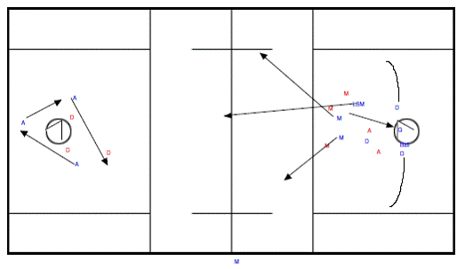

Emphasize:
Ball Movement (Catching and Throwing)
Communication

Variations:
Add a stronger ride for the defensive team and practice getting the ball down the field

