Drill Name: Save to Clear – Warm-up drill Drill Theme: Goalie play, Clearing,

Time Needed: 10 mins Field Positions: Goalie, Def Skill Level: Basic

Objective: Warm up your goalie’s clear game by giving them shots from about 10 yards away and then requiring them to clear to certain areas of the field, right away.

Description of Drill:
Have your goalie get in goal and take shots from the coach from about 10 yards away.

Have 2 players or coaches roam around in the area between midfield and the attack zone.

You will shoot on the goalie, which will make a save and then clear the long pass out to on of the players/coaches in the midfield area.

The next shot will require the goalie to clear to the other player/coach in the midfield area.

Have the players/coaches in the midfield area move around and change the distance of the clears for the keeper.

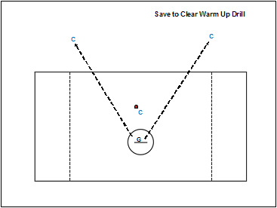

Emphasize:
Focus on save first
Look up field for open man
Crisp pass

Variations:
Add a stronger clear for the offensive team and practice forcing turnovers in situation play.

