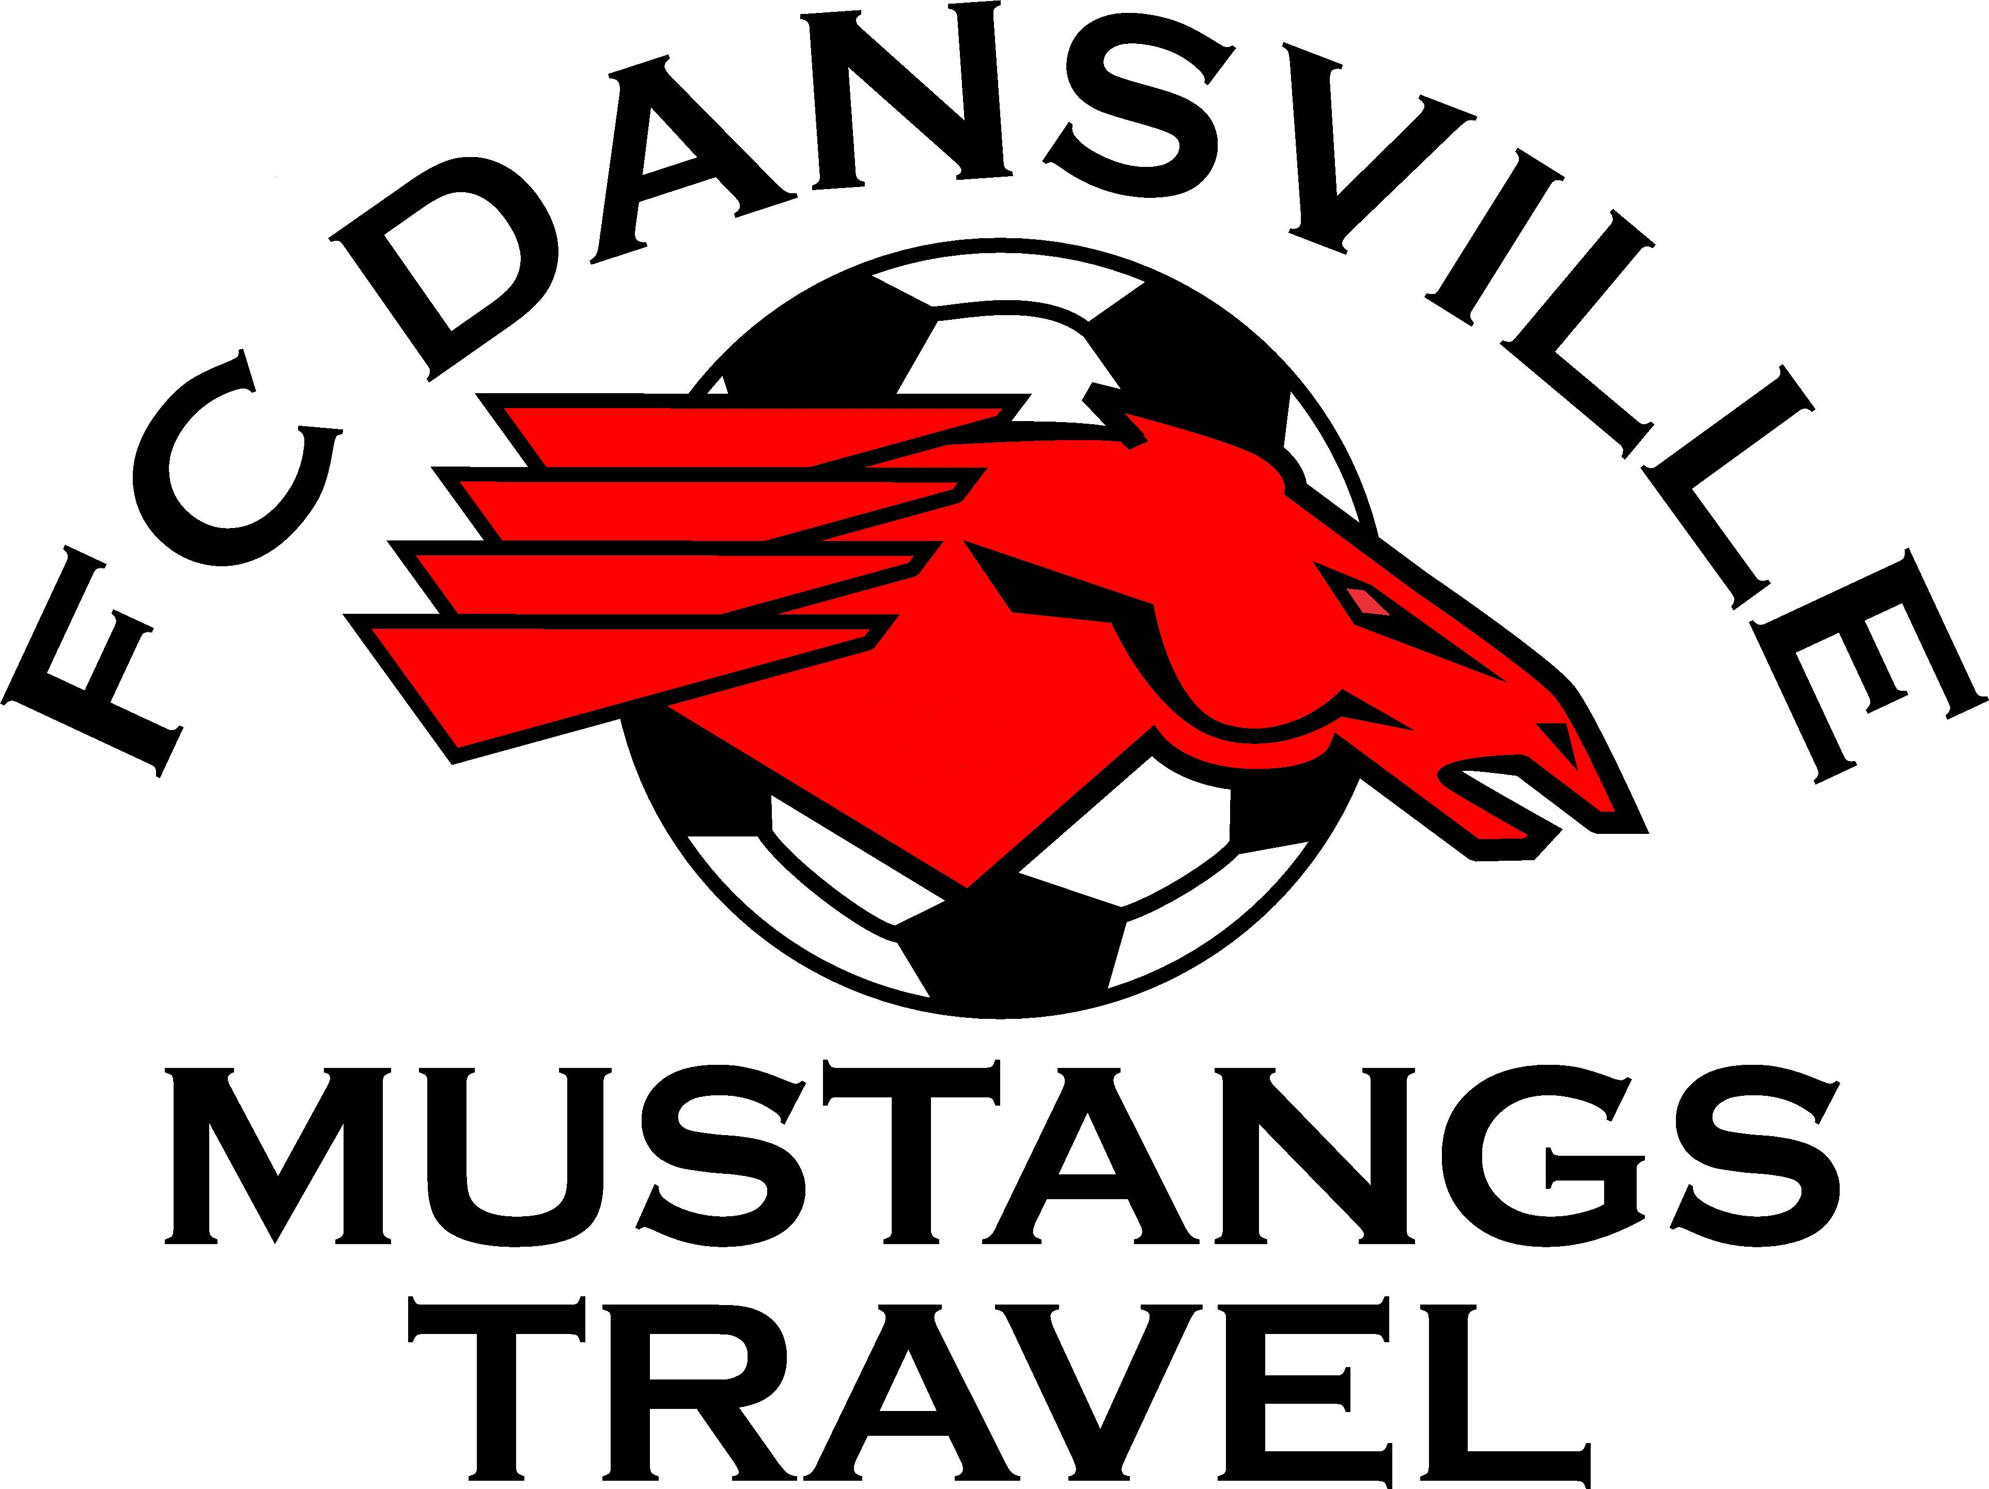

FC Dansville Mustangs & Lady Mustangs Soccer, Inc.
January 12,2012
- Roll-Call: Julie Camacho, Lisa Rosica, Jeremy Adams, Mike Kozak, Amy Oldfield
Excused: Shawn Harnish, Carrie Newcomb, Aarin Belden, Jim Cotton, Randy Drake, Diane Mountzorous.
- November Minutes – Motion by Jeremy Adams, to accept the November minutes. It was second by Amy Oldfield. All in favor, motion carried.
- Reports
President – FC Dansville Rotary Tournament to be held on March 25th and 26th. Graham Markus is rotary official. All checks will be made out to FC Dansville. All Dansville teams will be granted a place in the tournament for free. Dansville will host 44 teams each day. Dansville Middle School will play from 8pm to 6pm each day and Dansville High School will play from 8am to 11pm each day. We will have to have a few parents help out with concessions and other items at the tournament. The number will be determined.
Update: After a meeting with Dansville Rotary, Dansville Central School and Mike Kozak it was determined that all future checks will be made out to Dansville Rotary as they originally booked the event and hold the insurance.
Vice President – None
Treasurer – Current balance was $5500 will about $600 in cash and checks to be deposited.
Registrar – Outstanding balance to NYS west is $180 which 80% is JV/Varsity Girls fees that will be paid back.
Secretary- Nothing to report
Fundraising – None
Apparel – Looking to sumbit a new order in the very near future. Few items to be done yet.
Boy’s Director of Coaching – none
Girl’s Director of Coaching - none
4. New Business
A. Twin Tiers League for Spring has dissolved. We have to look at options for Spring Play. Suggestion one is we become part of Central Western United which requires a $100 bond which is consistent with Twin Tiers. The problem is that when yellow or red cards are issues the fees are costly. More information is needed about this. We would then play in the RYDSL which is more competitive as we would face teams in Pittsford and Webster and would require travel to these teams home field. Another challenge is where our home field would be located. Mt. Morris and York are possible options to explore. Suggestion two is that we set up a few friendly matches with teams from the area. We then could conclude with a tournament at our fields. Mike and the coaches are discussing their options and will get back to us on what they decide.
B. Mike is serving on the NYS West committee for Rec Soccer. NYS West is taking a careful look at Rec Soccer and how it is run. We need to decide for ourselves if we want to run a developmental soccer program in the summer for the younger ages. Mike is currently looking at a u8 tournamnet this summer which would consist of small side games 3 vs 3 or 4 vs 4.
C. Resignation: A motion by Jeremy Adams to accept the resignation of Jim Vogler. This was second by Mike Kozak. Amy Oldfield and Lisa Rosica abstain from the vote. Motion was carried.
5. Adjourn a motion was made by Amy Oldfield which was second Lisa Rosica. All in favor and none opposed – motion carried.

