PSHS Booster Club - Updating Team Roster
Created by: Ralph Whitehouse
Create date: August 28, 2014
Log into the PSHS Booster Club website:
http://www.southpanthers.com/
User id: email
Password: provided by webmaster
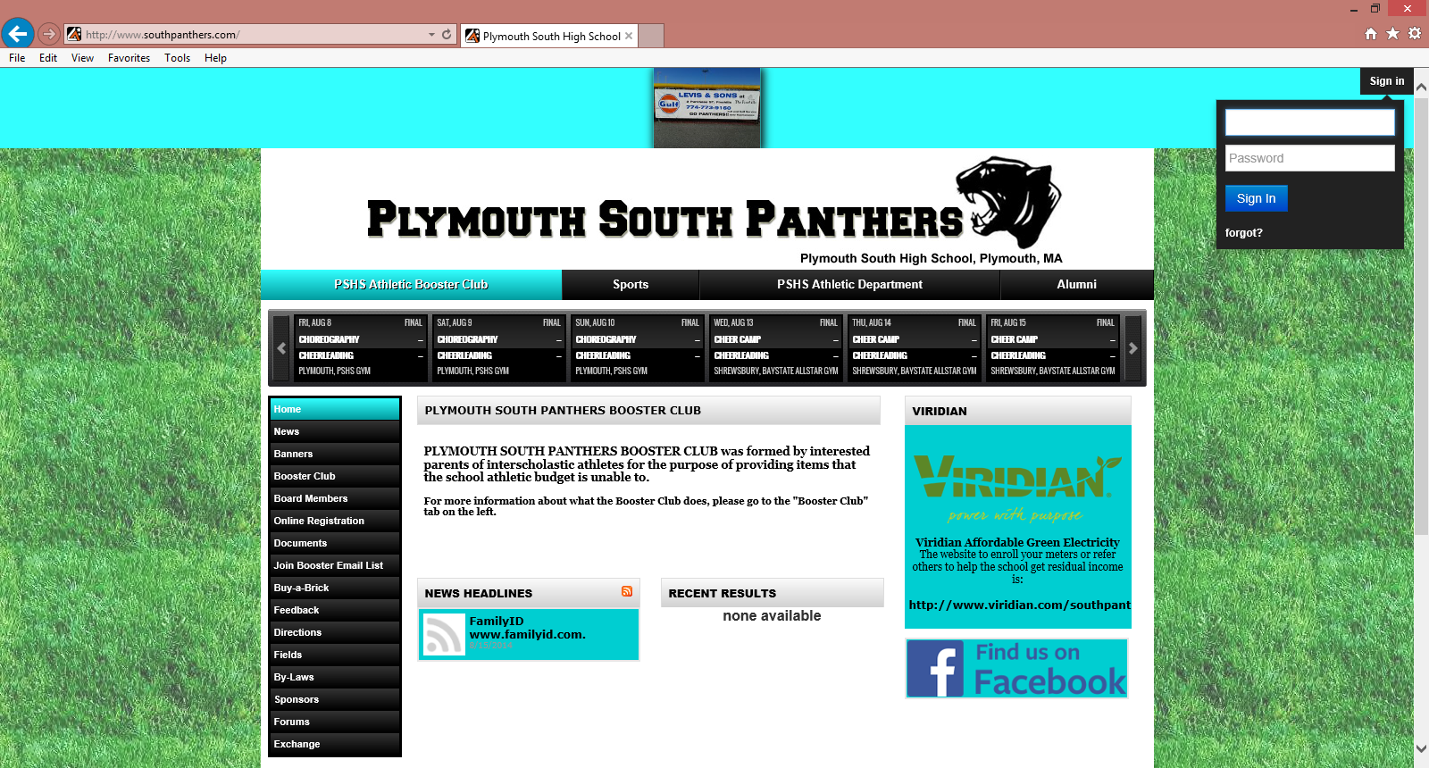
Next -> Click on Admin -> Teams -> Assign Rosters
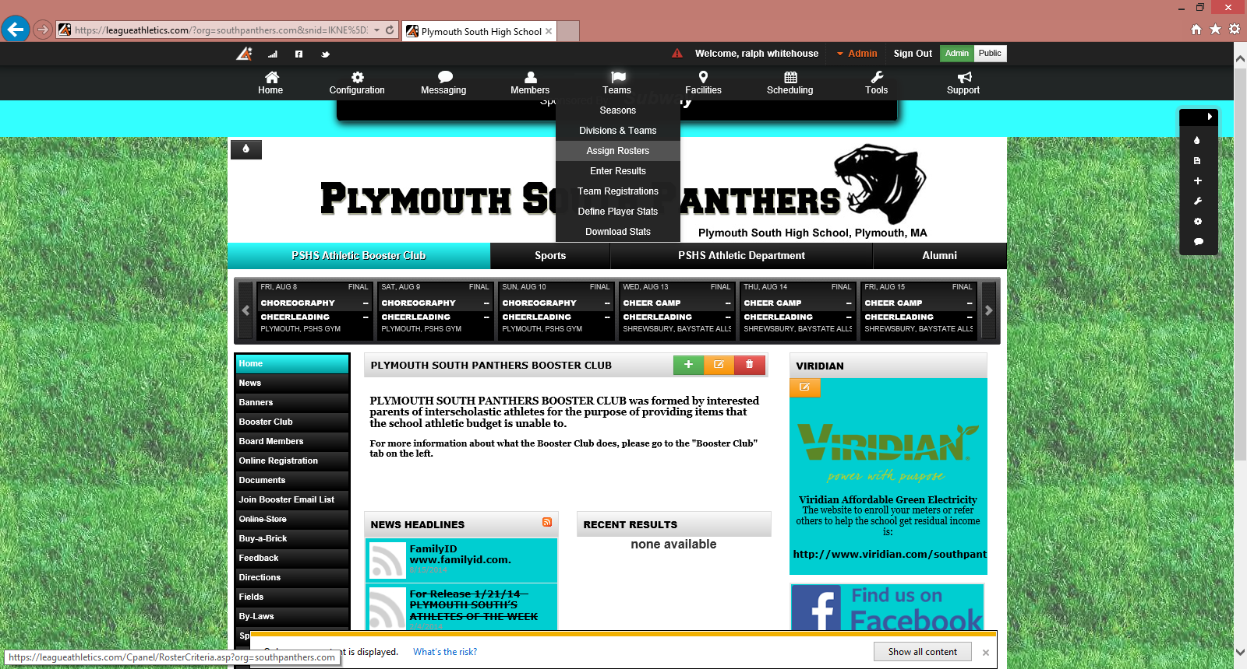
Select a Team -> Season and Team
Then Submit
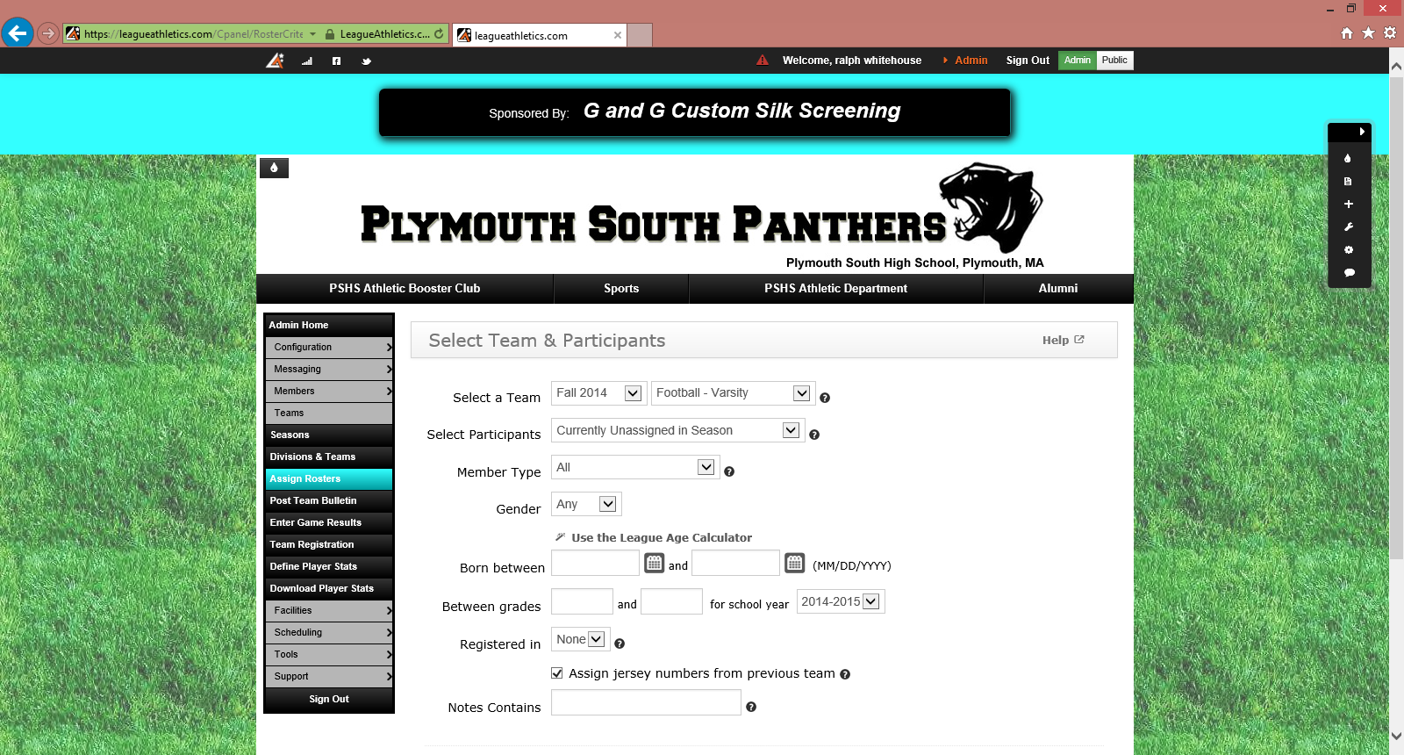
Current Roster is in the left column. Players can be removed by clicking on the individual.
Players can be added by selecting an individual in the Eligible Members columns.
New players will need to be added via the Members page -> add Members page.
After you have updated the roster you must click -> Save Roster at the bottom of the page.
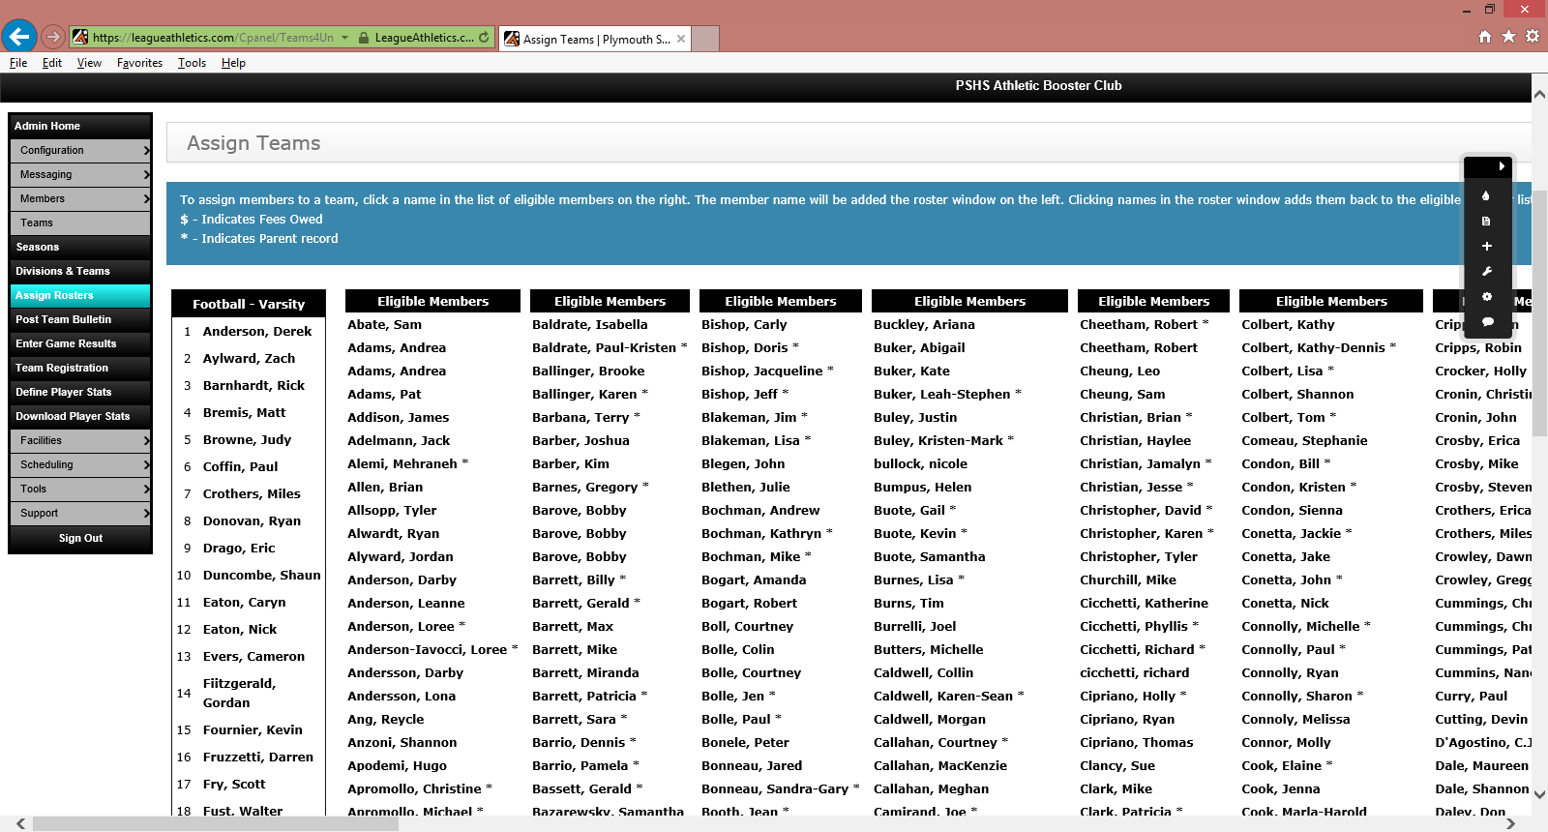
Section - Add Member
Next -> Click on Admin -> Members-> Add Member
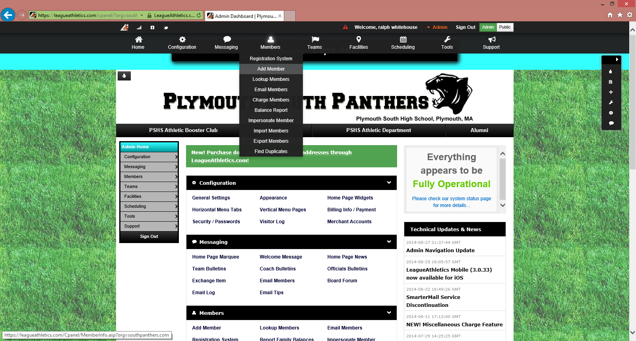
Fill in relevant information and hit Submit at the bottom of the page.
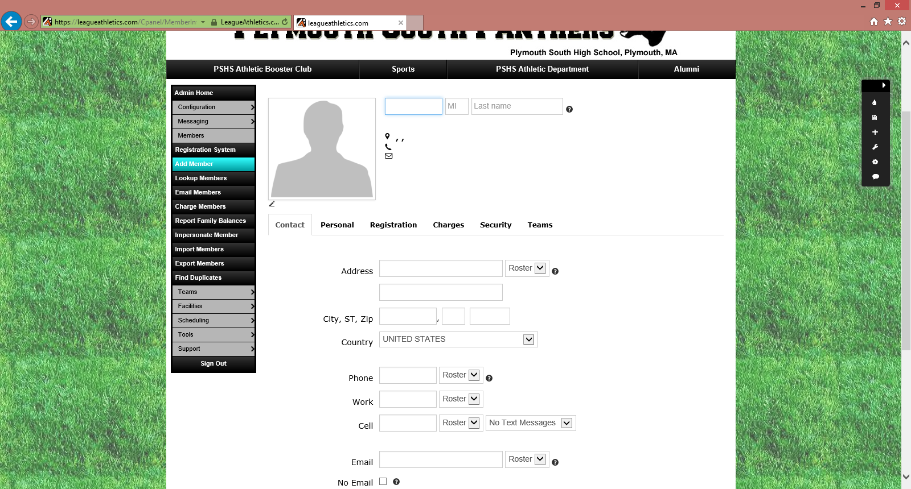
Please note: A member can be assigned to a team by the following:
Click on the Teams tab.
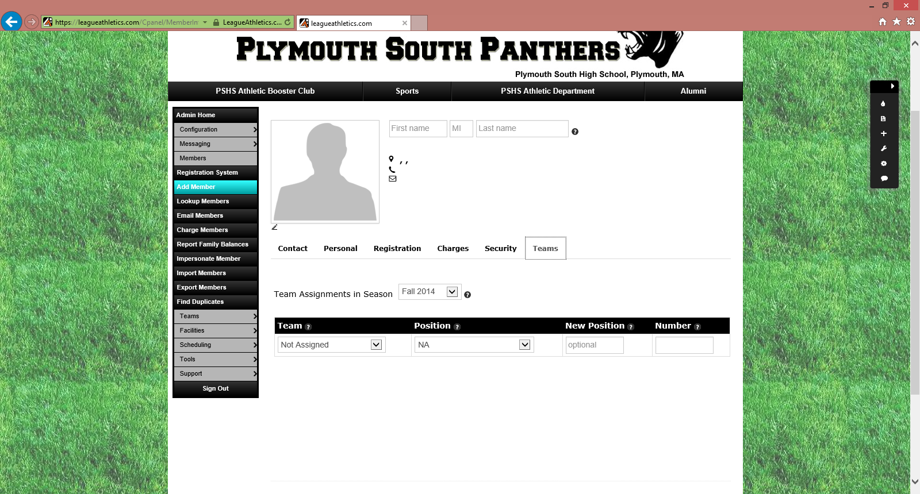
Assign a team for that individual and Submit.

