**Holloway Game Jerseys (generally fits true to size)**

ADULT sizes

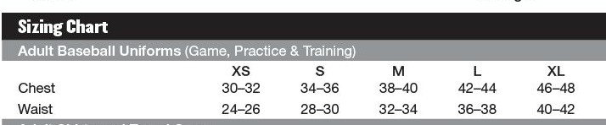

YOUTH sizes **S M L XL**

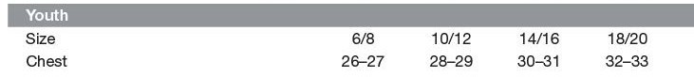



**Richardson Hats**

**We will have FLEX/FIT 40pt hats. XS/S, S/M or L/XL**