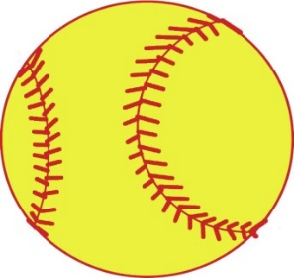
M e d i c a l
I n f o r m a t i o n

Person to notify in case of emergency
___ _ _ _ _ _ __ _ _ Relationship_ _ _ _ _ __ __ Phone #__ _ _ _ _ _ __ __ Insurance company name
___ _ _ _ _ _ __ _ __ __
Policy Number__ _ _ _ __ __ The undersigned hereby acknowl-
edges that participation in this camp and related activities an inherent risk of injury, and the undersigned on be- half of the registrant, hereby assumes all such risk and does hereby release and forever discharge the camp and all employees and agents thereof from any and all liability of whatever kind of nature arising from and by reason of any kind an all known and unknown damage to property, and the conse- quences resulting from participating in this camp, including any defect in equipment or in premises.
The law requires parental permission be obtained for operative procedures on minors. The following consent form should be signed by a parent so that procedures may be promptly car- ried out and that no unnecessary delay will occur with operative procedures. No operation however, will be per- formed, except emergency, without parents being contacted.
I give permission for such diagnos- tic, therapeutic and operative proce- dures as may be deemed necessary for my child.
Parent/Guardian Signature

___ _ _ _ _ _ _ Date __ __

2017 Fleming Island
Softball
Summer Camp
June 26-29 & July 24-27
4-7 pm @ FIHS

Girls ages 6-14

What to bring: cleats, tennis shoes, glove, bat, helmet, water and snacks

Cost: 100.00 for a single week; 175.00 for both weeks; 10.00 sibling discount

What’s included: Instruction on the fundamentals of the game; Hitting, fielding (both infield and outfield), throwing, catching, pitching and sliding

Please indicate your campers t-shirt size
(youth S-L or adult S-XL)

For questions or registration arrangements please contact Jen Bucklew
Jen.bucklew@comcast.net
Please fill out & Mail-in

Full Name Address City State Zip Age at camp DOB Grade Entering Fall 2017 School Attending Fall 2017
___________________________________________

Parent Name

Phone # Emergency # Email:
Check one or both
_____June 26-29

_____July 24-27
$100.00 for the week; $175.00 for both camps

(For multiple campers)
Family Discount: $10.00 off per child
T-Shirt Size (Circle one below)
Youth - S M L Adult - S M L XL

Please make checks payable to: Fleming Island High School

Mail to: Softball Camp
2233 Village Square Parkway Fleming Island, Fl. 32003
Phone: 904-336-7500
Fax: 904-336-7478

