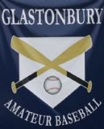 | Basepaths  Competitive Travel Baseball Since 1995  July 20, 2011

  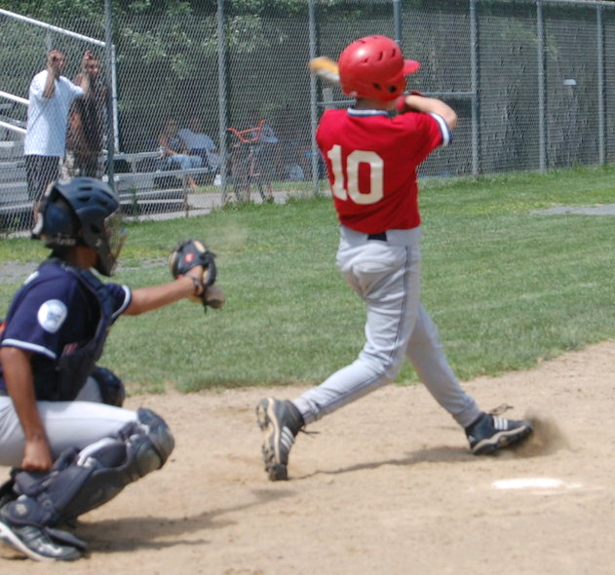  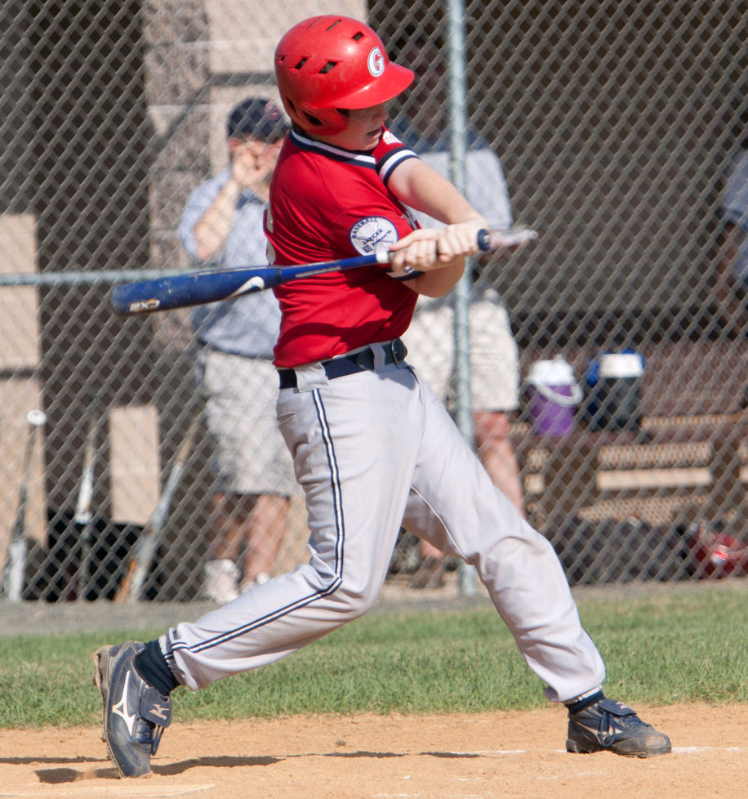  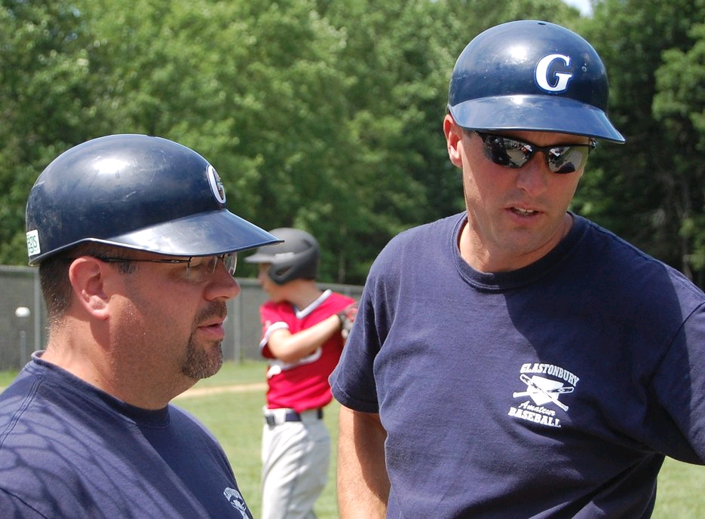 | SPOTLIGHT SHINES ON 13 YEAR OLD PREP RED......  Glastonbury has placed 2 teams in the Jaycee-TD Bank Baseball League of Greater Hartford. The "Red" team has been placed in the competitive Central Division, which currently sports 5 of the top 8 teams in the 21 team league. If you look at the overall record, you would not judge the season as a success. However, for many of these players it is their first Spring/Summer on the 90 foot diamond and perhaps the first time they have played teams from across the county. The Achilles heel of the team has been falling behind early in games. When the defense holds the opponents in check, the bats don't come around and on nights when the hitting is there they have tended to fall into too big of a hole early.  The bulk of the pitching duties have been carried by Dylan Finamore, Jeff Murdoch, Kyle LaBrosse and Matt Miller. These pitchers have faced some aggressive and skilled batters but have come back for more and grown throughout the year and they have enjoyed working their strategy with Aidan Benner behind the plate. Steven Bedard has come back from a spring arm injury that kept him in the "EH" slot to play very solid defense at 2nd. Dylan Cyr, Austin Hyatt, Ben Hecker, Michael Talbot and Chris Craig have had to cover a lot of territory in the large 90 foot diamond outfields but have done a great job and come up with some spectacular grabs. Connor McMorrow has been versatile on both corners of the infield and our pitching staff switches from the mound SS, 3rd and 1st with ease.  Aidan Benner and Ben Hecker both enjoyed a 3 for 3 day at the plate against the CT Tides in West Hartford. Matt Miller and Dylan Finamore have been impressive in the 3 and 4 spots in the line-up and key hits have come from Connor, Austin, Dylan and Chris. The base paths have been a bit of a struggle but this summer has definitely been a learning experience for all. Needless to say, the boys and coaching staff of Kevin Benner, Tim Finamore, Tom McMorrow and Walter Murdoch have enjoyed the opportunity to play a few games at Riverfront and look forward to finishing the season strongly.

 | GAB TO HOST AMERICAN LEGION ZONE 7 ALL-STARS  GAB will host the annual American Legion Zone 7 All-Star Games at Riverfront Park on Thursday, June 21, 2011. Both the Junior Legion & Senior Legion All-Stars will take the field that evening; Junior Legions stars at 5:30pm, Senior Legion stars at 8:00pm.  Glastonbury Junior Legion players selected as All-Stars are: John Russell, Mike Surface, Kyle Wucherpfennig, Nick Berey, Ben Berey & Duke DiMarco.  Glastonbury Senior Legion players selected as All-Stars are: Matt Bedard, Chris DuVerger, Emmett Ravis. Ronnie Emanuelson was the Sportsmanship Award recipient.  Stop down for a fun evening of excellent baseball!!!!

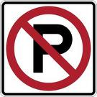 | PARKING AT RIVERFRONT PARK  Parking at Riverfront Park for GAB baseball games is plentiful, especially when there is no other activity taking place at Riverfront. It has been observed that many times folks are parking vehicles on grass areas at the front of the lot when spaces are available in the rear portion of the lot. Parking is also prohibited on both sides of the road from the entrance to the parking lot. GAB is asking that folks respect the park and park in available parking spaces rather than on grass areas & in fire lanes. Your cooperation in this is greatly appreciated & will go a long way in preserving Riverfront Park. Let’s do our part!!!!!!!!

2011 ALL-COURANT BASEBALL  GAB Senior Legion pitcher Conor Leblanc was named to the 2011 All-Courant Fab 15 for his outstanding 2011 high school season. Conor polished an 8-0 record with 70 K’s and an ERA of 0.66. Conor will be taking his talents to UMass-Amherst as he begins his collegiate career in Fall 2011. | 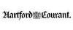

 | On July 21 in Baseball History….  1956 - Brooks Lawrence of the Cincinnati Reds had his 13-game winning streak broken as Roberto Clemente's three-run homer led the Pittsburgh Pirates to a 4-3 victory.  1973 - Hank Aaron of Atlanta hit his 700th home run in the third inning of an 8-4 Braves loss to Philadelphia. Aaron connected on a 1-1 fastball off Phillies pitcher Ken Brett

SPOTLIGHT SHINES ON 13 yr old PREP WHITE

13. Lucky 13. Thirteen local youths have given up a large part of their summer to play the game they love—baseball. Sponsored by GAB and under the burgeoning leadership of Matt Marchinetti and Ricky Marimon, the boys are competing in the tough Eastern Division of the TD Bank Jaycee Prep League. To date, they have put up a respectable 4-7 mark with over half of those losses coming to powerful teams from Manchester and South Windsor. Although their record belies it, Glastonbury has been improving every game, and the coaches have commented that this group is a “great group of kids” and “a pleasure to coach.”
Testament to the teams resiliency, they recently suffered a terrible loss to South Windsor 18-0 and were scheduled to play them the very next night. With new found energy and a renewed vigor, Glastonbury played them even for six full innings eventually succumbing by only two runs. One coach commented, “this was the best we played all year. That’s what it’s all about.”

The team has received excellent starting pitching from Austin Buck, Will Duggan, John Sadak, Andrew Cordova, and Justin Damone amongst others. The offense has been led by Duggan, Marchinetti, Cordova and Sadak, but everyone has contributed key hits during the season. Exceptional outfield play has been provided by Connor McManus (an acrobat in left), Stephen McCauley, and Hayden Rossi, and Alex Dahlem, Andrew Piskura, and Daniel Connolly have played almost every position on the field affording the coaches creative options and versatility. The aforementioned Marimon has been a rock behind the plate.

Glastonbury has solid wins over Windsor and Hebron and has swept Marlborough in a two-game series. With three games left, Glastonbury is confident that they can even their record for the season and be a “Cinderella story” making some noise in the playoffs. One other highlight of the season came when Glastonbury White played exhibition game vs. Glastonbury Red, the town’s other 13-year-old summer team at Riverfront. Although the game was hotly contested with both sides striving to win and earn bragging rights, once the game was concluded (a 10-4 Red win), both teams sat down for pizza and soda—together. Many thank to Kevin Benner for orchestrating many of the logistics of the game.

The team would also like to thank GAB for that event, all of their help and guidance this season, and most importantly for the opportunity to play summer ball. Finally, the team would like to thank their coaches, Gordon Rossi, Dan Buck, Paul Marchinetti, and David Rose who have given their time and their baseball knowledge throughout the season.

SANDY KOUFAX TEAMS END SEASON

The two GAB 14 year old Sandy Koufax teams playing in the Greater New Haven Baseball League ended their season playing each other in a doubleheader at Riverfront Park.

After battling and each winning a game in this friendly rivalry, they enjoyed each others’ company at a barbecue under the pavilion.

These teams played 25 games this summer against AAU / travel teams from all over the state of Connecticut. Both teams ended up being competitive and having winning records.
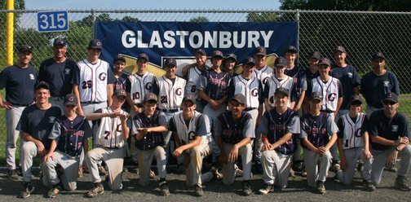
Sandy Koufax Teams

GAB FALL BASEBALL REGISTRATION ENDING SOON!!!  Don’t be late, don’t miss out… Registration for GAB Fall 2011 Baseball Programs ends on July 31, 2011.  All registrations must be completed utilizing the On-Line registration process on the GAB webpage (www.gburybaseball.com). | 

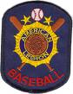 | JUNIOR LEGION QUALIFIES FOR STATE TOURNAMENT  The Junior Legion team qualified for the CT American Junior Legion State Tournament by sweeping a double header at Wethersfield on Saturday by scores of 14-3 & 4-1.  The Juniors open play in the single elimination tournament on Saturday, July 23 @ 11:00am taking on South Windsor @ Rotary Field in South Windsor.  Good luck!!!!!!!!!

 | SAVE THE DATE!!!!!  It's never too early to plan ahead!!!!! Save this date!!!! Put your time off requests in now!!!!  What: Annual GAB Golf Tournament  When: Tuesday, October 4, 2011  Where: Blackledge Golf Club  Scramble format; lunch & dinner; raffle prizes; contests. Sponsorships available. Donations for raffle prizes accepted.  Registration form is now available on the GAB webpage (www.gburybaseball.com); additional information is forthcoming.  Join us for a great day!!!!!

GLASTONBURY AMATEUR BASEBALL
gburybaseball@sbcglobal.net
www.gburybaseball.com

