Registering on the OFA Site
http://ontariofootball.ca/

Choose the appropriate registration – player or coach
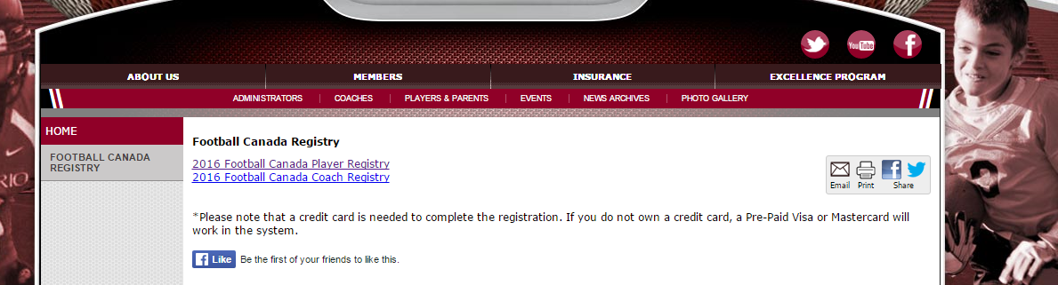

Step 1 - Be sure the change the are you a returning player to no for your first registration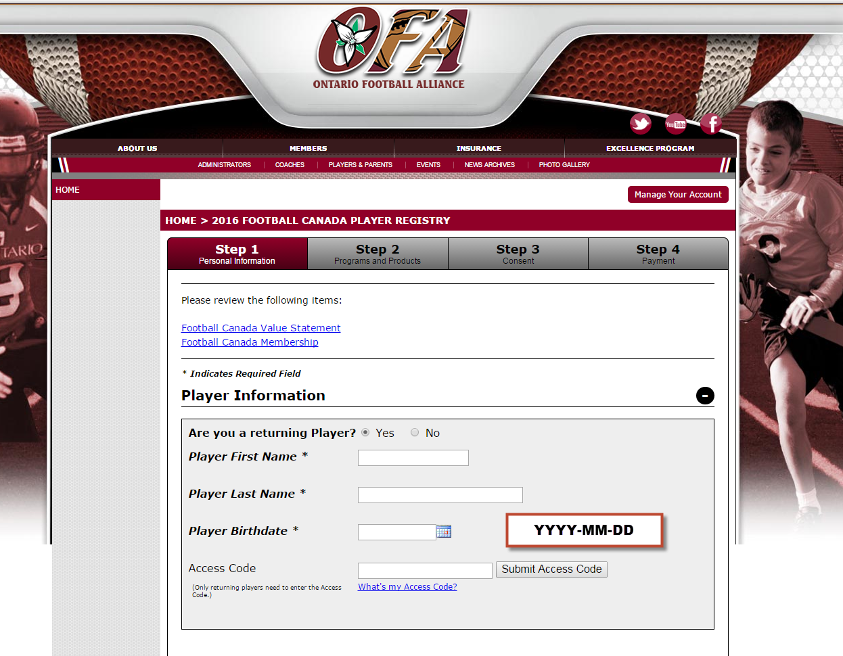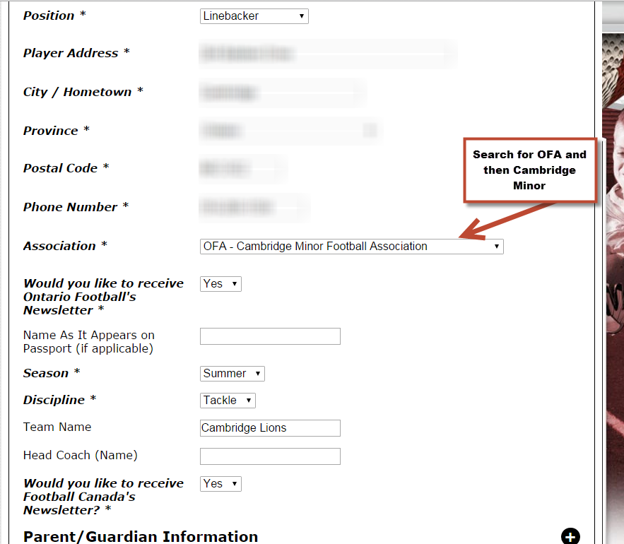
Be sure to fill in parent/guardian information for at least 1.

Step 2
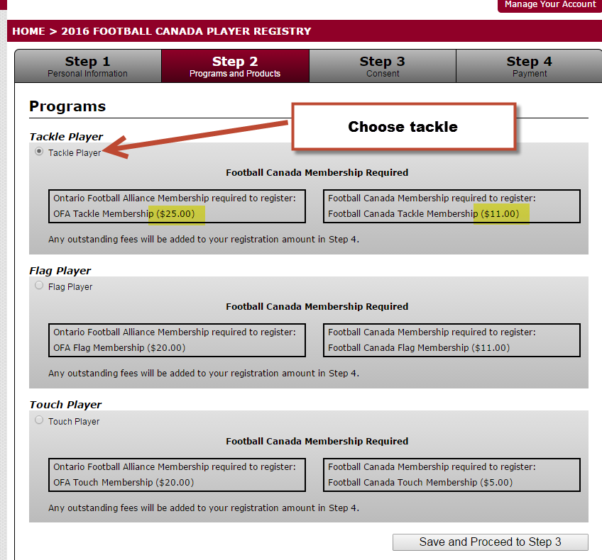

Step 3
Review the information entered on the screen. Be sure to open and read each applicable waiver and print/save to your computer for reference.
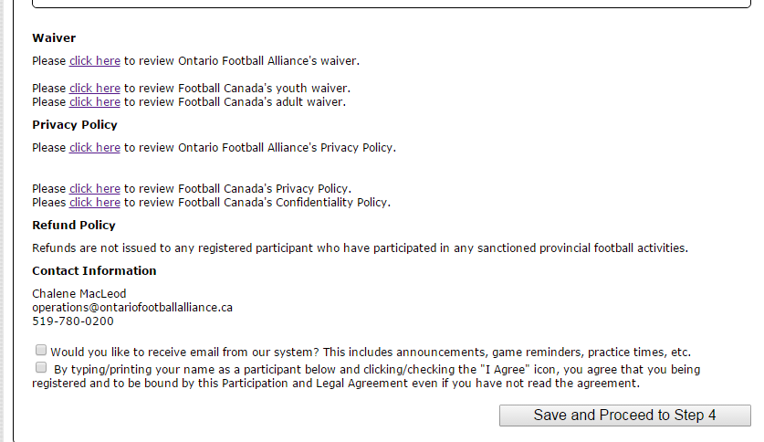

Step 4
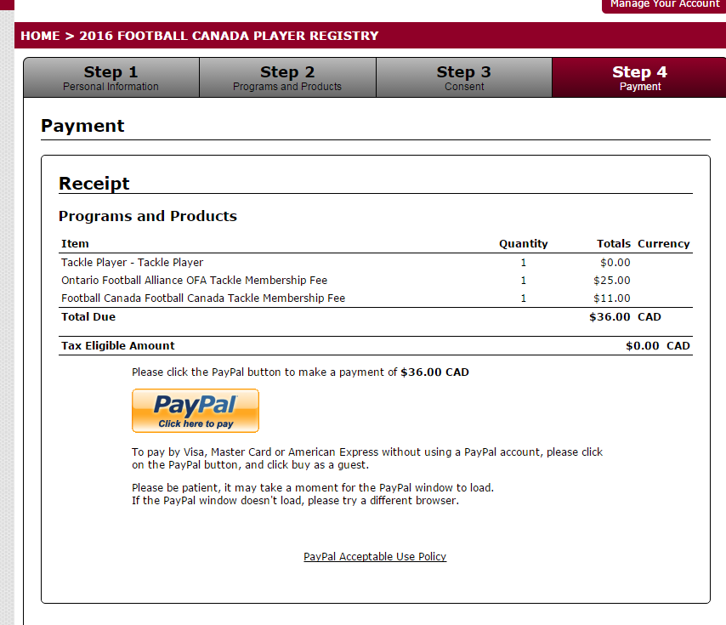

Follow the instructions on the paypal page to either log in with your paypal account or continue as a guest.
Once processed you will receive an email with your registration number and the below message.

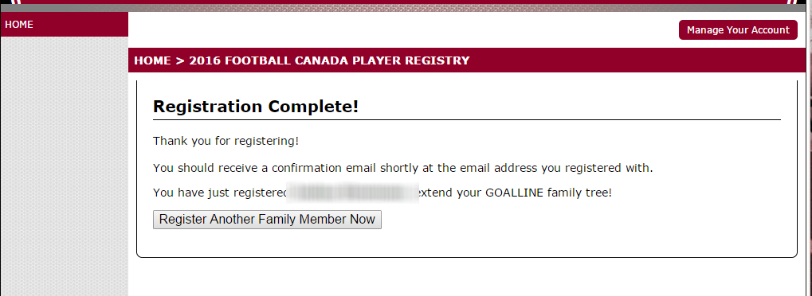

You will receive an email like the below from Chalene MacLeod, this should be instantaneous if you do not see it check your junk mail.
