League Athletics App Instructions

- Search for “League Athletics” in App Store or Google Play Store

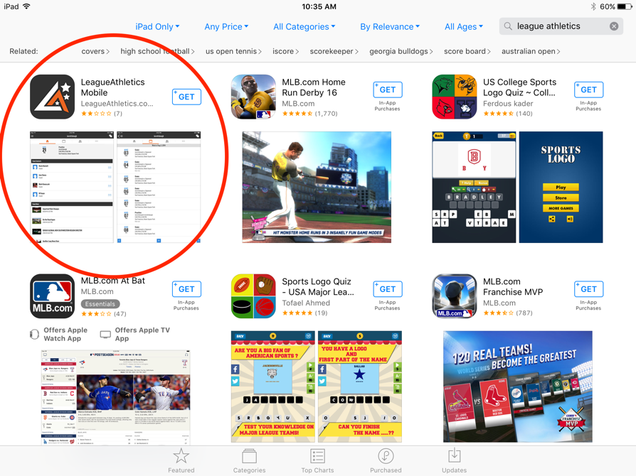

- Download Mobile Athletics App

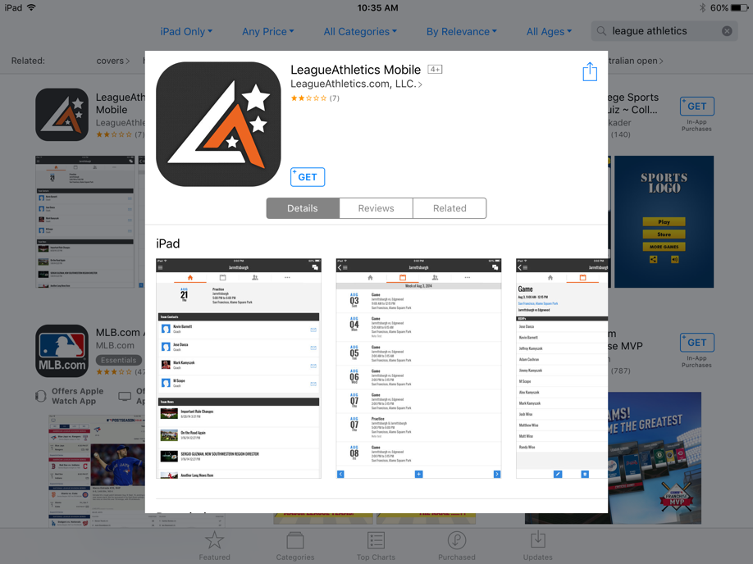

- Turn On Notifications

- Press the blue button, “Click to add” at the top of the screen. You will see a pop-up titled New Organization.

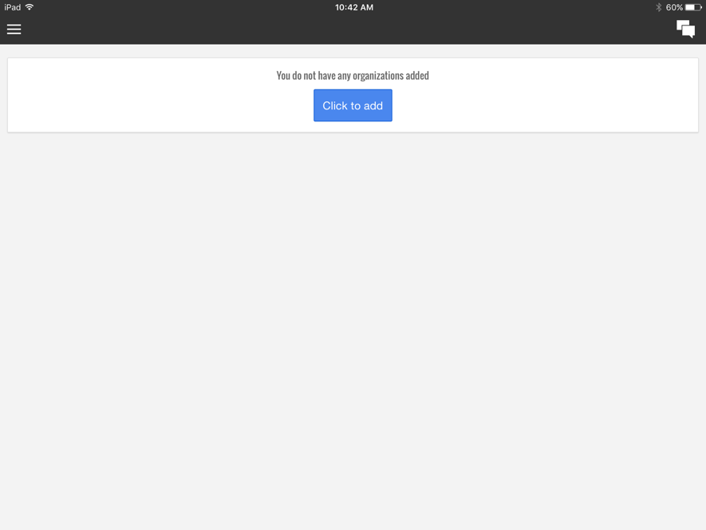

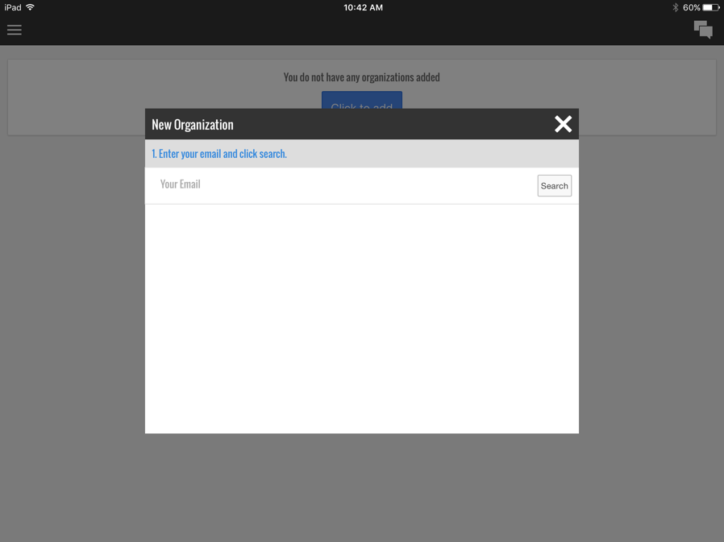

- Enter the email you use to sign up with the Sycamore Lacrosse Association, Press Search

- Under “Select Organization from the List”, there will only be one option, Select Sycamore Lacrosse Association

- Use the same password that was used to setup your account on the Sycamore Lacrosse Association website.

- Press Save

- You are now setup on League Athletics. I’ll be sending out emails at the beginning of the season, but will transition more to League Athletics once we get the game schedule and practice schedule uploaded.

