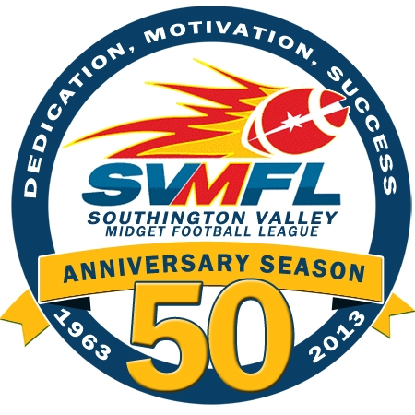
SVMFL General Membership Meeting Minutes
Date: November 26, 2013
E-Board: George Cardozo, President; Jeff Buonanni, Vice President Scott Kieras, Treasurer; Terri O’Shea League Auxilary; Tim O’Shea, Equipment Manager Andy Pettola, Flag and Powderpuff Commissioner, Tommy Porter, Tackle Commissioner, Hope Chapman, Secretary, Kim Beaudoin, Cheer Director
Attendees: Jim Tracy, Chris Laporte, Jeff Graziano, Jeff Rees, Rich Casella, Howard Campbell, Tito Roderick, Fred Parke, Chris Matusik, Ron Pastor, Pat Testa, Shari Kohl, Dave Schneider, Chris Kohl, Sara Jean, Dave Harrold, Stacey Porter, David Sullivan, Bonnie Sullivan, Jon Evjen
Meeting Agenda:
Call to order - meeting was called to order at 8:04pm by President, George Cordoza
- Roll call was conducted by Hope Chapman
- Accept minutes of last meeting – Motion to accept minutes approved
- Treasurer Report - Scott Kieras
  - League balance is $25,720.83 with all bills paid including officials except $4400 for lights.
- League Auxilary – Terri O’Shea
  - Anticipating a check from Buffalo Wild Wings
- Cheer Report – none
- Powderpuff and Flag Report
  - Flag Steelers champions
  - Powderpuff Steelers champions
  - Anticipating a check from Buffalo Wild Wings.
- Tackle Report – Tommy Porter
  - Championships went well at the High School
  - West Hartford sent note to league/George appreciated medals and organization. They weren’t going to participate this year for All-Star game and they were pleased with that decision.
- Equipment Manager Report
  - Outstanding equipment needs to be returned.
  - List of outstanding to be sent to George.
  - Anyone playing winter league needs to still return their equipment and they will be reclaimed during the winter. No charge/deposit may be required.

- New Business
  - Field Day Cleanup scheduled first week or so in December to cleanup fieldhouse, restrooms, bleachers, posts, etc… to close for the season.
  - Scoreboard – working with town and issues surrounding posts and other items.
- Voting
  - Tackle Saints – Jeff Buonanni
  - Tackle Patriots – Scott Kieras
  - Tackle Chargers – David Schneider
  - Voted to separate Tackle A and B – YES
  - Revote for year to separate – 2016
Meeting adjourned 9:02pm

