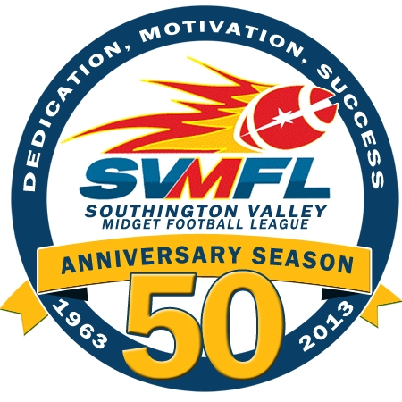
General Meeting Minutes
Date: June 11, 2013
In Attendance: Sarah Jean, Howard Campbell, Dave Harrold, Pat Testa, John Dogumbia, Jim Tracy, Chris Kohl, Ron Pastor, Theo Roderick, Shari Kohl, David Sullivan, Greg Sioch, Rob Thomson, Fred Parke
E-Board: George Cordoza, President; Jeff Buonanni, Vice President
Scott Kieras, Treasurer; Hope Chapman, Secretary; Terry O’Shea, League Auxilary; Tom Porter, Kim Beaudoin
Tim O’Shea, Equipment Manager and Andy Pettola, Flag and Powderpuff Commissioner
Absent: Tom Porter, Tackle Commissioner
Attendees:
Meeting Agenda:
- Call to order - Meeting was called to order at 8:02pm by President George Cordozo
- Roll call was conducted by Hope Chapman
- Accept minutes of last meeting – Motion to accept minutes.
- Vendors
  - Embroidery A-Z – Lisa Roberge
    - Everything done in-house
    - Can set up online store offering products August-September
    - Needs 2 ½ - 3 weeks turn around time
    - Digital process for numbers, no separation with vinyl and doesn’t peel
    - Team colors would be available for sweatshirts; online design studio for cheer design on sweatshirts
  - American Stitch & Print
    - George Cordozo to discuss with E-Board
  - Lou Urso – Officials
    - Submitted his officials By-Laws that the officials adhere to
    - George to send over new By-Laws to Lou Urso
    - Mandatory Coaches meeting to be set up with officials
    - Powder Puff will have playoffs and a Super Bowl game
- Tackle Commissioner’s Report – Tom Porter, absent/Presented by George Cordozo
  - Practice starts 8/12
  - Draft – 7/30, 7/31, 8/1
  - Combines – 7/15, 7/22, 7/29
  - Football Camp Options –
    - Jack Cochran a possibility for 7/8
    - St. Paul’s High School Camp
    - Jeff Buonanni referral
    - Giants Clinic coming up
    - Uconn Clinic
  - Light Update – Awaiting ratification on the loan for the bank
- League Auxilary Report
  - Registration update – On site registration Saturday 6/14/ and 7/13 9am-12pm
  - NFL Punt, Pass and Kick September 22nd
  - Dick’s Sporting Goods Partnership “A Day at Dick’s” Sunday 7/28 – 25% discount on that day for everyone who visits Dick’s that day.
  - Sponsorship opportunities – Stickers for back of helmet/field signs and web sites and Yearbook for the league. Sponsorship information to come from Terri shortly.
  - Halloween Bash – November 2nd 8pm-midnight, appetizers, open bar, raffles, silent auction partners
  - Field Day for kids on lower field
  - UConn Game a possibility based on interest
  - Food Drive for Bread for Life
    - Needs New Logo
    - Needs team information of how many teams for bins to compete weekly.
    - Publicize in newspaper
  - October Breast Cancer Awareness month
    - Wrist bands – SVMFL “tackles” breast Cancer
  - Prize Calendar submitted by Chris Kohl
- Treasurer Report - Scott Kieras
  - Balance at $25,017.30
  - Old Scoreboard to be moved to lower field and refurbished.
  - Online registrations light at this time of year
  - Send out electronic version of registration fliers
- Cheer Report – Kim Beaudoin
  - Cheer Camp is tentatively booked – We have 8 girls signed up and need 15. Set for July 24, 25, 26 for $150 3 sets of camp wear.
  - Cheer coaches clinic to be either July 24 or 25th.
- Andy Pettola – Flag/Powderpuff
  - Had successful Powder Puff clinic on Sunday 5/19/13 with 18 girls
  - Flag report – 2013 will have less teams due to 3rd grade moving to Tackle C
- Tim O’Shea – Equipment Manager
  - Tim purchased 50 Zenith helmets for C Division (comes with chin strap)

- New Business
  - Coaches meeting prior to first combine (Early July)
  - Next membership meeting 7/9/13 for Coaches and bring Assistant Coaches
  - First Aid training and CPR training for all coaches
  - Tentative Jamboree is 8/24/13
  - Greg Sioch is retiring as head coach of the Raiders.

- Meeting adjourned at 9:42pm
  - Flag and powderpuff coaches clinic times TBD

- Old Business
  - Light updates
      - Vote on purchase of lights
      - Musco and Techline Sports were two vendors
      - Techline 26K less expensive $109,600 installed this year with no money down and 7 payments of $19,640.93 with 5.51% interest. Payment deferred for first 12 months.
      - Musco was 25% down 5 year term at 8% for 7 payments
      - Warranty maintenance for 10 years covers both labor and material
      - Open new bank account for lights
      - Motion carries unanimously for lights on lower field
  - Scoreboard
      - Sign pro will install the scoreboard. $3500 to refurb. Motion carries unanimously to pay.
  - Scholarship/Graduation
      - Two scholarships given to SVMFL alumnae by George. Looking to get photo of them at field house.
- New Business
  - Sponsor signs on the scoreboard pole at $500 per
  - Sign for permanent sponsors/plaques

- Meeting adjourned at 9:20

