MCLA Division I Top 25 Poll  1 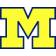 University of Michigan 400  2 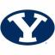 Brigham Young University 368  3 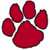 Chapman University 365  4 Simon Fraser University 360  5 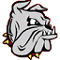 University of MinnesotaDuluth 336  6 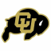 University of Colorado 298  7 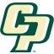 Cal Poly SLO 282  8 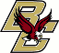 Boston College 278  9 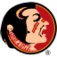 Florida State University 269  10 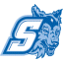 Sonoma State University 261  11 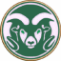 Colorado State University Ft. Collins 240  12 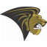 Lindenwood University 231  13 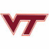 Virginia Tech 180  14 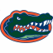 University of Florida 174  15 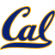 University of California Berkeley 168  16 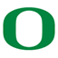 University of Oregon 150  17 University of California Santa Barbara 136  18 University of Texas 126  19 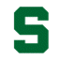 Michigan State University 115  20 San Diego State University 84  21 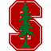 Stanford University 84  22 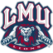 Loyola Marymount University 76  23 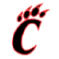 Claremont College 68  24 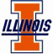 University of Illinois 37  25 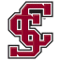 Santa Clara University 28  State University of New YorkBuffalo (18), University of Washington (16), Auburn University (14), University of Arizona (12), Southern Methodist University (8), Northeastern University (7), University of Minnesota (6), University of North Texas (4), University of San Diego (1) | MCLA Division II Top 25 Poll  1 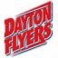 University of Dayton 396  2 University of St. Thomas 379  3 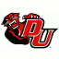 Davenport University 358  4 St. John's University 351  5 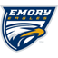 Emory University 350  6 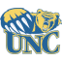 University of Northern Colorado 305  7 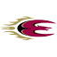 Elon University 286  8 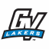 Grand Valley State University 279  9 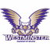 Westminster College 263  10 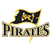 Southwestern University 231  11 Tennessee Wesleyan College 170  12 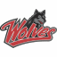 Western Oregon University 169  13 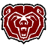 Missouri State University 165  14 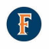 Cal State Fullerton 143  15 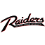 Southern Oregon University 135  16 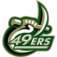 University of North Carolina at Charlotte 132  17 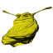 University of California Santa Cruz 116  18 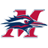 Metropolitan State College 112  19 Fort Lewis College 105  20 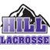 Stonehill College 92  21 Grove City College 82  22 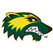 Utah Valley University 77  23 Kennesaw State University 73  24 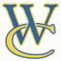 Whitman College 69  25 Hope College 62  Northern Arizona University (49), Coastal Carolina University (47), Montana State University (39), Creighton University (37), Briarcliffe College (31), Western Washington University (27), Savannah College of Art and Design (22), Wheaton College (22), Oakland University (19), Worcester Polytechnic Institute (3), DePaul University stana College (1), North Dakota State (1)

