Please join us for Exton Little
League Spirit Night

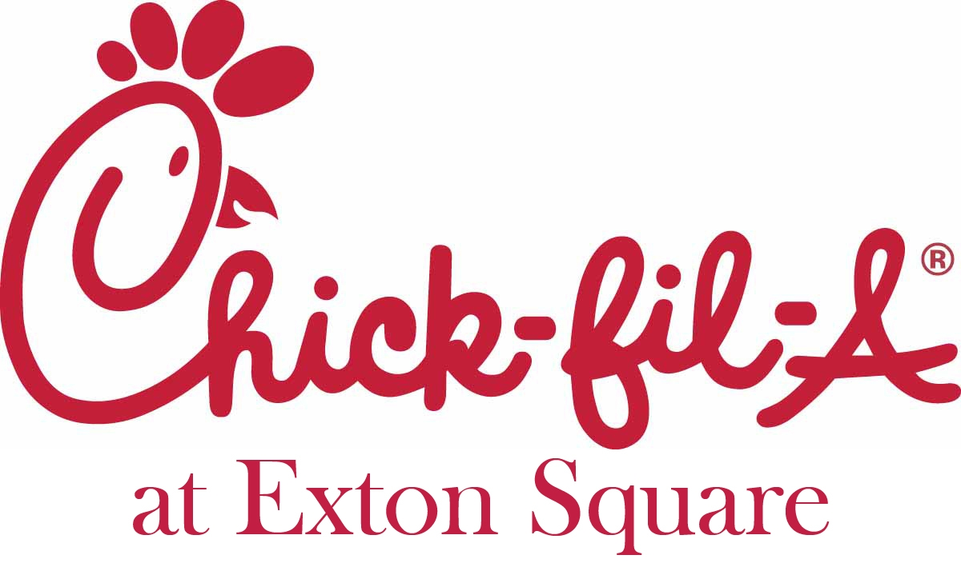

All players, coaches, parents and friends are encouraged to show their team spirit by dining at
Chick-fil-A at Exton Square Mall
Wednesday, October 10, 2012
between 5:30pm and 8:00pm.

To reward your team for your patronage, Chick-fil-A will donate a percentage of the dinner sales on October 10th to the Exton Little League. The stronger your participation, the more money we can raise!

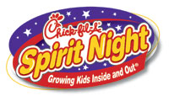Mark your calendar for dinner at
Chick-fil-A at Exton Square Mall
Wednesday, October 10th, 2012.
Enjoy a great meal and socialize with your family and friends all while supporting your league!!!

