Live Love Lax
Girls Lacrosse Camp
When: July 22-25, 2013 (Mon-Thurs)
9-11am
[Friday 26th Rain Date]
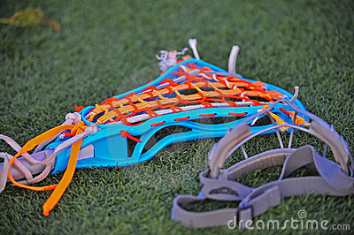
Where: The Bromfield School
[Field in front of the school]
Cost: $70
Information:
Available for any girls entering Grades 3-6
Come to improve your skills as a lacrosse player, or come to learn how to play the game.
[No experience necessary]
Most importantly come to have FUN!
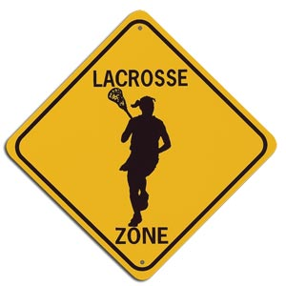
Please bring a mouth guard, goggles, and a stick
[We will have spare sticks available]
If interested contact:
Email: jhoggins@verizon.net
or
Phone: 1(978)-844-3428
Hosted by:
Jackie Planchet, Soph Turchetta, Julia Hoggins, and Lindsey Hoggins
Camper’s Contact Information
Camper’s Name: _____________________________________________________
Year’s Experience: __________________ Preferred Position: _________________
Birth Date(MM/DD/YYYY): ___________________ Campers Grade Fall 2013: ________________________
Street Address: ______________________________________________________
City: ___________________________________ State: ___________ Zip: ______________
Father: _________________________________ Day Tel.____________________ Cell: ____________________
Mother: ________________________________ Day Tel. ____________________ Cell: ____________________
Name of emergency contact (other than parent): ______________________________________________________
Day Tel. ________________________________Cell: ______________________
Family Physician: ______________________________________________________________________________________________
Address: ________________________________________________________________ Tel. __________________
Campers cannot be registered without providing complete insurance information.
Medical Insurance Company Name: ________________________________________________________
Policy # __________________
Waiver and Release
Please read this form carefully and be aware that by registering for and having your child participate in the Live Love Lax Girls Lacrosse Camp Program at the Bromfield Middle School in Harvard, MA you will be waiving all claims for injuries your child might sustain arising out of her participation.
I recognize and acknowledge that there are certain risks of physical injury to participation in lacrosse programs and I voluntarily agree to assume the full risk of any and all injuries, damages or loss, regardless of severity, that my minor child/ward may sustain as a result of said participation. I further agree to waive and relinquish all claims against Jackie Planchet, Julia Hoggins, Lindsey Hoggins, Soph Turchetta, and any other coach involved with the program that I or my minor child/ward may have (or may accrue to me or my minor child/ward) as a result of her participation.
I do herby fully release and forever discharge Jackie Planchet, Julia Hoggins, Lindsey Hoggins, Soph Turchetta, and any other coach involved with the program from any and all claims for injuries, damages or loss that my child/ward or I may have or which may accrue to me or my minor child/ward and arising out of, connected with, or in any way associate my child’s lacrosse participation.
I have read and fully understand the above waiver and release of all claims.
Authorized Signature: ____________________________________________________________________

Date: ____________________________________________________________________

