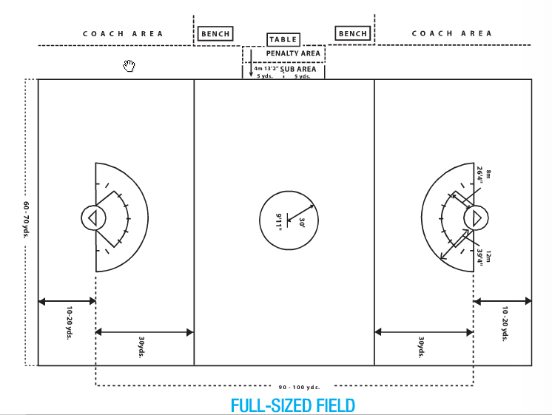

Goal Line Extended

Goal Line

Restraining Line

Goal Line Extended

Goal Line Extended

Goal Line

Goal Line

Restraining Lines

