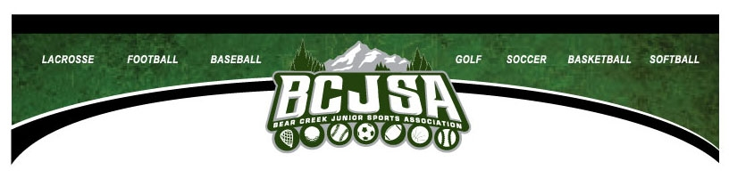
HOW TO GET REIMBURSED FOR TEAM SPONSORSHIPS
Team sponsorships, which need to be made out to “Bear Creek Junior Sports Association” or “BCJSA” and mailed directly to the Association to be tax-deductible to the contributor, will be paid out to the team as either:
- A reimbursement to the team for a team expense already paid for (paid receipt must be included along with Requisition Form)
- Payment of a team expense directly to a vendor (invoice from vendor with payment instructions must be included with Requisition Form)
Guide for Completing Requisition Form
Using the Requisition Form for the appropriate sport (upper right corner), check the line after “Sponsorship”, unless you are requesting BOTH sponsorship money and raffle money on the same form.
Fill in the “Payable To” section with either the team name (for a reimbursement already paid by the team) or the vendor name (for a direct pay of an invoice for a team expense) AND the address the check should be mailed to. Payments made out to coaches/team moms are STRONGLY discouraged. It is recommended that teams get a bank account in the team name with two unrelated signors. BCJSA will not be liable for misappropriation of funds by an unauthorized team representative.
Complete the section for Team Name, Coach, and Age Group/Level (i.e., 12AAA) so I know whose account to charge for the payment. Add who to call if questions arise about the requisition.
Enter the details for the purpose of the payment request in the table. Include any special instructions necessary. For example, a copy of a paid receipt for $1,000 in expenses may be included, but the team only has $500 in sponsorship and $300 in raffle money available. A comment to that effect in the “Purpose/Special Instructions” section will help. Indicate the amount being REQUESTED in the Total column (even if it differs from the invoice amount).
Have the Team Representative sign and date the Requisition.
Preferably, scan and e-mail the Requisition Form along with supporting documentation (paid receipts for reimbursement requests or invoices for direct payment requests) to treasurer@bcjsa.com. Alternatively, the forms can be mailed to or dropped off at the office at:
BCJSA
Attn: Treasurer
2750 S. Wadsworth Blvd Ste C-204, Lakewood, CO 80227
Remember, we are all volunteers & the office is not manned. There is a drop box under the window to put any paperwork in. Please allow 1 week for processing of Requisitions.

