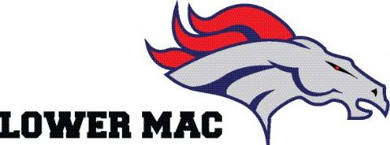
"Celebrating 10 Years of Excellence in Football and Cheerleading"
Lower Mac Families, great news for our program..
Below are two fun, fast and easy fundraising tips that will generate much needed funds for our Mustangs!! Donations received help us pay for new equipment, new uniforms, lights for field and much more while keeping our registration rates manageable.
Support what you love and love what you support!

2 “FUN”DRAISING IDEAS:

SNACK STAND DONATIONS: Donate products to the “Mustang Munchies” Tent. Your donation will instantly double, triple or QUADRUPAL in value when used at the snack stand!!! What a great way to give back! You can bring your donation to the trailer any night at practice. It is a great way to get involved when you don’t have the time to volunteer. Specific items needed:
- Case of 20 oz. Water Bottles
- Case of 20 oz. Gatorade/Powerade Bottles
- Case of 16.9 oz Coke/Pepsi Products Bottles
- Case of Full Size Candy Bars

"Celebrating 10 Years of Excellence in Football and Cheerleading"

HAVE A PARTY!: Too busy to join a committee or help with the End of Season Banquet? Invite your friends and family over for a cookout. Kindly ask everyone to bring a gift card to donate for the program. Any amount is appreciated, and they quickly add up! Gifts card ideas-grocery stores, restaurants, sports stores, gas stations, Amazon…

As the season moves on we will have many other ways for you to help contribute to the financial success of the program with minimal effort and minimal cost to you. We are only as successful as our families allow us to be. Each year it cost almost $50,000.00 to field our teams, half of which comes from registration. Donations from our families and the community at large allow us to continue to provide a First Class Football and Cheerleading experience.

Thank you for your continued support of the program. We would not be here without you.

