Pelham Travel Basketball

“How To” Pay Registration Fees Online

- You will be provided a link to the online payment system via email. Click on the link and you will be brought to the screen below. Click “Continue”.

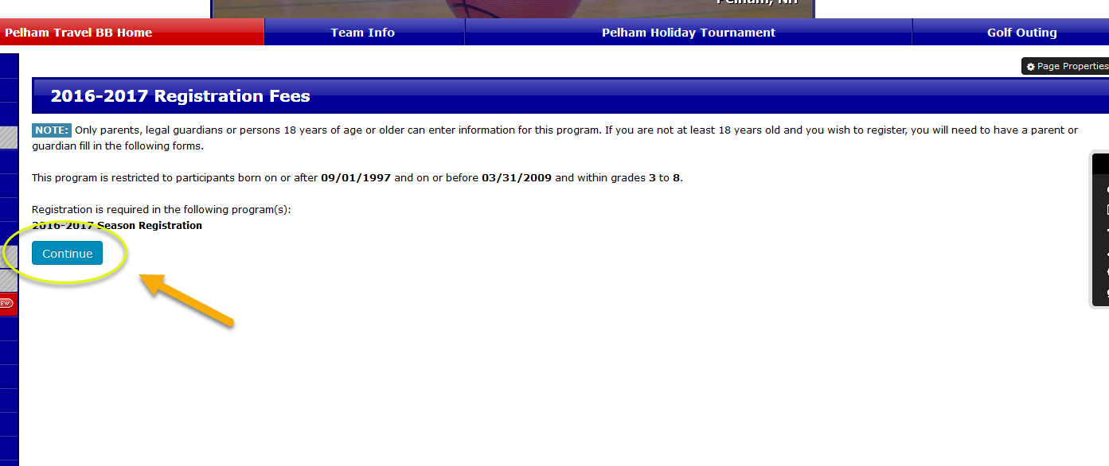

- You will be required to sign in. This will be the same email address & password that you previously used to register for the season. If you forgot your password, you can use the “Forgot” link.
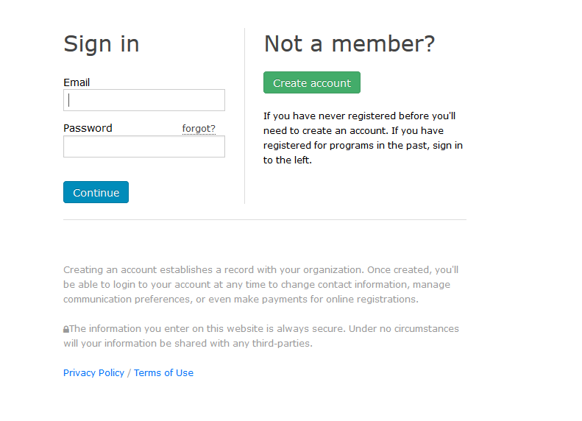

- You will be presented with a list of family members. Children currently rostered on a team for the coming season will have a “Register” button. Click Register to proceed. To note – you families with mulitple children you will only have to do this once.

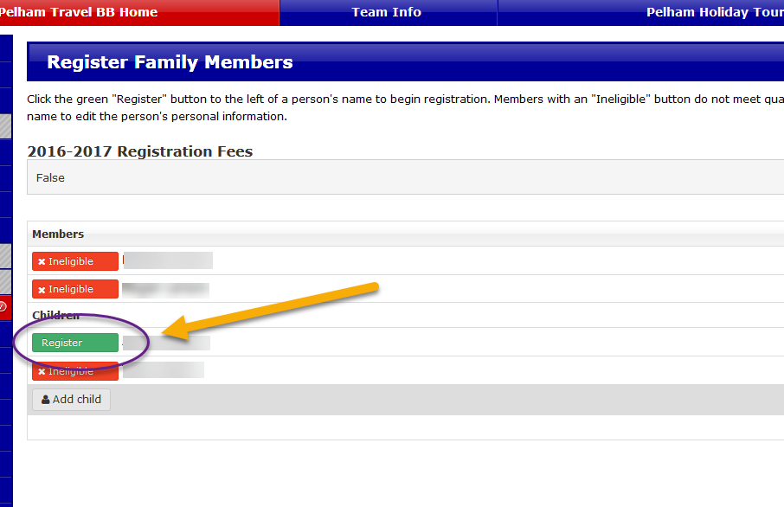

- You will next be presented with a screen that allows you to update your information. Please review and update if needed. Click “Submit” button on the bottom to continue.

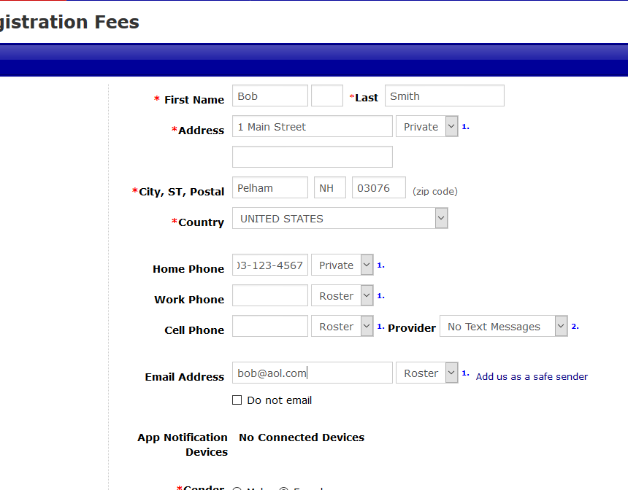

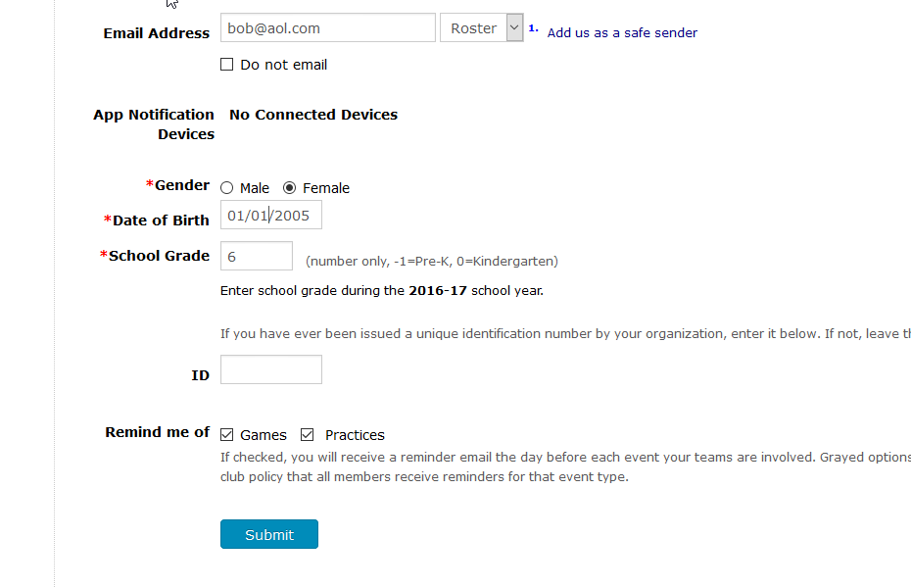

- On the next screen, Coaches will need to enter their code. All others can leave the field blank and hit the “Submit” button to continue.

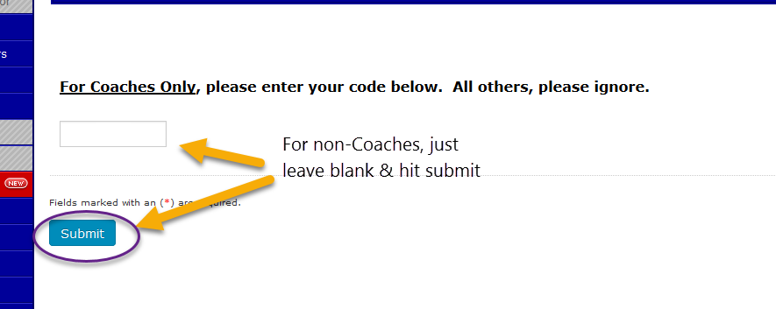

- The screen below will be next. It should include the amount owed. For families with multiple players, the overall total should be shown. Click the “Pay Now” button to proceed.

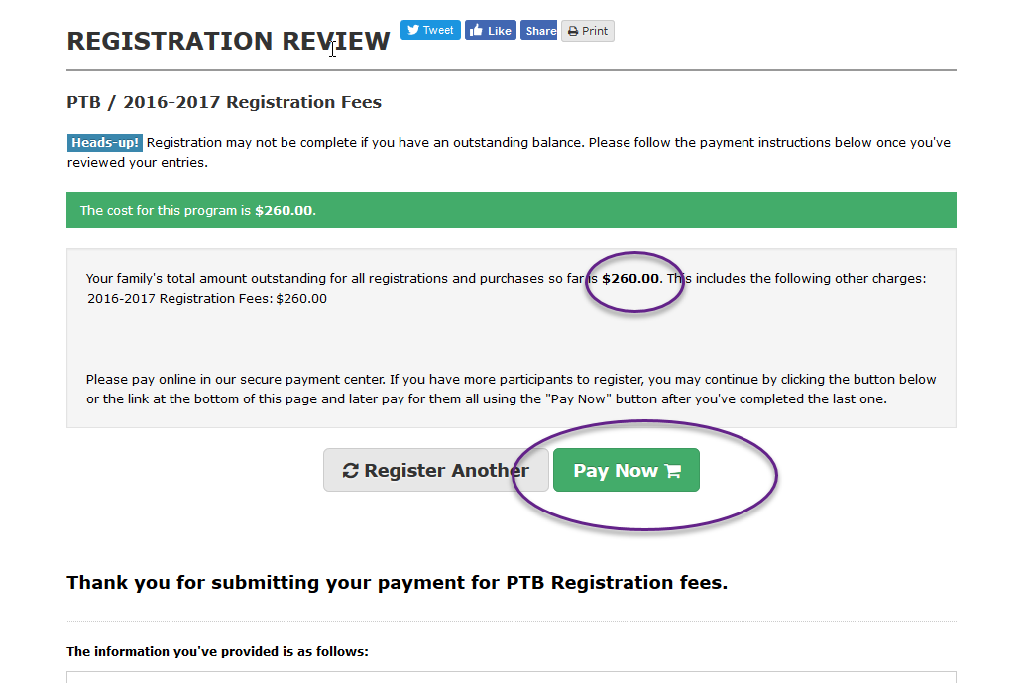

- The next screen below will ask you to enter your billing information. Please complete the form, including your credit card information. When complete, click the “Submit Payment” button. Once complete, you should be presented with a confirmation.
