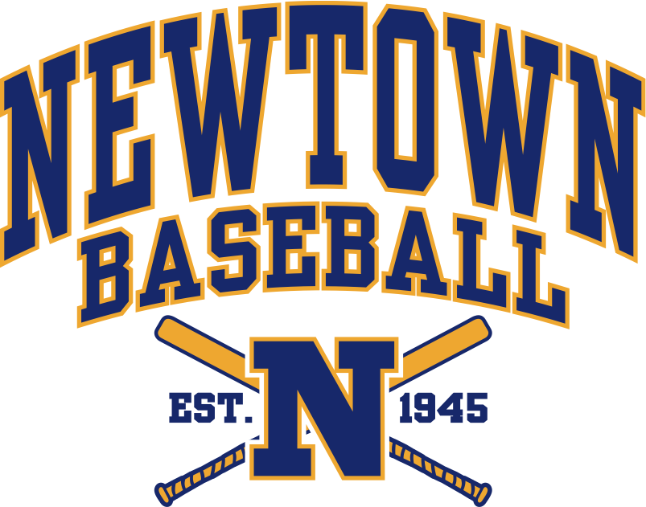

**CODE OF CONDUCT**

_________________________________________________________________

Newtown Babe Ruth Baseball asks for your cooperation in abiding by the rules and guidelines that players, coaches, umpires, and spectators are required to follow. This Code of Conduct is designed to help support the coaches, officials, players and parents in their effort to provide a positive learning experience and for the safety and enjoyment of baseball. Participation in Newtown Babe Ruth Baseball is a privilege for board members, coaches, players, and parents.

**BEING POSITIVE**

* Express support and encouragement for my child and his/her teammates as well as their opponents
* Attend as many games as possible
* Be a role model, not a critic; model appropriate behavior, poise and confidence
* Look upon opponents as friends involved in the same experience
* Accept the results of each game, do not make excuses
* Accept the goals, roles and achievements of your child
* Reward effort and positive behavior, not outcome
* Lead with character and by example
* Encourage multiple-sport participation
* Keep the game simple and fun
* Coach for the love of the game and the love of the ballplayer
* Encourage the development of all players on the team, regardless of their skill level and their impact on the team’s win-loss record

**RESPECT THE COACH**

* Understand and accept that the coach and coaching staff have the final determination as to playing positions and playing time
* Support the coaches and understand that coaching in NBR requires an extraordinary commitment of time, energy, effort and devotion
* While general words of encouragement for players are encouraged, understand that any coaching or tactical instruction from parents during games or practices is NOT allowed under any circumstances
* Release your child to the coach and the team
* View the game with team goals in mind

**RESPECT THE UMPIRES**

* Give respect before, during and after the game to umpires
* Do not verbally criticize umpires under any circumstances
* Accept official decisions without anger, no matter how unfair they may seem
* Remember that the youth umpire you see officiating your game could be your son… act accordingly

**RESPECT LEAGUE OFFICIALS**

* Accept and understand that Newtown Baseball and baseball in general has rules and guidelines and all decisions are based on those rules and guidelines
* Recognize that members of the board of Newtown Baseball volunteer their time and efforts

**BEING A GOOD SPORT**

* Teach your child good sportsmanship toward the opposing team, coaches and parents
* Play the game for fun
* Put the team ahead of yourself in every situation
* Accept decisions made by those in authority
* Be accountable for your own actions

**RECOGNIZE THE VALUE AND IMPORTANCE OF OUR VOLUNTEERS**

* Respect for the property owned by the school district and property owned or leased by the Town of Newtown, as well as opposing team’s locations. Police the area and assist with field preparation before and after games
* Respect coaches, umpires and league officials for giving their time and resources to provide recreational activities for your child
* Attend team meetings