U6 U8 Soccer Xpert Drills

Ouch!

U6, u8, soccer drill, fun soccer drill, free soccer drill, youth soccer drill, dribbling
Published 12/29/2005 12:00:00 AM
Author: Chris Johnson

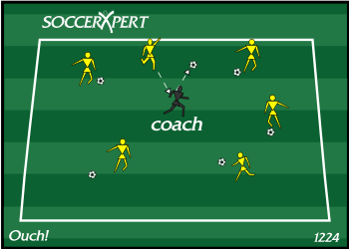
Drill Objective:
This drill should be used with younger players (U6 and U8) to introduce dribbling, looking up and properly striking the ball ball at a target. And best of all, it's FUN!

Drill Setup:
Build a grid 20X30 (may adjust if too large or small). Every player must be in the grid with a ball.

Drill Instructions:
The coach jogs around in the grid and players try to kick their balls and hit the coach. The players get a point each time they hit the coach. The coach should yell OUCH eah time they are hit to make the game FUN.

Drill Coaching Points:
- Encourage players to get their head up and look for the coaches while dribbling.
- Make sure the players are striking the ball with the proper part of the foot.

Drill Variations
- If the players are struggling to hit the coach, the coach should stop for a couple seconds to give the players a chance.
- Use different parts of the foot: Inside, Instep, Right and Left foot.

3v3 Plus 3
Published 10/20/2005 12:00:00 AM
Author: Chris Johnson

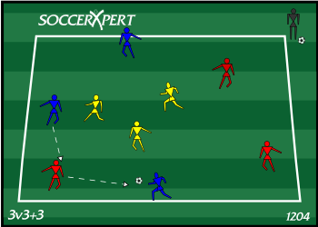
Drill Objective:
This drill focuses on keeping possession. Passing, receiving, movement, and angle of support can be singled out. Causes players to look up and be aware of the surrounding players.

Drill Setup:
Start with building a 20x20 grid. Create 3 teams of 3. One team Yellow, Red and White.

Drill Instructions:
Instruct the Yellow team to be defense first. The other two groups, Red and White, are responsible for keeping possession among the 2 groups.
If the defending team (Yellow) wins the ball o, the team who made the mistake automatically becomes defense. For Example, let's say Red has a bad first touch into the defender (Yellow), then the Red Group would become defense and the Yellow and White groups would then keep possession from the Red group. Any ball played out of the grid is considered loss of possession by that group, and that group should become defense.

Drill Coaching Points:
- Good First Touch
- Good Passes to Feet
- Proper runs/angle of support
- Facing the field

Drill Variations
- For lower level players, rotate the defenders every 2-3 minutes rather than automatically switching after loss of possession.
- Adjust the size of the field to make it more or less challenging
- Restrict the number of touches per player

Line Passing Combination Warm-up

Line Passing Combination Warm-up, Passing Soccer Drill
Published 7/18/2012 1:49:41 PM
Author: Chris Johnson

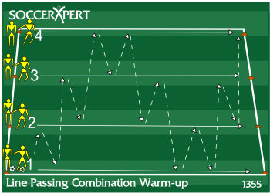
Drill Objective:
This combination passing drill is designed to work on combination play while advancing up the field. This will help focus on timing of passes, runs, combination play, and will be a great warm-up to passing practices.

Drill Setup:
- Start with 4 cones set along a sideline about 10 yards apart.
- The player on one of the far cones start with the ball.

Drill Instructions:
- Player 1 passes into Player 2 who returns the ball back to player 1.
- Player 1 then passes to Player 3 who returns the pass to Player 2.
- Player 2 then passes to Player 4 who returns the pass to Player 3.
- Player 3 then passes back to Player 4 who passes to Player 2.
- The pattern is repeated as the players move in a straight line down the field.
- Instruct the players to keep the same distance as much as possible when moving down field.
- When a groups reach the other side of the field have them wait until all groups have completed.
- Have the players repeat this pattern going to the other side of the field.
- Repeat a few times to allow the players to warm-up and get into a rhythm.

Drill Coaching Points:
- Focus on crisp clean passes with the right amount of pace.
- Slightly lead the player so they receive the ball as they are advancing down the field.
- Communication is important so each player is aware of the next move.

Drill Variations
N/A

Published 7/24/2006 6:19:18 AM
Author: John Bychok

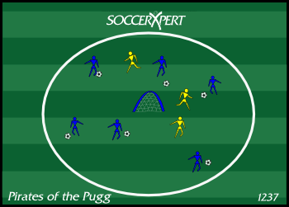
Drill Objective:
This soccer drill is a great soccer drill using a Pugg Goal that can be tweaked to focus on many aspects of the game. For younger players ages 8-11, the primary focus should be on good dribbling technique in traffic which requires vision and awareness. The coach can also focus on transition from offense to defense if the ball is lost, or recovering from a tackle and finding safety. Defensively, this allows defenders to steal the ball from attackers and play to a particular goal or target.

Drill Setup:
Build a circle approximately the size of the center circle with a Pugg Goal in the middle of the circle. The actual size of the circle will vary depending on the age and skill level of the players. With all players in the playing area, dedicate 9 players with the ball, and 3 players without a ball will be the "Pirates".

Drill Instructions:
Instruct the "Pirates" without the ball to defend the players with the balls. Once the Pirate wins the ball, they attempt to score on the Pugg Goal in the middle of the circle. If the Pirate scores the goal, that player too becomes a Pirate. Play continues until the last player with the ball wins. If the pirates have a hard time getting started, the coach can help the pirates at first.

Drill Coaching Points:
Attacking: keep the ball close with head up so the players are aware of defenders and safety areas (space). If the ball is lost, recover quickly and fight to win it back.
Defending: Transition quickly from defense to offensive and stay focused once the ball is won, and find the target.

Drill Variations
NONE

Angle of Support Possession Drill

Soccer Passing Drills, Soccer Passing Angle of Support, Soccer Possession, Soccer Passing Possession
Published 6/27/2007 11:10:35 PM
Author: Chris Johnson

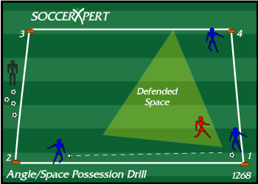
Drill Objective:
This soccer passing drill is a great drill for teaching young players angle of support and spacing.

Drill Setup:
Set up a grid that is 10 X 10 yards. Organize the team into groups of three players per grid. Each of the three players should position themselves near 3 different corners of the grid with one ball.

Drill Instructions:
The instructions are simply to never leave an empty cone adjacent to the player with the ball. For example, say the drill begins with a player at position 1 in possession of the ball while players at 2 and 4 start at the cones adjacent to the player at 1. The player at position 1 can pass to either of the players at positions 2 and 4. If the player at position 1 passes to the player at position 2, the player at position 4 must quickly move to position 3 in order to support the player in “un-defended space”. The play continues with no defensive pressure and players are allowed to pass to either supporting player. This soccer drill is simple, however, players will have to pay attention to the ball movement and often anticipate the next move in order to move to space quicker.

Drill Coaching Points:
- Make sure players are thinking and moving quickly to the next supporting position.
- Explain Defended Space (see diagram)
- Help players with good angle of support

Drill Variations
- Play in 1 or 2 touches.
- Add a defender

Jam-Packed Soccer Dribbling Drill

soccer dribbling drill, dribble soccer, fun soccer drill, fun soccer
Published 2/2/2008 12:58:28 PM
Author: Chris Johnson

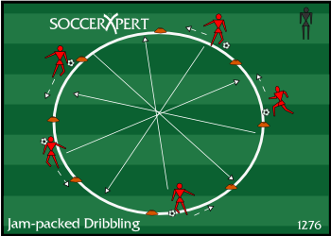
Drill Objective:
This soccer dribbling drill will give players confidence while dribbling through congested areas on the soccer field.

Drill Setup:
To begin this drill, create a circle with disc cones that is approximately 20 yards in circumference. Make sure each player has a ball, and instruct them to line up around the outside of the circle.

Drill Instructions:
Have the players begin the soccer drill by dribbling around the outside of the circle all in the same direction. The coach should inform the players to listen for certain queues and perform those actions once the coach shouts the command. These commands are:
- JOG - players should dribble at a comfortable speed
- FULL SPEED - players should dribble at their top speed
- CUT - players should cut the ball in the other direction and travel in the other direction around the circle
- CROSS - all players should cut across the grid avoiding contact with other players or other players balls.

Drill Coaching Points:
- Since all 4 players should be entering the center area at the same time make sure players are looking ahead of them with their head up.
- Remind players to keep the ball close when entering the traffic area.
- Have players start playing with their arms up and out for balance and shielding
- Instruct players to dribble with both feet and all parts of the foot.
- This is a fun soccer drill, so make sure to HAVE FUN!

Drill Variations
Think of other commands to add to the drill.

1v1 to Multiple Goals

1v1 soccer drill, 1v1 soccer, attacking soccer, defending soccer
Published 9/30/2006 3:42:06 AM
Author: Chris Johnson

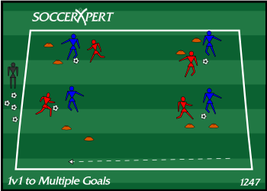
Drill Objective:
This soccer drill is great drill for focusing on teaching players attacking skills such as taking on their opponent or learning to attack space. Defensively it will teach players the responsibility of man marking.

Drill Setup:
Make a 40X40 grid. Split your team into pairs with one ball per pair. Randomly set up small goals (approx 2-3 yards wide) with flags within the grid; one goal per pair. Each pair should begin at their window.

Drill Instructions:
Each team will play 1v1 using their goal only. Goals are scored by dribbling across the goal line. Goals can be scored from either side of their own goal. Players play 1 to 2 minute games and rotate players.

Drill Coaching Points:
Attacking: Head up and aware of other players, change of direction, close control, and change of pace Defending: Bent Knees, aware of attacker, tracking attackers movement and protecting the goal

Drill Variations
Open it up where each pair can score on any of the other goals. They are still paired up with only their partner and should not interfere with any other pairs going on. Goals can still be scored from either side of the goals by dribbling through the goal.

Dribbling warmup

soccer dribbling skills, cutting, turning, movement, juggling
Published 10/18/2008 9:42:02 AM
Author: Chris Johnson

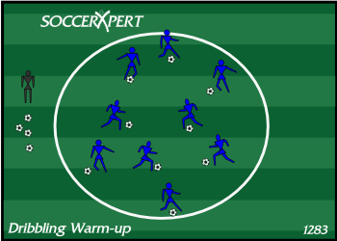
Drill Objective:
This soccer drill is a great warm-up drill that allows players to work on touching the ball with all parts of the foot. If you want to improve players footwork and dribbling skills this is a good start to each practice.

Drill Setup:
Either use the center circle of the field or build you a circle with cones. Each player needs to have a ball and start inside the circle.

Drill Instructions:
- Have players dribble anyway they want inside the circle as long as they are using both feet for 2 minutes.
- Have the players juggle for 1 minute using feet only trying to alternate from right to left.
- Have players dribble with inside and outside of each foot with the following pattern: right foot - inside, outside, inside, outside then switch to left foot inside, outside, inside, outside and continue to switch feet. Do this for 2 minutes.
- Have players juggle with their thighs and feet for 1 minute. Again instruct players to switch feet while juggling.
- Have players work on cuts and turns. The players should be instructed to cut the ball quickly and have a short sprint after cutting or turning the ball. Make sure players are exploring with inside and outside of the foot cuts and staying with the ball when they cut. Do this for 2 minutes.
- Now instruct the players to juggle again. This time juggle with the feet and pop the ball to the chest and back down to the feet. Do this for 1 minute.
- Now have players turn the pace up a notch and play full speed working on cuts, turns, and avoiding collisions. Push players to work hard for 1 minute straight.

Drill Coaching Points:
- Make sure the player is constantly lifting their head and checking their surroundings. This will help players find space and avoid other players.
- Make sure players keep the ball close to them while in congested areas. This will help them move the ball more quickly to avoid other players and obstructions.
- Encourage players to use all parts of their feet while dribbling (inside, outside, top, bottom).

Drill Variations
N/A

5v2 Rotating Defenders

5v2 Rotating Defenders
Published 10/20/2005 12:00:00 AM
Author: Chris Johnson

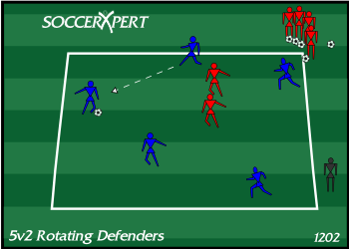
Drill Objective:
This 5v2 drill will focus on keeping possession by making good passes as well as good passing decisions, moving to open space, and good communication.

Drill Setup:
- Create a grid that is approximately 15X15 yards.
- Place 5 attackers inside the grid in an alternate jersey.
- The remaining players pair up as defenders behind one corner cone with the supply of balls.

Drill Instructions:
- The first pair of defenders passes a ball into the 5 attackers.
- The defenders immediately step into the grid and become defenders creating a 5v2 inside the grid.
- The 5 attackers attempt to put together a set number of passes. If this is achieved the two defenders do pushups.
- The attackers continue passing until the defenders win the ball, or the ball is knocked out of play.
- Once the play is dead, the next pair of defenders plays into the same 5 attackers, and play resumes.

Drill Coaching Points:
- Vision
- Changes in the direction and speed of play
- Appropriate use of 1st touch
- Appropriate use of short or long passing
- Good passes to feet
- Good first touch towards space
- Good decision making (make play easy)
- Speed of play/decisions

Drill Variations
- Adjust grid (larger grid = easier for attackers but harder for defenders; smaller drid = harder for attackers but easier for defenders)
- Introduce splits (split defenders, defenders do 10 pushups every split)
- Adjust the number of attackers (4 attackers vs 2 defenders)

Four Corners Aggressiveness and Fitness Drill

soccer fitness drill, soccer aggressiveness, soccer fitness, winning 50/50 balls
Published 9/29/2006 1:48:14 AM
Author: Chris Johnson

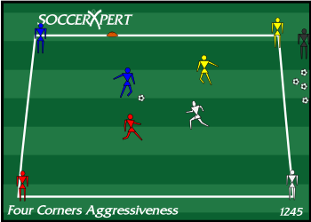
Drill Objective:
This soccer drill focuses on aggressiveness in winning 50/50 balls and fitness. This drill will be more beneficial for players under 8 and older.

Drill Setup:
Create a grid that is 30x30 yards. Create 4 teams and have them stand at each of the four corner cones. The coach stands outside the grid near the middle of 2 side cones with a large supply of soccer balls.

Drill Instructions:
The coach plays a ball into the center of the grid and shouts out a command (such as “GO”) to begin play. The first player in each of the 4 lines must sprint after the ball in attempt to reach the ball first. Once the ball is won cleanly, the player must hold possession from the other players for 5 seconds before passing the ball back to the coach. If any player steals the ball from the person in possession, that player will then attempt to hold possession for 5 seconds. A team scores a point by successfully holding possession for 5 seconds and making a return pass to the coach. The first team to reach 5 points wins.

Drill Coaching Points:
- Players should be taught to go after the ball aggressively with speed, determination and vigor.

Drill Variations
- The coach can play different types of balls such as flighted balls, bouncing balls, rolling balls, balls with large amounts of top or back spin.

Body Parts Warm-up Game

u-5, u-6, u-7 soccer drills, body parts game
Published 11/18/2006 6:15:36 PM
Author: Chris Johnson

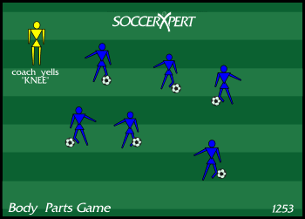
Drill Objective:
This soccer drill focuses on the younger player's dribbling skills and the ability to think quick on their feet while holding the ball close.

Drill Setup:
Create a grid about 15X15 yards. All the players should be inside the grid with a ball of their own.

Drill Instructions:
The coach shouts a part of the body that the player uses to stop the ball. For example right foot, left foot, knee, etc.

Drill Coaching Points:
- Encourage players to constantly move and zig-zag while dribbling.
- Keep Close possession.
- Head up to avoid collisions.

Drill Variations
none

World Cup Soccer Drill

World Cup Soccer Drill, World Cup Drills, World Cup, Soccer Drills
Published 6/16/2010 3:51:07 PM
Author: Chris Johnson

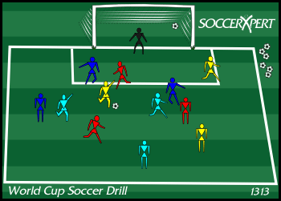
Drill Objective:
The World Cup Soccer Drill is a great shooting game for kids of all ages. The World Cup Soccer Drill is a great game to work on game like situations with number down situations.

Drill Setup:
Inside the penalty box, set up 4 groups of 3 players in alternate jersys with a goalkeeper in a full size goal. The coach should have the full supply of soccer balls nearby.

Drill Instructions:
The coach should serve a ball into the grid. Each team plays at the same time against the other teams. The team to score sits out for the remainder of that round and advances to the next round. The last team to score in each round is out of the tournament.
Round 1:
3v9
3v6
3v3
last team to score is out.
Round 2:
3v6
3v3
last team to score is out.
Round 3:
3v3
team to score first 2 goals wins the world cup.

Drill Coaching Points:
good team work
quick passes
take shots/chances
have fun

Drill Variations

Shooters and Shaggers Shooting Game

Soccer Shooting Drill, Soccer Shooting Game, Shooting Soccer Game
Published 4/19/2007 5:15:30 PM
Author: Chris Johnson

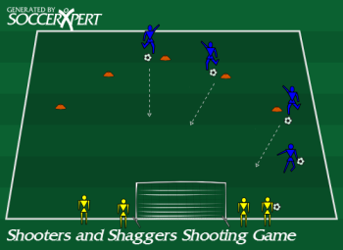
Drill Objective:
This drill, Shooters and Shaggers, is a great game to help improve shooting on target, leg strength and could be altered to help with the instep drive (shoe laces).

Drill Setup:
Organize your team into groups of 2. One player will be the shooter while the other player will be the shagger. The Shagger will only shag balls for their shooter as they are paired up as a team in this competition. Organize an arc of cones approximately 10 yards from goal with no keeper in the goal.

Drill Instructions:
Each shooter will begin at the start cone while their shagger will begin behind the goal. At the first cone, each shooter will take turns shooting on goal in attempt to score the goal with a direct shot into the goal without it hitting the ground (no bounce). If the ball bounces before scoring a goal, or if they miss the goal, the shooter retrieves the ball from their shagger and continue shooting from the same cone. However, if the player is able to strike the ball into the goal without it bouncing, the player will get to continue to the next cone. The first 3 players to successfully scored from each of the 5 cones win. Now switch and let the shaggers shoot and the shooters shag balls.
Note:The game will seem slow to start, but as the game gets going the players are working hard and friendly competition should kick in and elevate the game.

Drill Coaching Points:
- Watch the angle of approach, make sure they come at the ball at a good kicking angle
- Make sure their planting foot is not too close or too far from the ball.
- Make sure the player is locking their ankle

Drill Variations
- For younger players who are unable to lift the ball very well should be modified to scoring hard shots with pace on the ball.
- To get all the players participating at the same time, have each player start with their own ball (no shaggers) and have them keep up with their same ball through out the entire shooting game.

