FCYFL Weigh In

Saturday, August 9th

Door Assignments

Door 7 |  | Door 8 |  | Door 9
Vienna | 9:00 AM | Herndon | 9:00 AM | Springfield | 9:00 AM
Annandale | 10:00 AM | South County | 9:30 AM | Alexandria | 10:00 AM
Chantilly | 10:30 AM | Manassas | 10:30 AM | Gum Springs | 10:30 AM
Arlington | 11:30 AM | Braddock Road | 11:15 AM | American Pride | 11:15 AM
Gainesville | 12:15 PM | Dulles South | 12:00 PM | Fort Hunt | 12:00 PM
James Lee | 1:30 PM | Southwestern | 12:30 PM | Lee Franconia | 12:45 PM
Reston | 2:00 PM | Fort Belvoir | 1:15 PM | McLean Youth | 1:15 PM
 |  | Fairfax Police | 2:00 PM

When you arrive, please go to the appropriate staging area. Please see the map below.
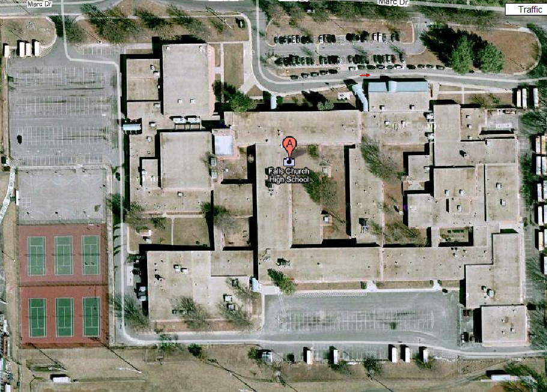
C
B
B
B
C
C
A
A
A
DOOR 8
DOOR 7
DOOR 9

Staging areas are marked as A, B and C. The teams will gather at staging area A. When everyone that is expected for the weigh-in is present, the club will move to area B. We will call the club into staging area C when it is time for that club to begin weighing in the gym.

