Y-D YOUTH HOCKEY ASSOCIATION
SCHOLARSHIP APPLICATION FORM
Application Deadline is at time of Registration, but no later than June 1, 2015

(One child per application)
Child Applicant Name:

M/F:

Parent or Legal Guardian Name:
Home Address:
Home Phone:
Primary Employer:
Age:
Grade in School:

Cell Phone:
Work Phone:
Hockey Level:

Email:

Please list all legal guardians in the household.
Name: Annual Income: $
Name: Annual Income: $ Household Income: $

Please list all other children in your household.
Name: M/F Age: Plays Hockey? Level:
Name: M/F Age: Plays Hockey? Level: Name: M/F Age: Plays Hockey? Level: Name: M/F Age: Plays Hockey? Level: Name: M/F Age: Plays Hockey? Level: Name: M/F Age: Plays Hockey? Level:

Note: Application deadline is at time of registration, but no later than May 1,2015
Please forward your completed application and
Y-D Scholarships are considered and granted based on the following criteria: information to:
* Availability of funds Y-D Youth Hockey
Confidential Attn: Scholarship Committee
* Financial need of parent(s) and child applicant P.O. Box 16 Yarmouthport, MA
* Special personal circumstances 02675
* No balance from prior year's fees

The Y-D Scholarship program in accordance with the Y-D mission is designed to provide an affordable, high
quality hockey experience to those who have a financial need. This program is not meant to be a handout but rather a financial
assistance program made available to those who meet the qualifying criteria and are committed to the organization. .

Page 1 of 2

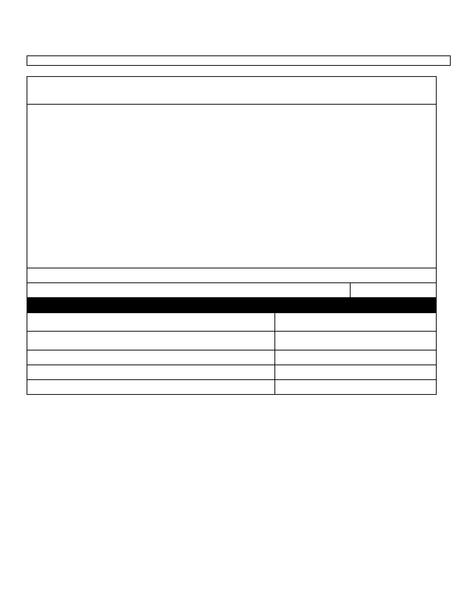
I understand that I am responsible for submitting the following information in order to apply and be considered for a scholarship:

* Completed Scholarship Application Form
* Copy of most recent income tax statement filed by parent(s) of child applicant
* Explanation of any special personal circumstances

I hereby certify that the information on this form is accurate and I understand that the Y-D Scholarship Committee may verify this information and I give authorization to Y-D Scholarship Committee to verify the information contained within this application.
Deliberate misrepresentation may result in termination of further financial assistance. I understand that any financial assistance is
granted through a confidential Scholarship Committee process based on the outlined criteria, and there is no guarantee made of the
granting nor amount of the scholarship. I understand and agree to abide by Y-D terms and conditions of accepting the
scholarship. I understand that continued financial support may be terminated if these terms and conditions are not met. I also understand that Y-D's scholarships are awarded seasonally, and that I must apply each season for scholarship consideration.

Parent or Legal Guardian Name:

Parent or Legal Guardian Signature:
CRYHA Executive Board Use Only:

Date Application Package Received:

Received by:
Application Package Complete or Incomplete:
Missing Information:
Notes:
Date:

Date Application Package Forwarded to Executive
Board:
Date Application Package Reviewed by Committee:

Application Approved or Denied:
$Amount Granted:
Date Parent(s) Applicant Notified:

Page 2 of 2

Y-D YOUTH HOCKEY
P.O. BOX 16
YARMOUTHPORT, MA 02675

February 26, 2015

Dear Members:

Attached is the 2015/2016 Y-D Scholarship Application. The application must be filled out and returned with support documents to the above address no later than June 1, 2015.

Y-D Youth Hockey does not discriminate against any member seeking a scholarship. Applications will be reviewed by the scholarship committee and awards will be made based on merit and funds available.

Thank you for your attention regarding this matter.

Y-D Scholarship Committee

