

**Morton Classic Tournament - 2016  
Ages U-9, U-11, & U-13  
May 25 - 29, 2015**

All Coaches please check in with the Tournament Director (under the tent located in the center of the complex) before your 1st game.

For weather updates please check our website at [www.mortonyouthbaseball.org](http://www.mortonyouthbaseball.org).

**\*General Tournament Information\***

The MYBA (Morton Youth Baseball Association) is hosting this tournament at the Westwood Park Complex on Veterans Road in Morton, Illinois. The complex has eight fields total, six of which have grass infields. The facility also has bathrooms, drinking fountains, a pavilion, playground equipment, two batting cages (one indoor), and a concession stand featuring a wide variety of food and snack items. We will also be grilling throughout the entire tournament. **NO DOGS ALLOWED (except service dogs)** in the Park, per Morton Park District Rules.  
  
Each team will play a minimum of three games unless weather or unforeseen circumstances forces changes to the tournament schedule. MYBA will award individual trophies for 1st and 2nd place. In some cases we may elect to form a consolation bracket depending on number of teams.  
  
We will not be charging a gate fee for the tournament. We will have a full service concession stand, so please no food, beverage, or coolers allowed in the complex. The players can bring individual jugs of water for their own use. Please comply with these rules. All money made on this tournament will go back into the complex and youth baseball.

**Teams Entered**

Please see the Website for the current list of teams

**\*Facility Rules\***

* Please park in the designated parking lot located at the end of the driveway at the East end of the facility. Please do not park along the driveway on the east, in posted areas, or along Veterans Road. If you have a special needs parking request or need special assistance please notify us in advance or see a tournament official.
* 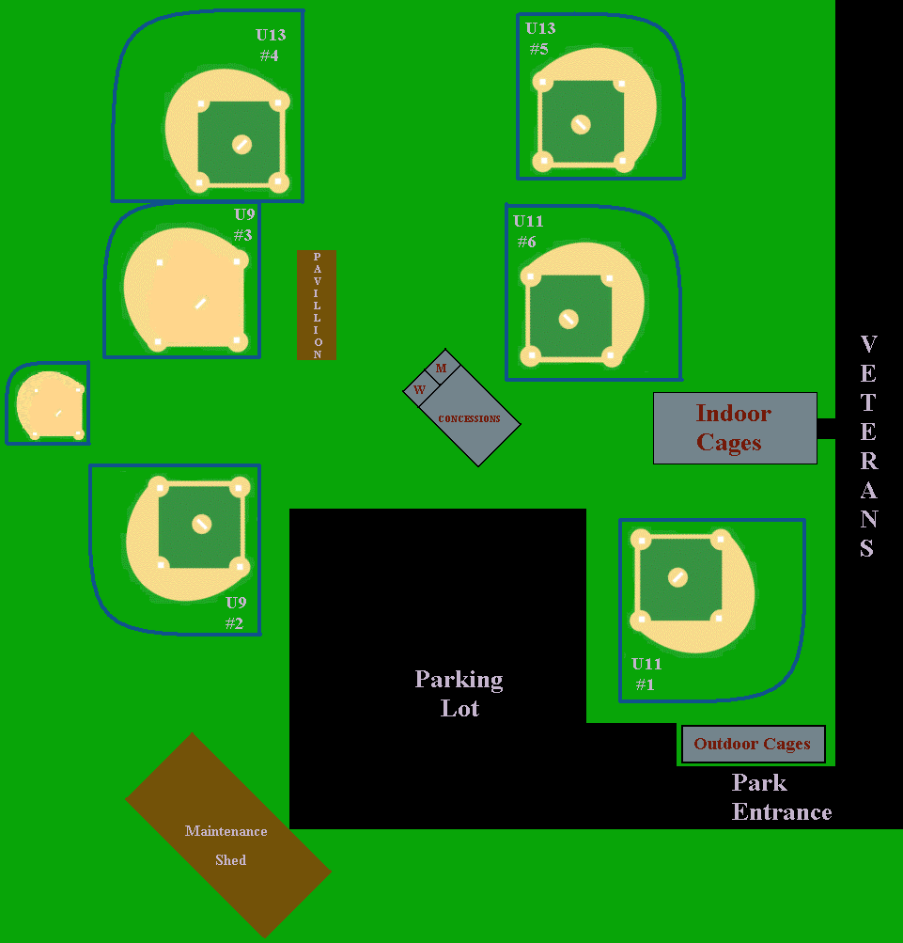We have limited bleacher seating. Please bring lawn chairs for your convenience.
* Please do not hit or play soft toss on the grass in the outfield. We also prohibit any soft toss being hit into any facility fence.
* Pre-game infield practice is prohibited.
* Please pick up the dugout after each game. Parents, grandparents, relatives, and fans:  Please pick up your general area after each game. Please throw your trash away in one of the many trash receptacles located throughout the facility and in the parking lot when leaving. Thanks in advance!

**PLEASE NO COOLERS OR FOOD BROUGHT INTO THE PARK. ALL CONCESSION PROCEEDS ARE RETAINED FOR PARK MAINTENANCE AND TOURNAMENT EXPENSES. YOUR PATRONAGE IS GREATLY APPRECIATED.** **DUE TO ABUSE OF THIS POLICY IN PAST YEARS WE ARE IMPLEMENTING THE FOLLOWING PROCEDURES:**

* **1st offense is a warning to the team’s Head Coach. The Coach will have to handle the problem to the MYBA’s satisfaction before play can start.**
* **2nd offense will cause the team to forfeit the next game in the tournament**
* **3rd offense, the team will forfeit all games played in the tournament and will be asked to leave the facility.**

**\* Tournament Rules \***

* We will follow the National Federation of State High School Associations Baseball Rules (NFHS) with tournament exceptions as listed below. Rule modifications during the tournament will be at the Tournament Directors discretion.
* The U-9 division base lengths will be 60’ and the pitching will be 44’. The U-11 division base length will be 70’ and pitching will be 48’. The U-13 division base lengths will be 80’ and pitching will be 54’.
* We will be using the EH not the DH. If a team elects to start the game with an extra hitter (EH) the team must use a 10 player line-up throughout the game. If, due to injury the 10 player line-up cannot be maintained by substitution then an out will be recorded when the EH is scheduled to bat.
* A team can elect to bat the entire lineup as well if they so choose. If a 9 or 10 (EH) boy roster is submitted then normal baseball re-entry rules apply.
* 1 hour 45 minute time limit for all divisions. The home plate umpire will keep the official time and call it out at the beginning of the game. No inning will start after said time limit expires. Time starts for the next inning upon the last out at the bottom of the just completed inning. In pool / preliminary round play: if the game is tied at the end of regular innings and there is still time left the game will continue until the game is won OR the time runs out. At the end of the time limit, a maximum of 1 extra inning will be played. If the game is still tied after the 1 extra inning a winner will be determined by the following tie breakers; (1) number of walks allowed, (2) number of walks allowed through 3 innings, (3) coin flip. In the Championship Tournament final and semi rounds the games must be played to a winner with no time limit for all age group. We have a lot of games to get in over the weekend so the umpires are asked to help keep the games moving. Any perceived stalling / delays will be handled by the umpires at their discretion.
* **Courtesy runners** for the catcher or pitcher are allowed any time. Have the catcher ready to go at the start of the inning. Courtesy runner must be someone not currently or previously in the game. If all players have been used, the last out from the previous inning will be the courtesy runner. No single individual player can courtesy run more than once in an inning.
* **Run Rule**: 15 after 3, 10 after 4, and 8 after 5 for U-9. 15 after 4,10 after 5, and 8 after 6 for U-11 & U-13
* **Innings -** U-9 division will play 6 innings. U-11 and U-13 divisions will play 7 innings.
* The game is official after 4 innings if called because of weather. If called before that it will be considered a suspended game and play will resume at that point.
* Have teams warmed up and ready to go at listed game time. No Infield will be allowed.
* **Dugout determination** -1st team listed on the pool play / preliminary round game schedule will have the 3rd base dugout. During the tournament round, the higher seed will have the 3rd base dugout.
* **Home Team determination** -Flip before the game will determine home/visitor in the pool play rounds. The team with the higher seed will have the home team designation during the Championship Tournament.
* Runners must slide to avoid excessive contact in umpire’s complete discretion.
* **Warm up pitches** -8 warm up pitches before the game and when a new pitcher comes into the game. 5 pitches between innings.
* **Pitchers innings** - Will not keep track or specify a limit on innings pitched. Coaches are responsible for using good judgment and not overusing a young pitcher
* **Balks/Walks/Other.** No balk warnings for the U-13 division. One balk warning per pitcher for the U-11 in Pool Play. No balk warnings for U-11 in bracket play. U-11 and U-13 are allowed to lead off. For U-9 there are no lead offs until the pitched ball crosses home plate, and no balks, no infield fly, no dropped third strike. In U-9 if a runner departs early from the bag it will be the umpire’s discretion to call the runner out or not.
* The **home team** is responsible for filling out a game report form at the end of each of game. The score and each coaches signature must be on the form. Please give the filled out form to the Field Umpire who will take it to the Information Tent for posting.
* **Seeding / Tie Breakers** – All teams will be seeded after the completion of Pool Play and will advance into the single elimination Championship Bracket Tournament OR Consolation Bracket on Saturday / Sunday.  If necessary the following rules will be used to break ties for seeding purposes:
  + Head to head results (winner gets the higher seed)
  + Fewest runs allowed in pool play
  + Most runs scored
  + Coin flip
* Umpires rulings are final. No protests. ***Please support the umpires.***   Ejected coaches will not be permitted on the premise during the continuation of the game ejected as well as the next game played.
* Baseballs will be provided by MYBA for each game. Umpires will pick up and return baseballs to the Information Tent.
* Each team must have birth certificates for each player on the roster. **April 30 is the cut-off date for age in each division.** All managers must make player birth certificates immediately available upon request by any tournament director or official.
* **Steel Cleats** No Steel cleats are allowed for the U-9 and U-11. Steal cleats are allowed for U-13
* Maximum of 3 coaches allowed on the field.
* **Substitutions** - Starters may re-enter one time in their original batting position if batting 9. Substitutes removed from a game are ineligible to return. All substitutions shall be reported to the home plate umpire, who will inform scorekeepers.

The MYBA reserves the right to alter the format of the tournament due to weather or other unforeseen circumstances. 

**·        Bat Regulations:**

**- U-9 and U-11: No 2 ¾ bats allowed. No BBCOR restriction**

**·        IESA Bat Regulations will apply only for the U-13 division as follows:**

**All bat's must meet the following guidelines:  
1. Any aluminum BBCOR baseball bat.  
2. Any aluminum barrel BBCOR baseball bat.  
3. Any BBCOR non-hollow (filled core) composite bat.  
4. Any solid (one-piece) wood baseball bat.  
  
All bat's for the 2012 season & beyond must meet the following diameter, length & weight requirements"  
1. Diameter at the thickest part: (wood) 2 5/8 inches or less.  
2. Diameter at the thickest part: (non-wood) 2 5/8 inches or less.  
3. Length: 36 inches or less.  
4. Weight: (wood or non-wood) shall not weigh, numerically, more than three ounces less than the length of the bat (e.g., a 33-inch-long bat cannot be less than 30 ounces).  
5. ALL 2 3/4-INCH BARRELS ARE ILLEGAL**

**Refund Policy:** If weather or any other unforeseen circumstance cancels the entire tournament, each team will receive a full refund— minus any tournament expenses. If a game is played, no refund will be given. A team entering the tournament that chooses not to play prior to start of tournament will only be refunded if prior to three weeks from start of the tournament, otherwise there will be no refund given.

**T-Shirts:** A limited supply of tournament T-shirts will be available for $15.00/ea.

**Batting Cages**

**Outdoor Cages**

There is one outdoor batting cage with two lanes. The outdoor batting cage may be used on a “first come, first serve” basis. Please cooperate with other teams so that all teams have an opportunity to use the batting cages. Only coaches may feed balls. Only one player is allowed in the cage at a time. Balls are to be provided by teams using the cages. Please use caution while using the cages.

**Indoor Cages**

The Indoor Facility has 3 hitting lanes and 2 pitching lanes and is available for use at a $25 additional fee. Please see the Tournament Director or Head Coach for your division for more information on using the Indoor Facility.

**Contacts**

|  |  |  |  |  |
| --- | --- | --- | --- | --- |
| **MYBA President** | **U13 Head Coach** | **U11 Head Coach** | **U9 Head Coach** | **Tournament Director** |
| Brad Mitchell | Brandon Parrott | Mike Kraft | Craig Loudermilk | Doug Hischke |
| 309-265-5932 | 309-472-2071 | 309-696-2454 | 309-266-9892 | 309-303-7725 |

**Park Address: 2150 Veterans Road, Morton IL. 61550**

