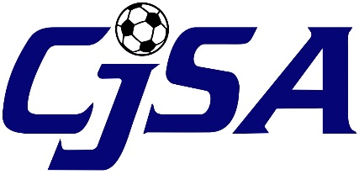

To: All CJSA Districts and Clubs

Re: Concussion Awareness

From: CJSA

November 13, 2015

Effective January 1, 2016 all CJSA clubs are required to “make available a written or electronic statement regarding concussions to each youth athlete and a parent or legal guardian of each youth athlete participating in the youth athletic activity. Such written or electronic statement shall be made available upon registration of each youth athlete and shall be consistent with the most recent information provided by the National Centers for Disease Control and Prevention regarding concussions.”¹

To comply with the law, and to provide consistent guidelines for all CJSA clubs, CJSA has developed a two (2) page concussion awareness document (Attachment 1). The document is based on the Center for Disease Control (“CDC”) Heads Up Concussion parent and athlete guidelines.

The document must be made available to the player at the time of registration. How a club elects to make the material available is up to the individual club. Clubs could elect to:

- Incorporated the guidelines into their club’s online registration system
- Hand the guidelines out to each player when registering
- Mail the guidelines to each player

CJSA also recommends posting the guidelines on the club’s website and sending it out in the club’s newsletter if applicable.

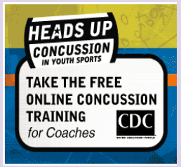
In addition, CJSA recommends that the information be provided to all coaches and encourages all coaches to take the Heads Up Concussion Awareness Course at:

- http://www.cdc.gov/headsup/youthsports/training/

CJSA has also posted the guidelines and links to the CDC Heads Up Concussion website on the CJSA website:

- http://www.cjsa.org/resource_center/concussion_information/

If you have any questions regarding club concussion requirements, please contact the CJSA office at 860-676-1161.
1 = CT Senate Bill No. 1502, section 114

