Cradling Games
CRADLING GAME (1)
Goal
To work on cradling skills

Description
Play 1 v 1 in a 15-by-15-yard square. Several squares can be set up within the penalty box to enable four groups to work at the same time. Start the game by tossing the ball to one of the players. He is to protect the ball by running and cradling. He must work to keep his stick to the outside, with his body between the defender and the ball. Award one point if the player is able to cradle the ball for 10 seconds without dropping it.

To make the game easier
Increase the size of the playing area.
Have the defender play without his stick.

To make the game harder
Reduce the size of the square.
Have the ball carrier cradle in his non-dominant hand.
Play two defenders against one ball carrier.

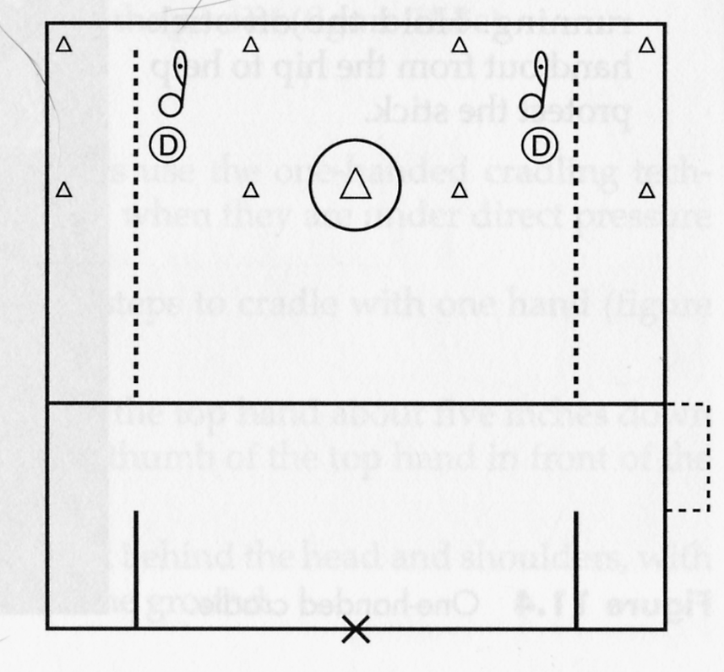

CREATIVE CRADLING (2)
Goal
To develop cradling skills while moving

Description
Have each player inside the defensive box with a ball in his stick. Players should be spread out evenly in the box. On your whistle, players move throughout the box while cradling and keeping their heads up. Players cannot run through the crease with the ball. Players stop and start on your whistle (10 to 15 seconds of cradling and moving, with a 5- to 10-second rest between repetitions). Players can use a variety of cradling techniques, and dodges can be added as players become better skilled. Encourage players to change direction and speed as they become more proficient at cradling.

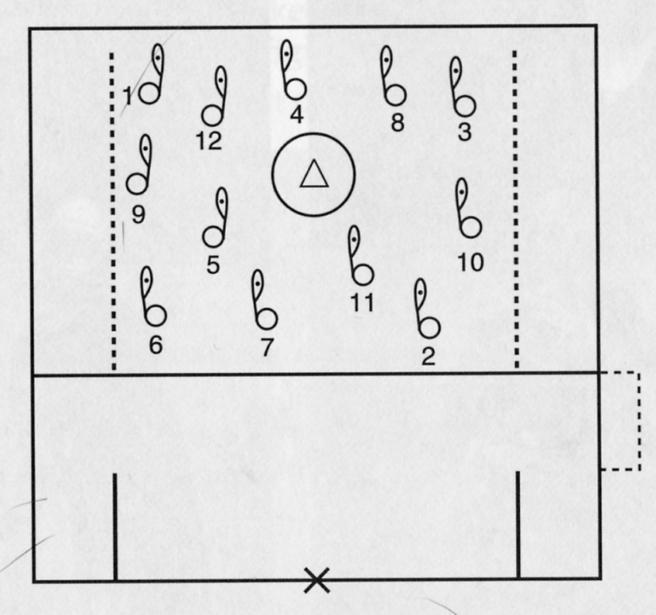

PARTNER PASSING-DOMINANT HAND (3)
Goal
To develop throwing and catching skills with the dominant hand

Description
Players line up in pairs 10 yards apart and pass the ball back and forth, concentrating on the basic throwing and catching mechanics: stand perpendicular to the receiver, point the stick shoulder at the receiver, hold the stick above the head, position the hands away from the body, step and throw, and follow through. Players cushion the ball when receiving it.

Variation
Catch with the non-dominant hand or catch with the dominant hand and switch hands to throw with the non-dominant hand.

RIGHT-ON-RIGHT PASSING AND CATCHING (4)
Goal
To develop passing and catching skills while moving

Description
Two lines of three to four players each stand 20 yards apart facing each other. Start the game with all players holding their sticks in their right hand. The first player in one line carries a ball a few steps and
throws it with his right hand to the first player in the other line, who is moving toward him. The thrower follows the pass, then goes to the end of the opposite line. The receiver and passer move toward each other, and the receiver calls, "Help!" The passer throws the ball overhand to the ready position of the receiver. Be sure players hold their sticks to the inside and in the ready position when passing and receiving.

Variation
Left-on-Left Passing and Catching. All players throw and catch with their left hands. Start by catching with the dominant hand then switch to the non-dominant hand when passing.

DIAMOND PASSING (5)
Goal
To practice advanced offensive stick handling

Description
Four lines of players stand in a diamond formation, each line 12 yards from a marker in the center of the diamond. Player 1 has the ball and passes it right handed to player 2, who has executed a V-cut by moving in toward the marker and then breaking to the outside. Player 2 plays left handed, with his stick to the outside. When player 2 catches the ball, his stick changes hands, and he passes to player 3 with his right hand. Each player follows his pass and goes to the end of that line.

Variations
Add four defenders to introduce pressure. The defenders move out to cover each receiver. When a defender moves out to play the receiver, he should arrive as the ball reaches the receiver and be positioned in the defensive ready position, stick down and parallel to the ground, knees bent, and partially sitting. Each off-ball defender moves to ^center and keeps his head moving to watch both his man and

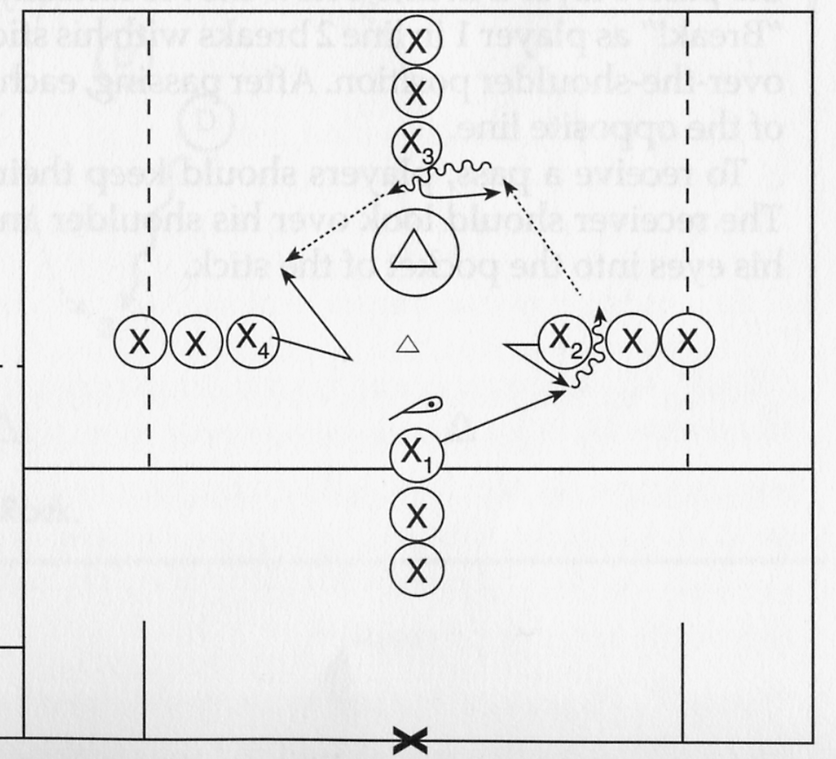

FOUR CORNER PASSING (6)
Goal
To practice throwing and catching on the run

Description
Lines of three or four players stand in each corner of the attack box. The first player in line 1 carries the ball and runs toward the first player in line 2, who acts as the receiver. When the ball carrier is midway between the lines, he yells, "Break!" and the recelver breaks toward line 3. When the receiver in line 2 catches the ball and is mid- way between lines 2 and 3, he yells, "Break!" and the first^person_m line 3 becomes the receiver. This process continues around the square until each person has caught and received the ball two or hree times Make sure all play is right handed, with sticks to the outside. Don t let the receiver break until the ball carrier is in positior^to "lake pass and yells for a break. Instruct the receiver to call. Help! and to give the passer a target in front so that he can make a lead pass.

Variations
For advanced practice, have players catch the ball over their shoulder (sticks to the inside) and then change hands (sticks to the outside).

The receiver can move directly toward the ball carrier to receive the pass, then circle away to pass to the next receiver. The receiver must move through the pass and circle away, keeping his stick to the outside. This variation provides excellent practice of clearing skills.

OVER THE SHOULDER (7)
Goal
To practice throwing and catching over the shoulder

Description
Two lines of three or four players stand 20 yards apart facing each other. Player 2 in line 1 begins with the ball and moves to his right When he yells, "Break!" player 1 in his line breaks with his stick in the right-handed, over-the-shoulder position. As player 1 receives the ball, he looks to line 2. Player 2 in line 2 calls, "Help!" and receives the pass. Player 2 in line 2 now moves laterally to his right and yells, Break! as player 1 in line 2 breaks with his stick in the right-handed over-the-shoulder position. After passing, each player goes to the end of the opposite line. To receive a pass, players should keep their stick at helmet level. The receiver should look over his shoulder and follow the ball with his eyes into the pocket of the stick.
HOT ROCK (8)
Goal
To improve throwing skills

Description
Position three offensive players against two defensive players in a square 20 yards by 20 yards (small cones can be used to identify boundaries). The three offensive players pass and move within the square trying to maintain possession. The defense works together, with one player covering the ball and the other defender splitting the remaining two offensive players. Several squares can be set up to allow more players to play All players should have an opportunity to play offense and defense.

Variations
Award a goal for four consecutive passes by the offense.
Award a goal for an interception or for the defense gaining position
See how many passes can be made in a 30-second period.

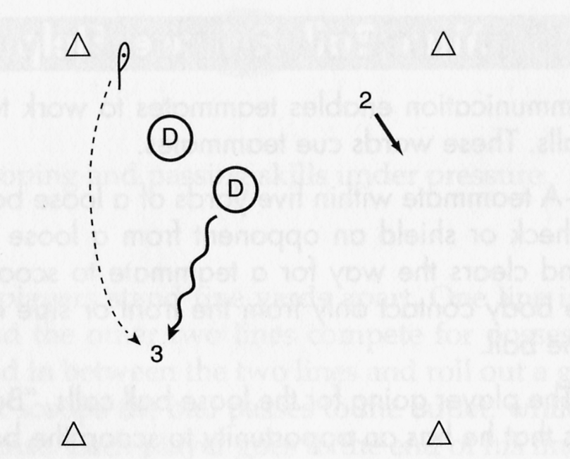
Scooping Games

1 V 1 SCOOPING WITH OUTLET (GLADIATOR) (9)
Goal
To develop scooping and passing skills under pressure

Description
Three lines of players stand five yards apart. One line is the outlet “help” line, and the other two lines compete for possession of the loose ball. Stand in between the two lines and roll out a ground ball. The player that scoops the ball passes to the outlet, while the opponent plays defense. Each player goes to the end of the line.
Instruct players to scoop through the ball and run away from pressure. They should protect their stick after scooping the ball by keeping their body between the defender and the stick.

Variation
Add more players by having two on one or two on two. Add multiple outlet area or change where outlet pass should go. Add defender to the outlet area.

PARTNER SCOOPING AND CRADLING (10)
Goal
To develop scooping skills

Description
Players line up in pairs 10 yards apart facing each other. One player has the ball at his feet. On your command, he scoops up the ball and passes it to his partner. Be sure the scooper drops his leg on his offside stick side and bends his knees. The scooper must yell, “Ball”, and, “Release”, and the receiver yells, “Help”. After scooping the ball, the ball carrier runs several steps and passes to his partner.

Variation
Have players scoop with their non-dominant hand.

SCOOPING AND PASSING (11)

Goal
To develop scooping and passing skills

Description
Two lines of players stand 20 yards apart. Player 2 in line 1 rolls the ball forward to player 1 in line 1, who runs after it and scoops. The scooper goes through the ball, scoops it, and passes it to player 2 in line 2. Player 2 in line 2 then rolls the ball forward for player 1 in line 2. Player 2 in line 2 moves up to become player 1. Each player goes to the end of the line he has passed to. Require players to use appropriate communication.

2 V I GROUND BALL (12)
Goal
To develop skill and teamwork on ground balls

Description
Three lines of players stand five yards apart. Roll out a ball between the middle player and either of the end lines. The players in two of the lines are teammates, and the players in the third line are their opponents. The players in the teammates’ line work together against a single opponent to will a ground ball. The player closest to the ball goes to scoop the ground ball, and the other player goes between the ball and the opponent’s body to body check him from the front side and above the knees. Make sure teammates communicate clearly and correctly.

Dodging Games
LINE DODGING (13)
Goal
To develop face, roll, and bull dodging skills

Description
Two lines of three or four players each stand 20 yards apart, face-to-face. Player 1 in line 1 moves forward with the ball as player 1 in line 2 moves out to the middle to offer passive defensive resistance. The ball carrier dodges the defender and passes to player 2 in line 2. The former ball carrier then becomes the defender. Instruct the defensive player to set up the offensive dodger in one of three ways: by charging him with his stick low and at the dodger's stick (dodger roll dodges), by charging him with his stick high and at the dodger's stick (dodger face dodges), or by having the defender stand still (dodger bull dodges). Initially, work on one dodge at a time.

Cradling and Dodging Game
SHOWTIME (14)

Goal
To develop ball-handling and dodging skills without a defender

Description
Position all players in the penalty area, giving each player a ball. As players cradle and move throughout the penalty area, they execute one or more dodges indicated by the coach. Players must keep their heads up and not look at the ball in their sticks. The coach awards one point to each player who successfully cradles the ball and executes the dodge indicated.

To make the game easier
Have fewer players in the penalty box to create more space.
Have players execute only one dodge at a time.

To make the game harder
Have players combine two dodges.
Have players use their off hand.

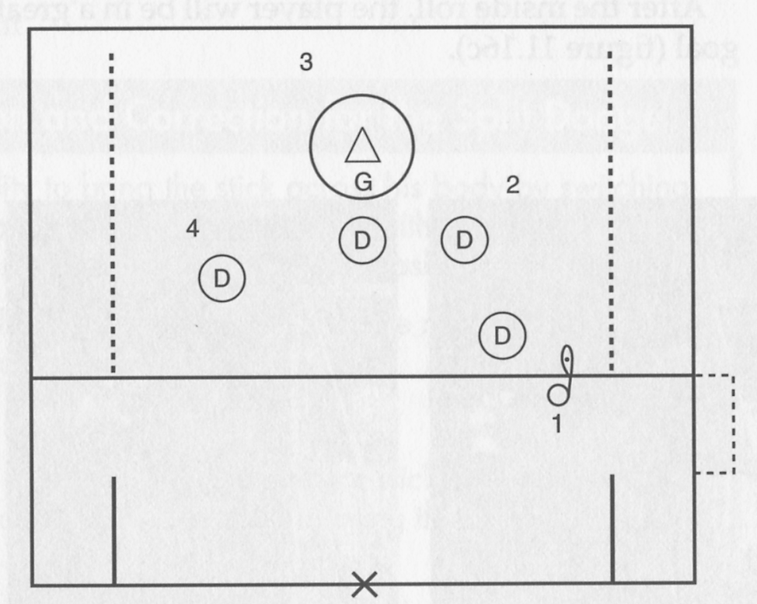
GO FOR IT (15)
Goal
To develop dodging and defending skills

Description
Play 3 v 3 with a goalie in the goal. Offensive players work the ball to set up an opportunity to execute the dodge specified by the coach. Award one point to the offense for successfully creating dodging space (off-ball players) and executing the dodge (ball carrier) specified by the coach. Award the defense one point for stopping the dodger.

To make the game easier
Play 1 v 1.

To make the game harder
Play 4 v 4.

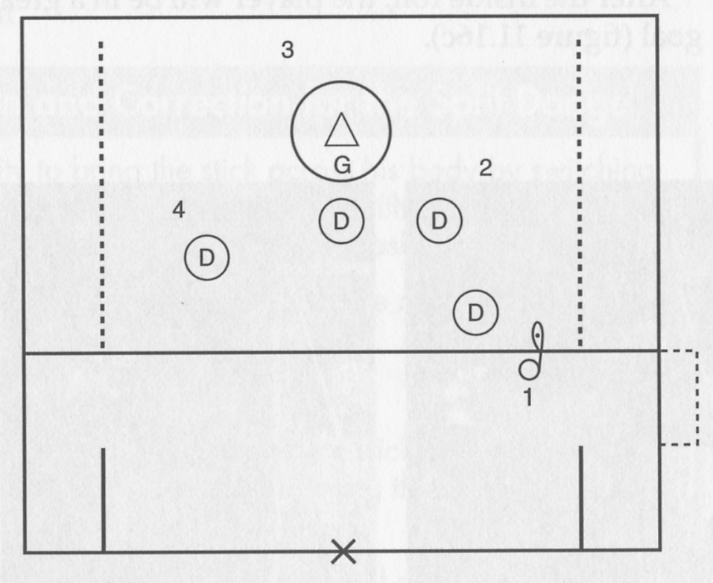

Shooting Games
SAME-SIDE SHOOTING (16)

Goal
To practice shooting accurately while on the run

Description
Two lines of feeders stand behind the cage, and two lines of cutters and shooters stand at the top of the restraining box – one line of cutters and one line of feeders on each side of the goal, drilling together. Each of the feeders has a ball. The first cutter cuts to the side of the crease, with his stick to the outside; and the first feeder, also with his stick to the outside, moves laterally and up the field to feed the ball to the curter, who takes an inside shot. Feeders go to the end of the cutters’ line and the cutters go to the end of the feeders’ line, but all players stay on their original side of the cage. After a designated time, they switch sides.
Require feeders to move laterally and up the field to create a feeding lane. The shooter should catch the ball and shoot it to the scoring triangle at the far post.

Variation
Switch roles so that the players behind the cage are cutters and the players at the top of the restraining box are feeders. The feeders feed the cutters coming up the field for a shot.

DRIVE FROM THE CENTER AND SHOOT (17)
Goal
To practice shooting accurately while on the run

Description
One line of players faces the goal at the top and in the center of the attack box. Each player in turn runs left or right and shoots the ball with his stick to the outside. Give each player a ball to keep the game moving quickly. Have players execute a bull or split dodge while shooting the ball on the ground toward the far scoring triangle. Instruct players to shoot while running. Do not let them slow down to wind up.

SHOOT AWAY (18)
Goal
To work on shooting skills

Description
Play 3 v 2 with a goalie in the goal. The offense works the ball around to create a clear shooting opportunity. Award two points for every goal scored using a bounce shot and one point for every goal scored with a different shot. Award the defense two points for gaining possession.

To make the game easier
Play 3 v 1.
Award a point for all shots on goal.

To make the game harder
Have players shoot with their off hand.
Subtract one point from the offense if they miss the goal.

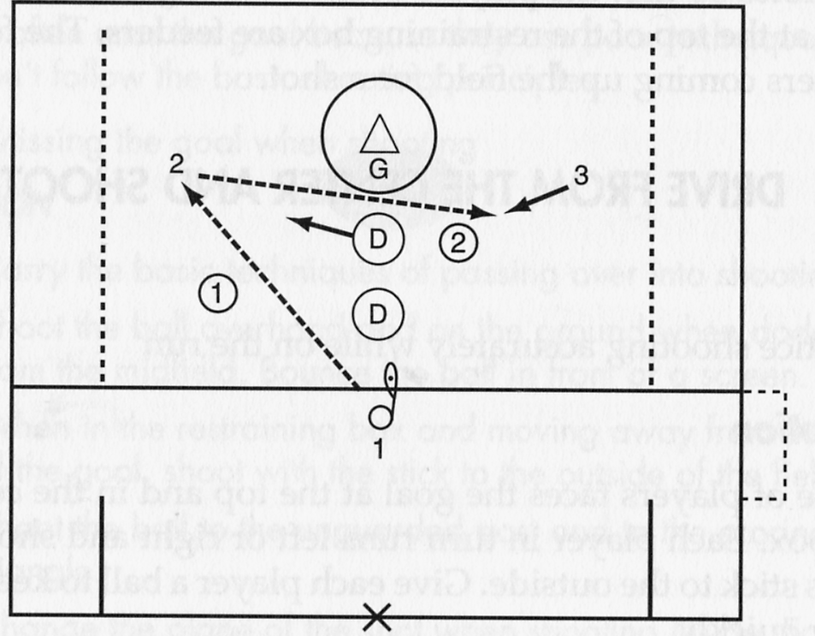

Cutting Game
PLAYING THE CUTTER (19)
Goal
To develop offensive and defensive cutting skills

Description
Two lines of midfielders, one offensive and one defensive, stand at the top of the attack box. One midfielder from the defensive line steps forward to defend the cutting offensive midfielder. Two attackers, each with a ball, stand behind the goal, with the goalie in position. On your signal, the cutter runs at the defender, fakes, and cuts to an attacker. That attacker feeds him. Be sure the cutter head fakes as he moves toward the feeder and that he angles to the edge of the crease to avoid running into it. Teach the defender to watch the cutter's hips—not his head, shoulders, or eyes—as the defender shuffles back and cushions the cutter on his approach.

Footwork Game
AGILITIES (20)

Goal
To develop footwork fundamentals

Description
Four lines of players are positioned side by side, 10 yards apart, facing you. The first player steps out and reacts to your stick movement and verbal signals that include the following:

Shuffle right and left.
Shuffle right and left, then drop and run.
Run hip to hip laterally
Shuffle back at a 45-degree angle.
Spring back at a 45-degree angle.
Drop-step, open hips, and run straight backward.
Run at me, and then on my signal break down to the defensive ready position.

After players go through the series of commands or various combinations of the commands, they go to the end of the line. Keep movements short and at high intensity.

Checking Games
STICK CHECK (21)

Goal
To develop poke check and stick check skills

Description
Conduct this drill without a ball. Two parallel lines of players stand at the top comer of the attack box. The line closest to the midline is offense, and the line inside the attack box is defense. Signal the first pair of players to step out. The offensive player faces the cages, his stick in his left hand. The defender assumes the defensive ready position, with his stick ready to practice the poke or stick check. The offensive player jogs across the field as the defender shuffles with him and poke or stick checks. Players continue to the opposite top corner and stop. On your signal, the second pair begins. When all players have gone in one direction, repeat the drill in the opposite direction.

Variation
The offensive players carry a ball to work on stick protection. The ball carrier alternates between a jog and a run to give the defenders practice in shuffling and running hip to hip.

TURN IT OVER (22)
Goal
To develop defensive checking skills (poke and slap)

Description
Play 3 v 3 with the goalie in the goal. The offense works for a shot and the defender tries to force a turnover by using one of the two basic checks. Award the offense one point for a goal and the defense two points for each check that results in a turnover.

To make the game easier
Play 1 v 1.

To make the game harder
Remove the goalie and shooting option. Have the offense try to maintain possession in the penalty box while the defense tries to force a turnover.

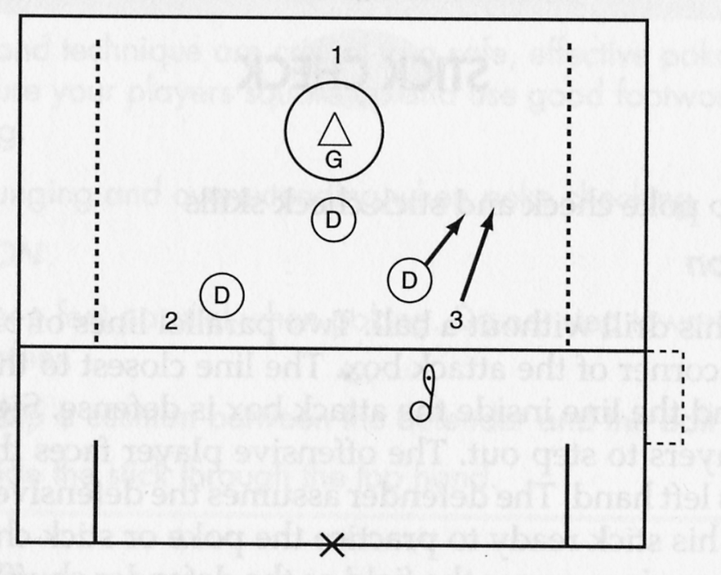

Holding Game
DEFENSIVE HOLD GAME (23)
Goal
To develop correct hold techniques

Description
Two parallel lines of players stand at the top corner of the penalty box. The line closest to the midline is offense, and the line inside the attack box is defense. On your signal, the first pair of players steps out. The offensive player faces the cage, with his stick in his left hand, and the defender assumes the ready position. The offensive player jogs across the field and steps up to the attack box every six to eight yards. As the offensive player steps up to the line, the defensive player steps up to execute the correct hold technique. After the first pair has completed its second step up and hold, the next pair begins. Pairs continue across the box to the opposite comer. No offensive or defensive player should cross over the attack box line. Check that the defender places his feet and shoulders parallel to the attack box line, drops his center of gravity, and extends his hands during the hold.

Fast-Break Games
HALF-FIELD FAST BREAK (24)
Goal
To develop offensive and defensive transitional skills and tactics

Description
Players form two lines—one line of attackers and one line of defenders. Three attackers from these lines stand ready just outside the attack box. A line of midfielders stands just inside the midfield line. A goalie is optional for this game. Roll the ball for one player from the midfield line to scoop; then the player runs the four-on-three fast break. As the fast break begins, the ball carrier or goalie yells, "Fast break." The point defender yells, "Ball," and moves to defend the ball carrier as he crosses the restraining box. Remind the offense to set up in an L formation, the defense to form a triangle, and both teams to watch the ball as they funnel toward the goal.

Variation
The first player in the attacking line scoops up the ball; and the first player in the defensive line delays, then chases. This may end in a 4-v-4 situation.

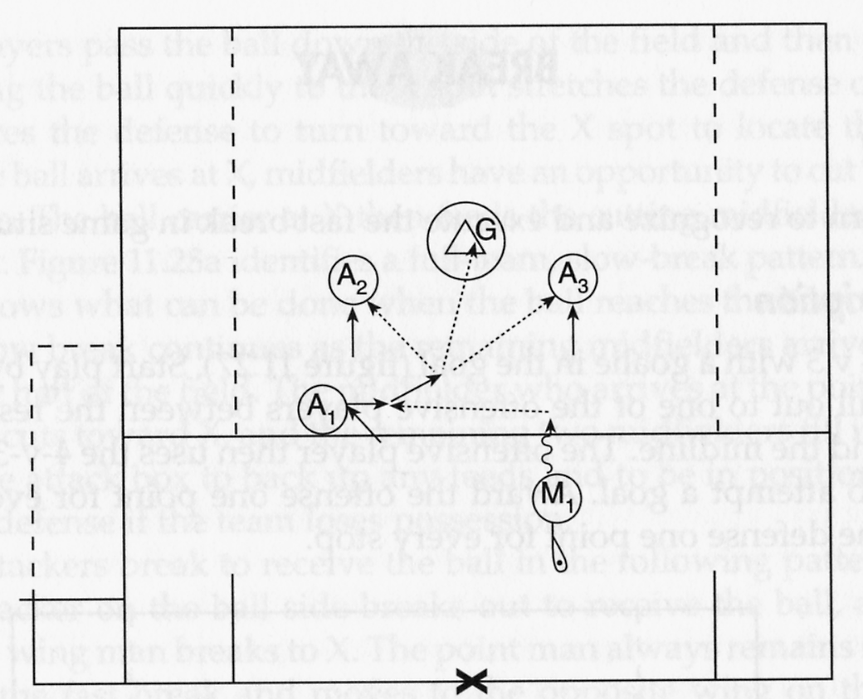
BREAK AWAY (25)
Goal
To learn to recognize and execute the fast break in game situations

Description
Play 4 v 3 with a goalie in the goal. Start play by rolling the ball out to one of the offensive players between the restraining line and the midline. The offensive player then uses the 4-v-3 advantage to attempt a goal. Award the offense one point for every goal and the defense one point for every stop.

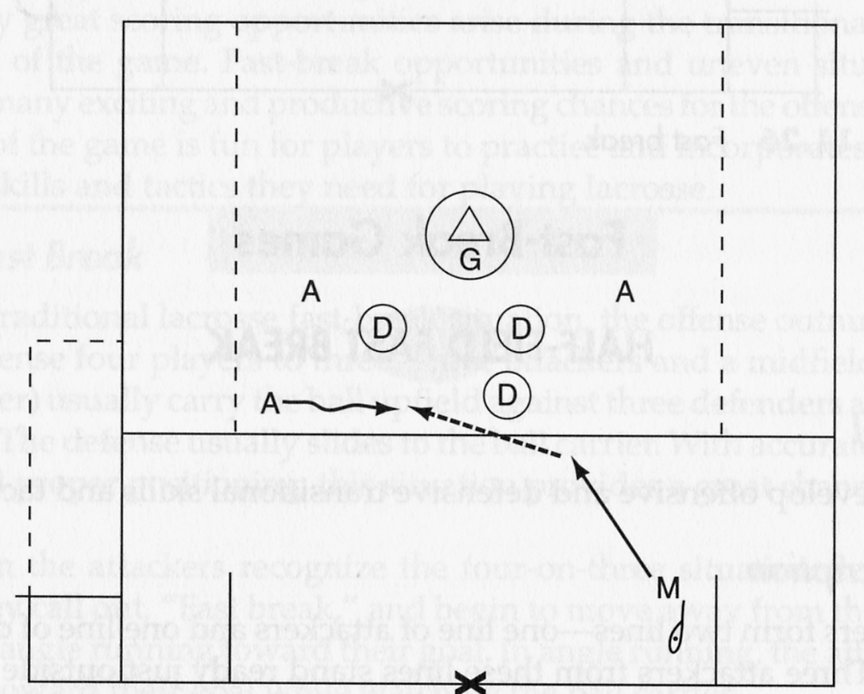

MAKING A BREAK (26)
Goal
To recognize and execute the slow break in game situations

Description
Play 5 v 4 with a goalie in the goal. Set up three attack and three defense players inside the box, with three midfielders at midfield (two on offense, one on defense). Begin play by rolling the ball to one of the offensive players at midfield. Once the ball has been picked up, the defensive players run downfield, cutting off the fast-break opportunity and forcing the offense to run a slow break. Award one point to the offense for each goal and one point to the defense for every stop.

Variation
Periodically hold the defensive midfielder to create a 5-v-3 situation. A second defensive midfielder delays and sprints into the defensive area, creating a 5 v 5.

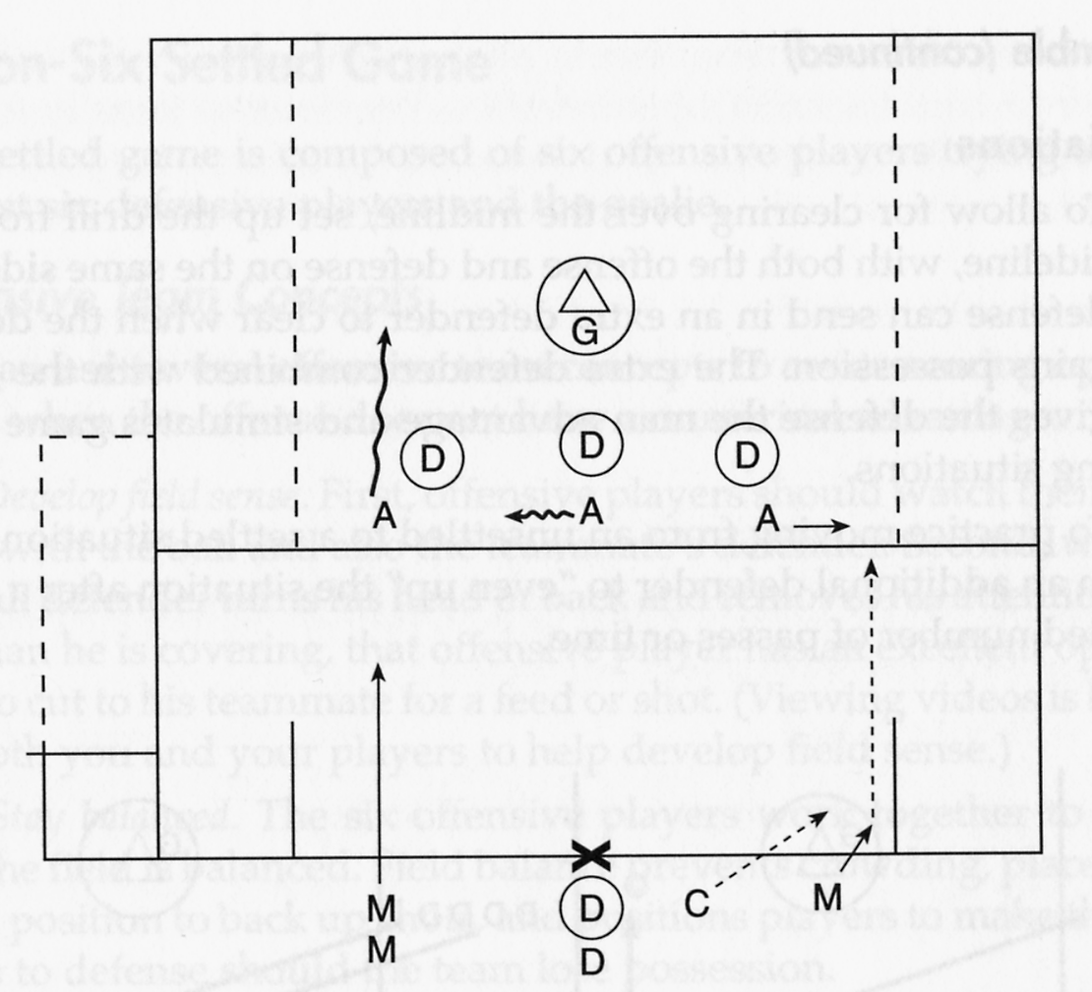

SCRAMBLE (27)
Goal
To develop offensive and defensive transitional skills and tactics

Description
All defensive players are outside of the penalty box in a straight line at the goal line extended. The offensive players are diagonally opposite the defense, 15 yards outside the comer of the penalty box. Call out a number from two to six. The offense sends out that number of players, and the defense sends out one less player. This always gives the offense a man-advantage situation. You can create a 2-v-l, 3-v-2, 4-v-3 or 5-v-4 situation. Rolling the ball out to the offense begins play. You can allow play to continue until a shot is taken, the defense or goalie gains possession, or the defense clears the ball out of the box

Variations
To allow for clearing over the midline, set up the drill from the sideline. with both the offense and defense on the same side. The defense send in an extra defender to clear when the defense gains possession. The extra defender combined with the goalie gives the defense the man advantage and simulates game clearing situations.

To practice moving from an unsettled to a settled situation, send in an additional defender to "even up" the situation after a specified number of passes or time.
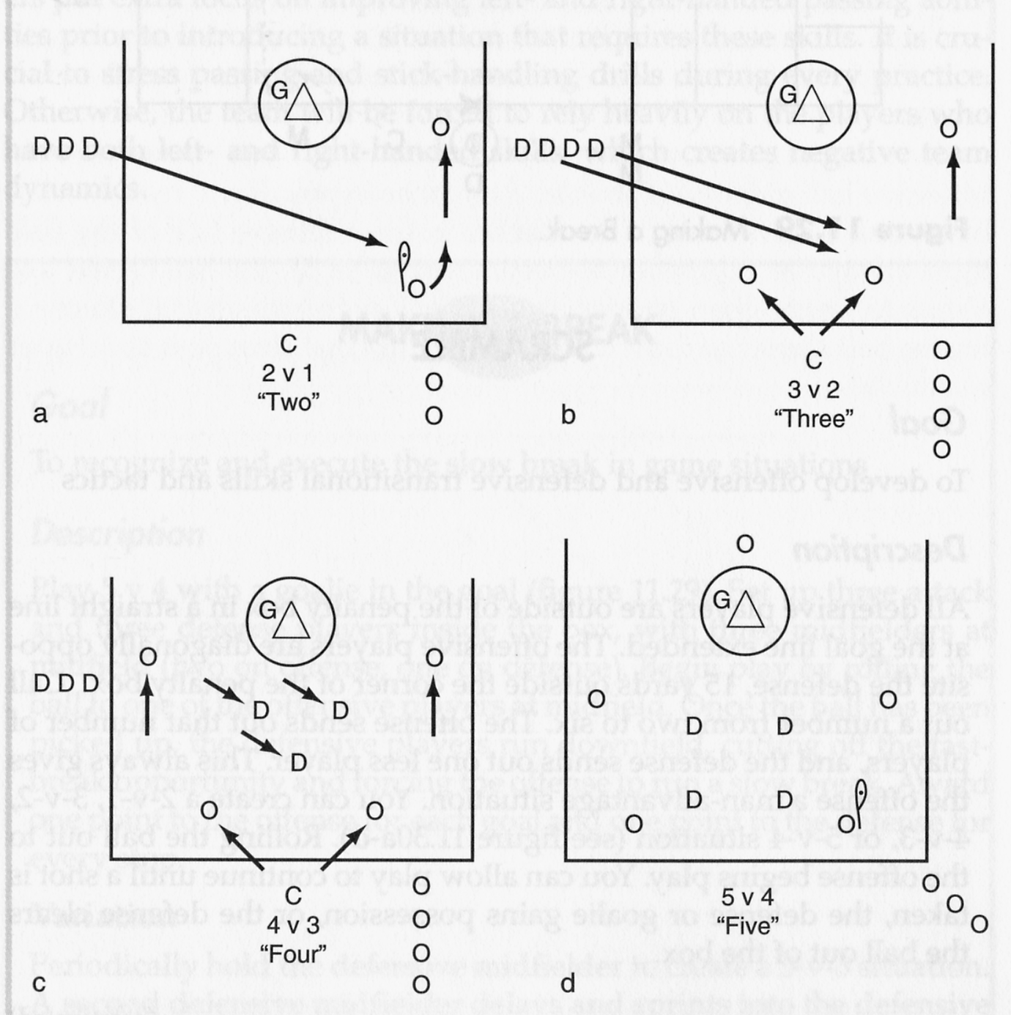

Cutting and Picking Games
CUT AND PICK (28)
Goal
To leam proper cutting and picking when the ball is behind the goal

Description
Play 4 v 4 inside the box with a goalie in the goal. One attacker and one defender are behind the goal, and the other players are in front of the goal. The three offensive players in front of the goal pick for each other and cut to get open to receive a pass from the attacker behind, who is trying to get open to feed the ball. Award the offense one point for a goal award the defense one point for a stop. Restart play by throwing the ball to the attacker behind the goal

To make the game easier
Play 4 v 3, leaving the attacker behind the goal unguarded.

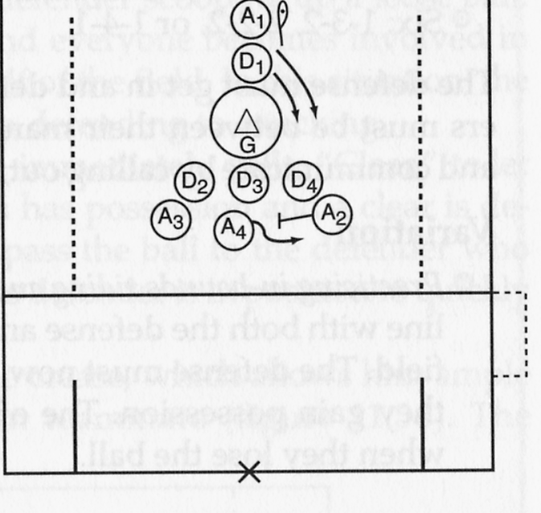

EVEN NUMBERS (29)
Goal
To develop settled offensive and defensive skills and tactics
Description
Create 1-v-l, 2-v-2, 3-v-3, 4-v-4, 5-v-5, or 6-v-6 setups in a half-field situation. All defensive players are out of the restraining box at the goal line extended. The offensive players are positioned 15 yards outside of the top of the penalty box, diagonally opposite the defense. You are in the center at the top of the box with a supply of balls. Call out a number from one to six, and the number of offensive and defensive players enter the box to attack and defend. Roll the ball to the offense and begin play. Allow the drill to continue until a goal is scored, or the ball is cleared to the outside of the penalty box.
The offense should balance the field in the same alignment as in uneven numbers:

Two: one at the midfield and one at attack
Three: triangle
Four: box
Five: 1-2-2
Six-1-3-2 2-2-2, or 1-4-1

The defense must get in and defend from the inside out. All defenders must be between their man and the goal. They must match up and communicate by calling out, “Ball”, and “One” and “Two” slides.

Variation
Practicing in-bounds riding and clearing. Set up the drill on the sideline with both the defense and the offense on the same side of the field. The defense must now attempt to clear over the midfield when they gain possession. The offense must try to regain possession when they lose the ball.

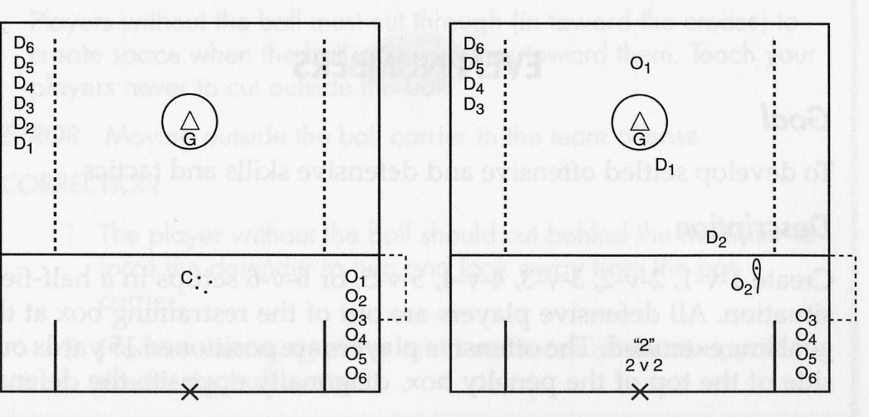
Clearing Game
CLEARING (30)
Goal
To develop stick skills and clearing tactics

Description
Remove the goal from the attack box area and position two teams of four players each and a neutral player in the area. The neutral player always plays offense, providing a 5-v-4 advantage to the team with the ball. Each team tries to maintain possession by running and passing the ball. The defensive team plays zone defense, with one player covering the ball and the remaining three players splitting the four remaining offensive players. The offensive player spread the defense by moving to open areas and calling, “Help”, when they are open to receive a pass.

Variation
Set up two 4-v-4 neutral games.

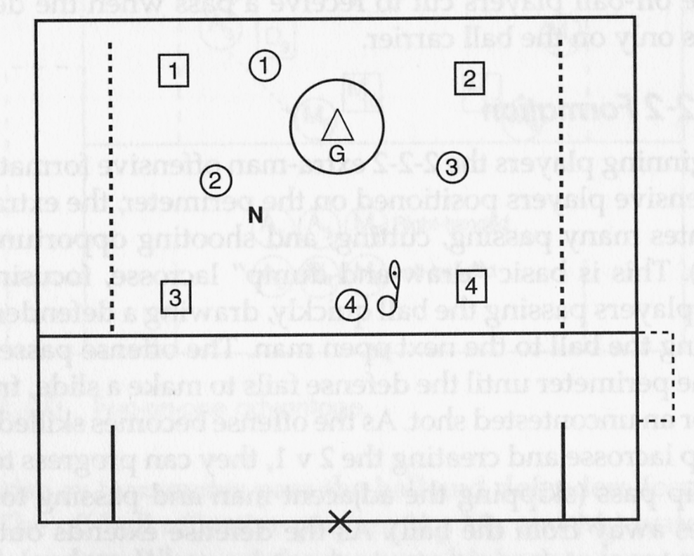
Extra Man Offense Game
MONEY, OR MONEY IN THE BANK (31)

Goal
To develop extra man offense and man-down defense skills and tactics
Description
Play 4 v 3 in the penalty box with a goalie in the goal.
The offense passes the ball around the perimeter, looking to create a shooting opportunity. The defense must play a zone and rotate to the ball carrier (this rotation is the same as the 4-v-3 fast-break defense).
The offense is awarded one point for each goal scored, and the defense scores one point each time they gain possession.

To make the game easier
Play 3 v 2.
Play 4 v 2.

To make the game harder
Have offense shoot only with their non-dominant hand.
If a shot has not been allowed within five passes, the defense is awarded a point.

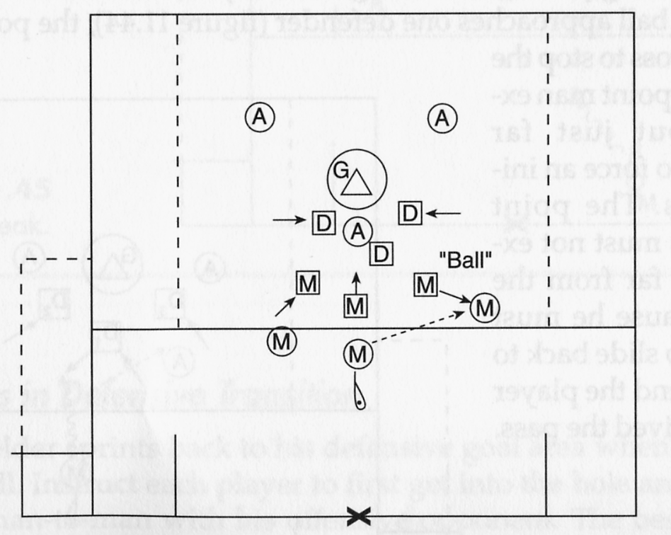
Fast-Break Game
STOP THE BREAK! (32)
Goal
For the defense to learn to properly defend against the fast break

Description
Play 4-v-3, in the box, with a goalie in the goal. Start play by rolling the ball to one of the offensive players between the restraining line and midline. The offense uses the 4-v-3 advantage to
try to score, while the defense tries to stop the ball using defensive tactics. Award two points to the defense for a stop and one point to the offense for a goal.

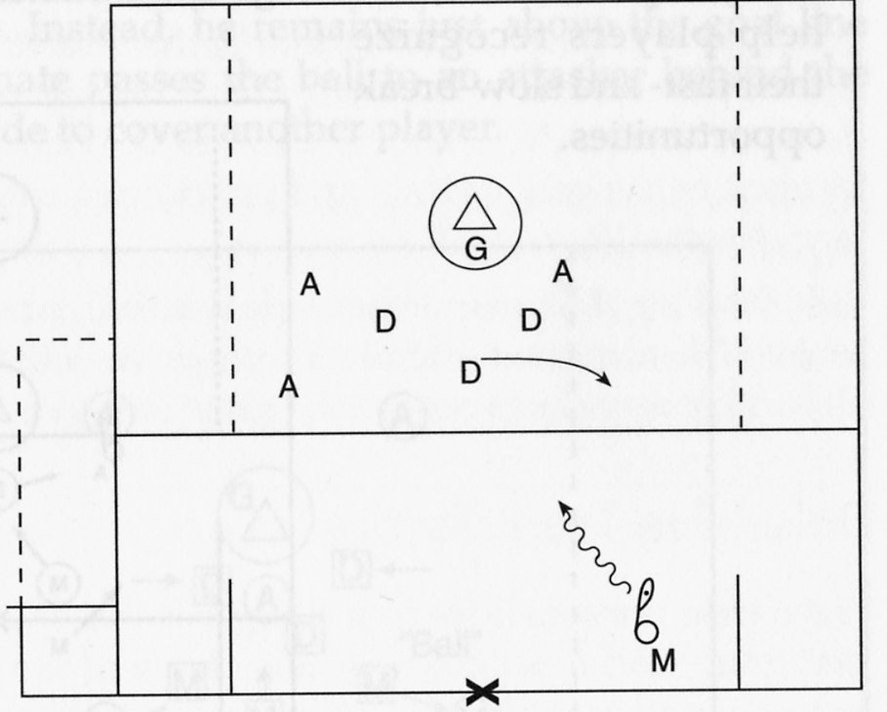
Transition Game
HIGHWAY 66 (33)
Goal
To develop transitional skills and concepts and overall stick work
Description
Place the goals at the top of each attack box to shorten the field. Two teams, each consisting of three attackers, two defenders, and a goalie, stand around their respective goals. Each team is short one defender, which results in a continuous transitional opportunity for the offense. Two midfielders for each team stand across the midfield line. Use offsides rules (three players must stay in the defensive side of the field). Each goalie has an ample supply of extra balls in the cage, and when a goal or missed shot occurs the goalie quickly scoops up a ball out of the cage and initiates a clear. Remember to help players recognize their fast- and slow- break opportunities.

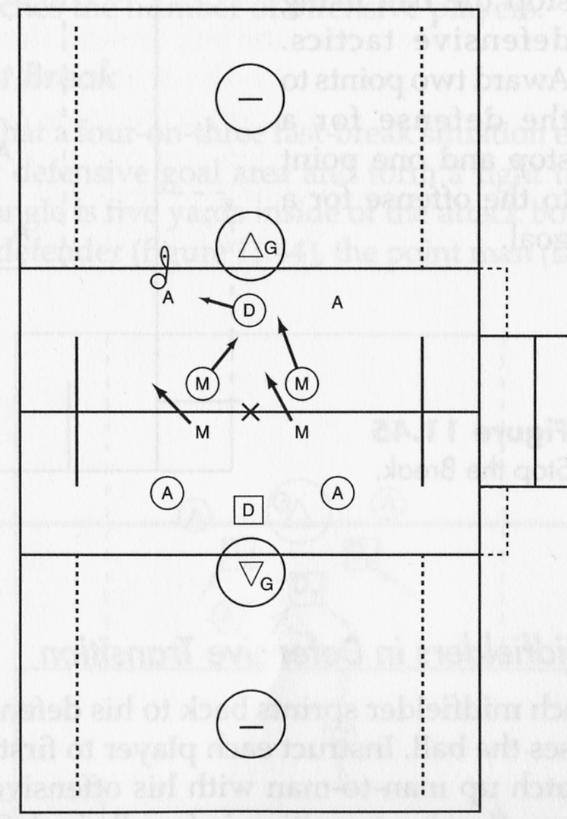

Defensive Game
BINGO (34)
Goal
To teach team defensive concepts

Description
Five offensive players in the attack box arrange themselves in a 2-1-2 formation, with five defensive players matching up on them. The offensive team passes the ball around the perimeter while you check each player's on-ball and off-ball positioning. Instruct the offensive played not to pass until you have corrected the position of all the defensive players.
Be sure the defensive players use the piston concept as the offensive team passes the ball: One defensive player moves out to the ball and one moves back in. Make sure that the defensive player move out to the ball in a controlled manner, otherwise the ball carrier will just run past the charging defender and have an open shot. Make sure players understand that if a defender runs out, there is no way he can change directions if the ball carrier decides to dodge. Emphasize the pinch concept: Four defenders play in the defensive hole and one plays the ball outside the hole.

Variation
When the ball is in the air on an oftensive pass, call, "Dodge." To create a slide situation, the defensive player allows himself to be beaten as the ball arrives. Defenders must then make correct slides

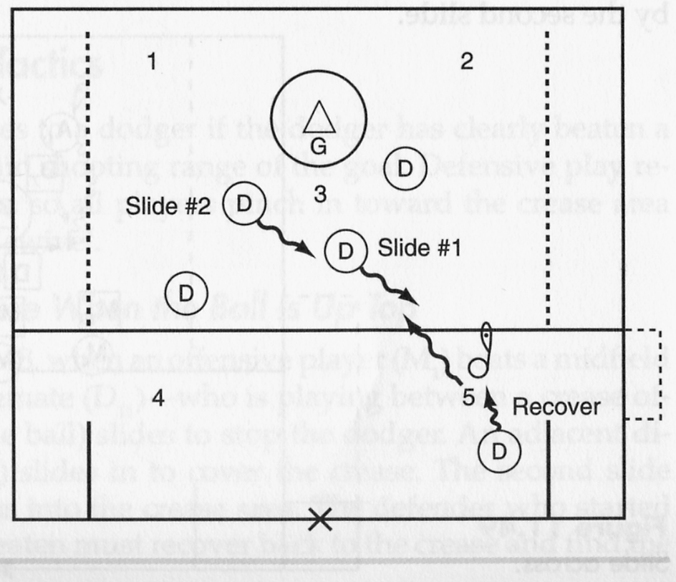

Man-Down Game
DOUBLE TIME (35)
Goal
To develop man-down skills and tactics
Description
Plav 5 v 4 with the goalie in the penalty box area.The offensive attempts to pass the ball to create a shooting opportunity while the defense works “double time” to prevent a shot. The offense aligns in a 2-1-2 and thehe defense in a box. The defense stays compact in a tight box attempting to force a shout from the outside. All ball players pinch to the crease man trying to deny a pass to the inside. All defenders should apply a basic man-down tenet of “sticks in and bodies out.” Defenders should position their sticks to the inside (pointing to the crease, cutting down passing lanes to the crease area. The defense should be ready to rotate if the offense creates a 2-v-l situation.
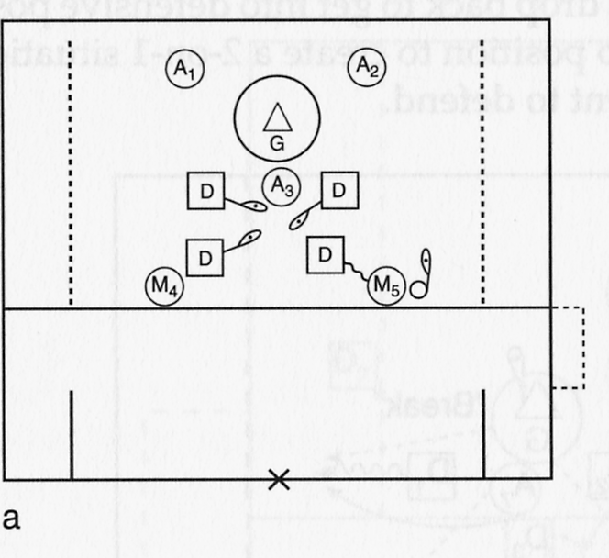
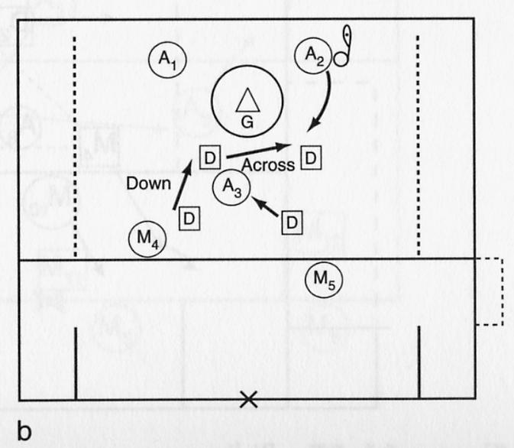
LACROSSE PRACTICE PLANS
Season Plan—Level A
(Bantum Division/Beginner)
Practice 1
Purpose: To learn the basics of cradling, throwing, and catching
Games: Partner Passing-Dominant Hand (3), Right Passing and Catching (4), Creative Cradling (2)
Skill development: Cradling, throwing, and catching

Practice 2
Purpose: To learn the basics of scooping and review cradling, catching, and throwing
Games: Cradling Game (1), Partner Scooping and Cradling (10), Hot Rock (8)
Skill development: Scooping, cradling, throwing, and catching

Practice 3
Purpose: To learn the basics of dodging (introduce inside-and-out dodge, roll dodge, and face dodge)
Games: Creative Cradling Game (2), Show Time (14), Go For It (15)
Skill development: Dodging

Practice 4
Purpose: To develop shooting skills
Games: Drive From the Center and Shoot (17), Shoot Away (18)
Skill development: Shooting skills

Practice 5
Purpose: To introduce man-ball, and ground ball situations
Games: 1 v 1 Scooping With Outlet (9), 2 v 1 Ground Ball (12)
Skill development: Scooping, catching, throwing, 2 v 1 ground ball tactics, body checking

Practice 6
Purpose: Introduce stick checks and holds
Games: Stick Check (21), Defensive Hold Game (23), Turn It Over (22)
Skill development: 1 v 1 defensive skills

Practice 7
Purpose: To develop skill and tactical understanding in unsettled situations
Game: Scramble (27)
Skill development: Transition skills and tactics

Practice 8
Purpose: Introduce 4 v 3 fast-break offense and defense
Games: Shoot Away (18), Break Away (25), Stop the Break! (32), Money in the Bank (31)
Skill development: Draw-and-dump skills

Practice 9
Purpose: To develop 1 v 1 offensive and defensive skills
Games: Agilities (20), Defensive Hold Game (23), Even Numbers (29), Turn It Over (22)
Skill development: 1 v 1 and 3 v 3 team offensive and defensive skills and tactics

Practice 10
Purpose: Introduce riding and clearing skills and tactics
Games: Hot Rock (8), Clearing (30)
Skill development: Clearing and riding skills

Practice 11
Purpose: Introduce 6 v 6 settled offense and defense
Games: Even Numbers (build up to 6 v 6) (29), Bingo (34)
Skill development: Team offensive and defensive tactics

Practice 12
Purpose: Introduce man-up and man-down skills and tactics
Games: Double Time (35), Scramble (27)
Skill development: Stick work, extra-man offense and man-down defense skills and tactics

Season Plan—Level B
(Lightning Division/Intermediate)
As players master basic skills they can apply them in small-group games. The opportunity to use skills in gamelike situations will expedite their mastery of basic skills and tactical development.

Practice 1
Purpose: To develop throwing and catching skills using both hands
Games: Over the Shoulder (7), Four Corner Passing (6), Hot Rock (8)
Skill development: Throwing and catching

Practice 2
Purpose: To develop scooping and passing skills
Games: Scooping and Passing (11), 1 v 1 Scooping with Outlet (9), 2 v 1 Ground Ball (12)
Skill development: Scooping, man-ball tactics, throwing and catching, body checking

Practice 3
Purpose: To develop dodging and shooting skills
Games: Same-Side Shooting (16), Money In The Bank (31), Line Dodging (13), Go For It (15), Shoot Away (18)
Skill development: Catching and shooting, shooting off the dodge

Practice 4
Purpose: To develop offensive and defensive transitional skills and tactics
Game: Scramble (27)
Skill development: Stick work, transitional skills and tactics

Practice 5
Purpose: To develop quick clear skills, and transitional offensive and defensive transitional skills and tactics
Games: Highway 66 (33), Break Away (25), Stop the Break! (32)
Skill development: Stick work, transitional skills and tactics, clearing

Practice 6
Purpose: To develop settled and defensive skills and tactics
Games: Defensive Hold Game (23), Stick Check (21), Bingo (34), Go For It (15)
Skill development: V-cutting, offensive and defensive skills and tactics

Practice 7
Purpose: To develop off-ball offensive and defensive skills and tactics
Games: Cut and Pick (28), Even Numbers (29)
Skill development: Cutting, picking, off-ball defensive skills

Practice 8
Purpose: To develop slow-break skills and tactics
Games: Making a Break (26), Scramble (5 v 4) (27)
Skill development: Stick work, transitional skills and tactics

Practice 9
Purpose: To develop riding and clearing skills and tactics
Games: Hot Rock (8), Clearing (30)
Skill development: Stick work, riding and clearing skills and tactics

Practice 10
Purpose: To develop extra-man offense and man-down defense skills and tactics
Games: Scramble (27), Double Time (35)
Skill development: Stick work, shooting and defensive skills

Season Plan—Level A
(Junior or Senior Division/Advanced)
Players who have mastered basic and intermediate skills and tactics can continue to develop their game by improving their non-dominant hand and learning the finer points of team play (such as playing with-
out the ball on offense and defense) and transitional offense and defense skills and tactics. Continual work on fundamentals should not be neglected and can be incorporated into practices in transition games
and drills. These drills and games allow players to practice fundamentals in gamelike situations.

Practice 1
Purpose: To develop throwing and catching skills (using both hands)
Games: Right-on-Right and Left-on-Left Passing and Catching (4), Diamond Passing (5)
Skill development: Throwing and catching

Practice 2
Purpose: To develop change-of-direction dodge
Games: Four Corner Passing (6), Diamond Passing (5), Clearing (30)
Skill development: Throwing and catching, change-of-direction dodge

Practice 3
Purpose: To develop transitional skills and tactics
Games: Scramble (27), Break Away (25), Highway 66 (33)
Skill development: Stick work, transitional skills and tactics

Practice 4
Purpose: To develop shooting skills with both hands
Games: Same-Side Shooting (16), Drive From the Center and Shoot (17), Shoot Away (18)
Skill development: Throwing and catching, shooting

Practice 5
Purpose: To develop scooping skills and tactics
Games: Scooping and Passing (11), 1 v 1 Scooping With Outlet (9), 2 v 1 Ground Ball (12)
Skill development: Scooping, man-ball tactics, throwing and catching, body checking

Practice 6
Purpose: To develop transitional skills and tactics
Games: Scramble (27), Break Away (25), Highway 66 (33)
Skill development: Stick work, transitional skills and tactics

Practice 7
Purpose: To develop settled offensive and defensive skills and tactics
Games: Even Numbers (29), Turn It Over (22), Go for It (15), Bingo (34)
Skill development: Stick work, dodging, settled offensive and defensive skills and tactics

Practice 8
Purpose: To develop in-bounds clearing and riding skills and tactics
Games: Highway 66 (33), Clearing (30)
Skill development: Stick work, riding and clearing skills and tactics

Practice 9
Purpose: To develop off-ball skills and tactics
Games: Playing the Cutter (19), Cut and Pick (28)
Skill development: Picking, cutting, feeding, shooting, crease defense play

Practice 10
Purpose: To develop extra-man offensive and defensive skills and tactics
Games: Scramble (27), Double Time(35), Money In The Bank (31)
Skill development: Stick work, shooting, extra-man offense and man-down defense skills and tactics

