Entering scores and statistics in the Davis Lacrosse Association website

1. Go to the Admin tab (top right side of home page) and log in with the team manager’s password.
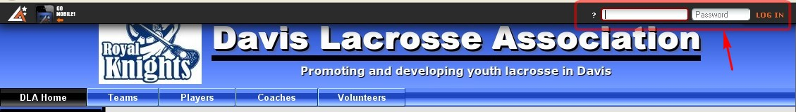

Click on Administer to get to the general administrative page. On the bottom right click on the Manger’s Manual link in the box titled Support.

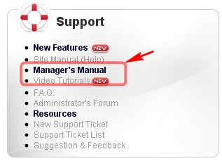

On this page you can READ the directions for editing a game result and player statistics. For games for which there are no posted results, click on Results and post the score.

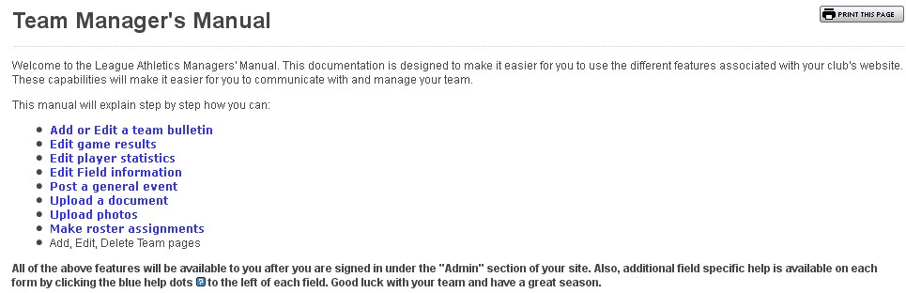
To edit game results click on Teams, select the correct season and your team. Click on Results.
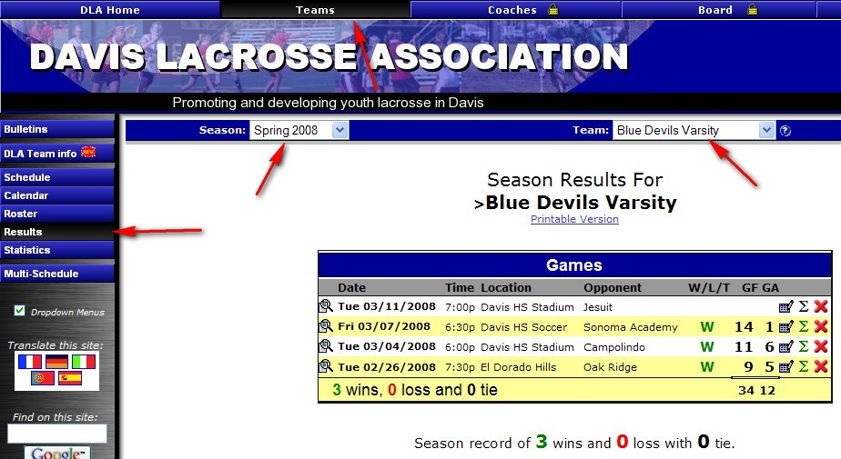

Click on the icon box with the pencil next to the game you wish to edit.
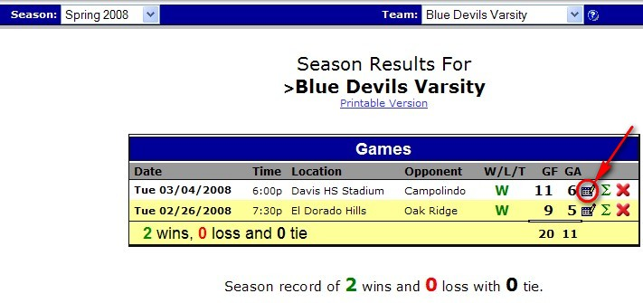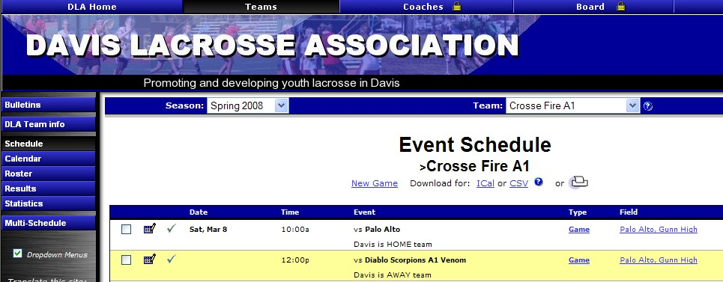

Put in the score for each team.
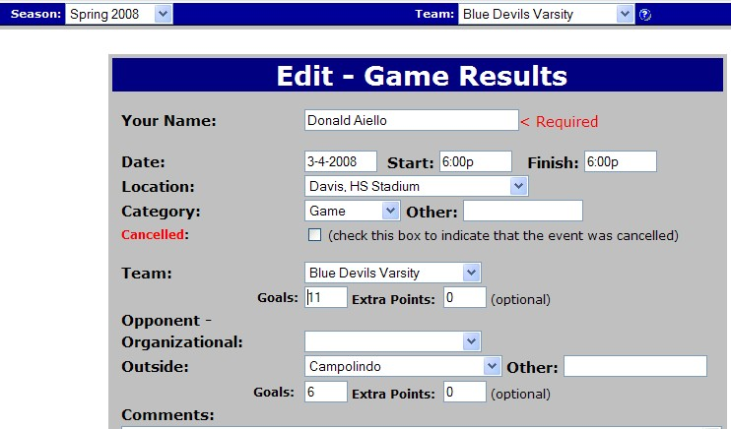

Click SUBMIT after editing the score

Before posting statistics become familiar with the definitions and codes used by finding and reviewing Statistics categories and definitions which can be found under the Documents tab on the website or by clicking on http://files.leagueathletics.com/Text/Documents/2273/12228.doc

To enter statistics for a game click on the green sigma next to the game of interest
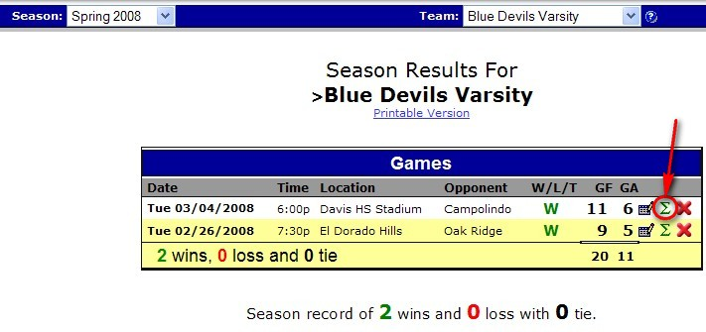

which will take you to the following Player Statistics screen.
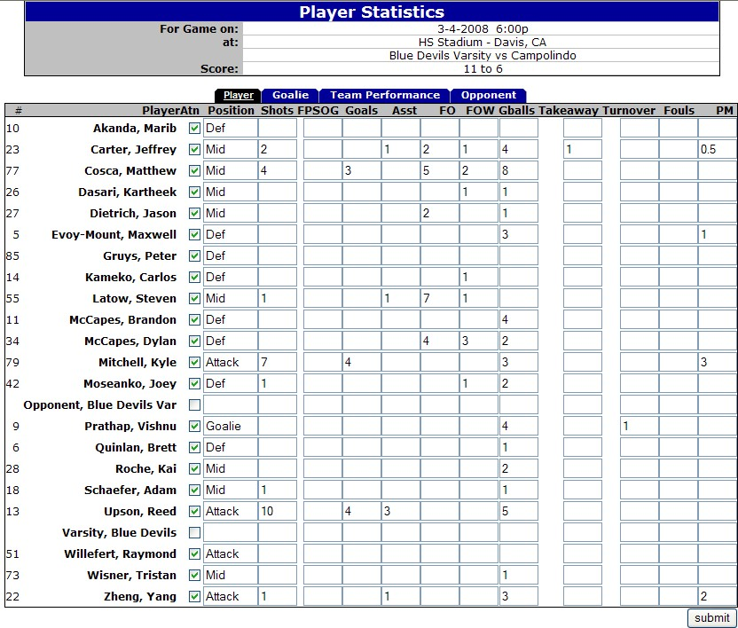

This screen shows individual Player stats. If desired, complete the position played. Mark the box for each player that played in the game, include their individual statistics and click SUBMIT.

Click on the Goalie tab. Click on the box next to the goalie(s) name (s) and then enter the goalie statistics and click SUBMIT.

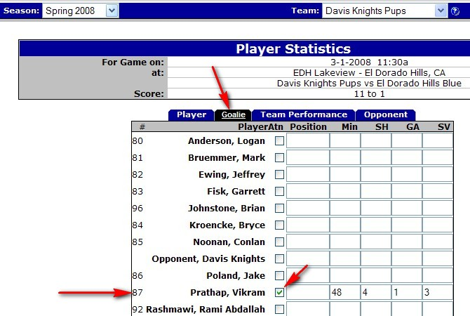

Next, click on the Team Performance tab. Click the box next to the Team Name, enter the team statistics and click SUBMIT.

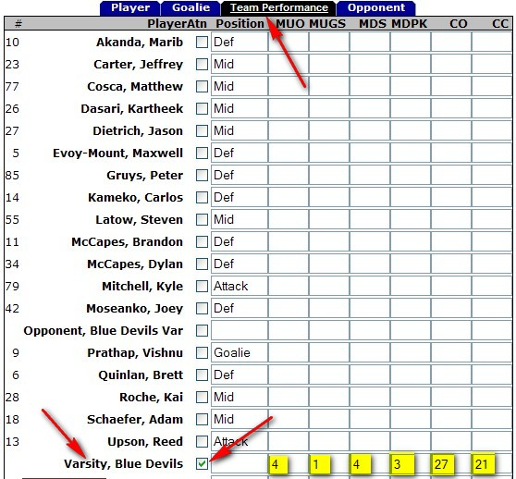

Next click on the Opponent tab. Click on the box next to the Opponent and put in the opponent statistics and click SUBMIT.

