March 7, 2016
To: Connecticut High School Lacrosse Coaches Association
Connecticut Lacrosse Officials Association
Western Connecticut Lacrosse Officials Association
From: Steven Hinchey, CIAC Interpreter (laxoid@cox.net)
Re: NFHS – Corrections, Clarifications, and FAQ’s regarding 2016 Rules
Two Editorial Changes to the 2016 NFHS Boys’ Lacrosse Rules:
P 79 Rule 7-3: 4th line, after word ‘RESTARTED’, add the words ‘LATERALLY OUTSIDE’. This was inadvertently left out.
P 80 7.3 Situation D: 4th line, change ‘AWARDED TO TEAM B’ to read ‘ AWARDEDTO TEAM A’

The following rules clarifications have been forward by the NFHS:
Crosse:
- Changes to crosse dimensions as described in Rule 1-6-1 on page 13 do not take place until 2018, so please IGNORE that section for this season. All crosses must comply with current rules (i.e. collegiate dimension crosse is NOT allowed for play for 2016)
- Rule 1-8 – pull strings are prohibted and only one sidewall string on either side will be allowed
- Face off players are required to have 6 inches of contrasting tape that starts below (not on) the head of the crosse.
  - Contrasting means a color that is DIFFERENT from the Head of the crosse, the shaft, and the player’s gloves.
  - Tape means TAPE – painted shafts (manufactured or added) are NOT Legal for faceoff.
- Strings outside the head are NO LONGER THAN 2 inches – this is not an illegal stick – the stick cannot be used.
- Any shooting strings, channels or laces are confined to the space four inches from the head of the crosse.
- None of these provisions apply to the goalkeeper’s crosse
- Goalkeeper cannot face off at any time.
Goalkeeper Equipment 1-9-1k,2: Throat Protector and Chest Protector must be designed for lacrosse
Rule 4-3 Face Off
- The new procedure allows officials to adjust players before placing the ball.
- Prewhistle violations – restart is one step OVER the Center Line on the Attack half of field.
- Post whistle violations – restart where play was stopped by the whistle. There is NO ‘free clear’.
Rule 4-14-3 Over and back :
- For the purpose of determining a violation, the CENTER LINE is NOT a plane.
- For a violation to occur, the ball MUST TOUCH the Center Line, the ground on the defensive half of the field or anything that touches the ground on the defensive half of the field.
- Players on the defensive half of the field (Team A or Team B) may bat or kick the ball to PREVENT it crossing the CENTER LINE. They may NOT possess the ball (cradle) even though their crosse is on the attack half of the field if they are grounded in the defensive half of the field or if they ‘launch’ from the defensive half and are airborne.
- Players on the attack half of the field may possess or bat a ball that is in the air space over the defensive half of the field to prevent the ball from touching the ground in the defensive half of the field as long as they are still on the attack half of the field.
Rule 4-18-1 Defenders in the goal crease area
- Defenders may not stand in the crease with the intention to block shots rather than defending a player. If TWO or more NON Goalkeeper players are standing in the crease and not defending an opponent, a TECHNICAL foul is called (Conduct foul served by INHOME). Multiple violations will be Unsportsmanlike Conduct.
Rule 4-22-2 Restart for Non time serving violations in Goal area:
- By the defense: offense restarts laterally outside attack area
- By the offense: defense restarts in goal area or goal crease.
Rule 7-13-2 Mistakes by Officials – replaced language
- A mistake by officials is corrected promptly which may include disallowing a goal
- When officials are aware of mistake – correct before next live ball
- If not sufficient time (quick restart for example), correction must be made before second live ball whistle.
Attached below are the documents as received from the NFHS
Have a great season

- NFHS Boys Lacrosse - Frequently Asked Questions

- NFHS Rule 1-7-3 provides, in part, that: “Any additional strings or laces (e.g., shooting strings, V channels) must be located within 4 inches of the top of the crosse.”
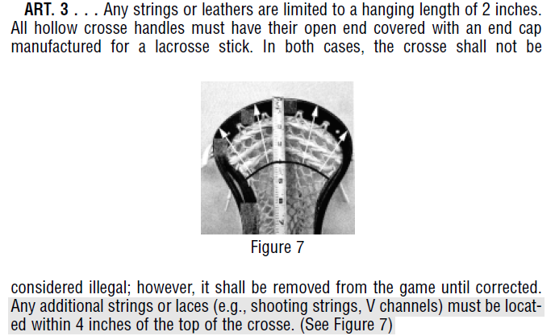
Q. Does this restriction apply to the Goalkeeper’s crosse?
A. No. That part of the rule does not apply to the Goalkeeper’s crosse.
Q. What is the penalty for a violation?
A. Under Rule 5.5 - 3 minute non-releasable penalty and the crosse remains at the table for the remainder of the game.

- NFHS Rule 4-3-3n
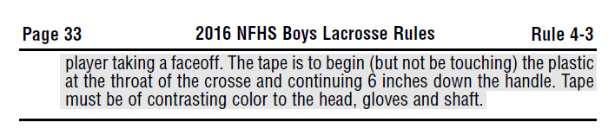
Q. Can paint be used in place of tape on the crosse?
A. No, tape must be used.

- NFHS Rule 4-14-3
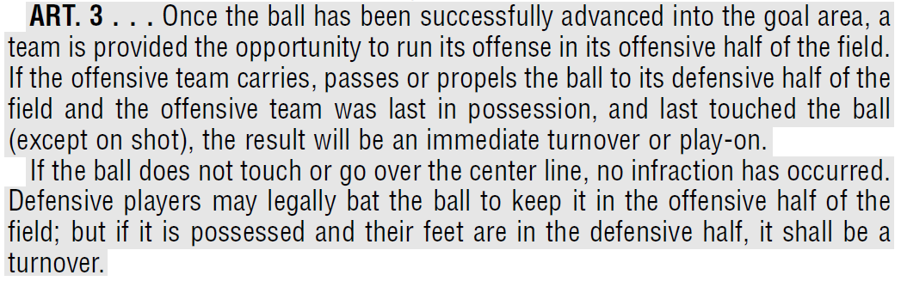
Note: For all questions below, consider that Team A has cleared the ball and established possession in the box, ending the 10-second clearing count. A pass from A1 to A2 is missed, and the ball bounces toward the centerline without being touched by Team B.
Q. Is the center line treated as a plane so that if a ball crosses the center line it is an immediate violation?
A. No the ball must touch the center line, the ground on the defense half of the field or anything in defensive half.
Q. May a player in the defensive half of the field bat the ball with his cross or kick the ball so that the ball does not cross the centerline?
A. Yes.
Q. May a player in the offensive half of the field reach across the centerline and either catch the ball or bat the ball back over the centerline, so that it never touches the center line, the ground on the defense half of the field or anything in contact with the defensive half?
A. Yes

- NFHS Rule 4-18-1 SITUATION E:

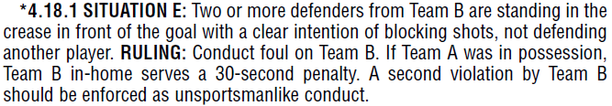
Q. Does the goalkeeper count as one of the two defenders referred to in the situation?
A. No the goalkeeper does not count as one of the two defensemen under this rule.
Q. Is this an immediate whistle?
A. The officials will stop play as soon as they notice the situation. However, if a shot is already in flight when this is noticed, the shot will be allowed to come to its normal conclusion before the whistle blows to stop play.

- Restarts
Q. Where is the play restarted when there is a technical foul before the faceoff begins or while the faceoff players are down battling in the faceoff position?
A. The offended team is awarded the ball in its offensive side of the field at the center.
Q. If after the face off is started, the ball is directed or moves away from the Center if a player commits a loose ball infraction, e.g. a push or hold, where does the play restart?
A. The play is restarted where at the spot where the ball was when the whistle blew.

