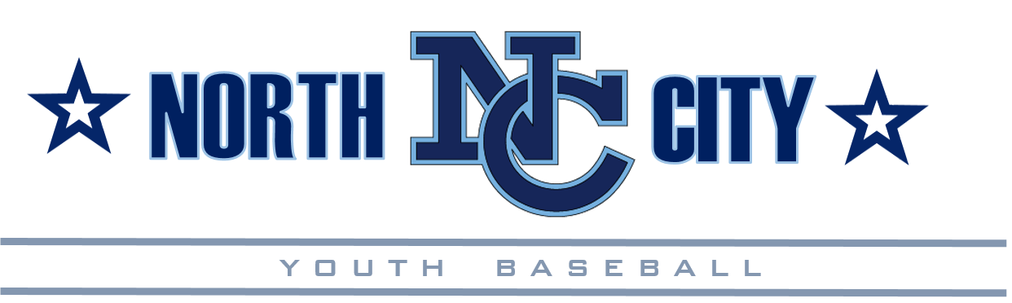
Turkey Tournament Team Commitment Letter & Agreement
November 2018
Dear Parent(s) and Guardian(s), Congratulations!
Your child has been invited to participate in North City’s 14th Annual Thanksgiving Tournament (aka Turkey Tournament) as a player on one of NCYB’s Turkey Teams. The purpose of this letter is to inform you of the commitment NCYB is asking you to make, that is, if you and your child accept the invitation to play on the 2018 Turkey Team.
First and foremost, being selected to participate on a Turkey Team is a great accomplishment and honor for your child. They should be commended. Second, being a part of this tournament team will involve time, dedication, and commitment from both you and your child. Practices could take place upwards of two weeks prior to the tournament and will encompass the entire Thanksgiving Day weekend (Thanksgiving Day excluded). This is a popular time for vacations; however, we will need to know your commitment to tournament participation. We know it is a lot to ask of your family, but we hope the reward is that you and your child will have an experience that you both will remember for a long time. If you cannot commit to full participation, then we respectfully ask that you refuse your invitation so that another deserving player is offered the opportunity to commit to play on this year’s team for NCYB. Your understanding and cooperation is greatly appreciated! Because your child received an invitation to play, we are asking if your child can attend all of the practices and tournament games once their participation in the NCYB Fall Ball season has come to an end. Please inform your Turkey Team Manager if there are any potential conflicts with any tournament or practice dates and/or times prior to accepting the invitation. It will be at the Manager and Coaching Staff’s discretion to determine if the time conflicts and will pose a negative impact to the team. Obviously, they will try to work through any issues; but if deemed so, the player may be asked not to participate as a result. In certain cases, the Coaching Staff, with the advice and approval of the Fall Ball Coordinator and the Tournament Director, may have to extend the roster to accommodate these issues. Again, your understanding is greatly appreciated!
Tournament play is highly competitive (play to win) and NOT comparable to our normal instructional season program. Players may be asked to practice longer and more often at the Manager’s discretion. Players may play only 1 or 2 positions much of the time. Each team will carry 10 to 12 players, but during tournament time, games require only 9 starters (up to 10 for Pinto). This means that in many games, some players may not see as much action as others. Where the Fall Ball Program promoted instruction, inclusion, and fun; Tournament play and preparation is more focused on developing advanced skills, a competitive spirit, and a winning attitude; hopefully all while having fun! Some players thrive in this environment, while other players (and their parents) do not. It is important for us as parents to make this distinction for ourselves, as well as for your child.
Time Commitment:
NCYB is hosting the Turkey Tournament. If possible, we are asking each family to volunteer some of their time to help their team and coaches when needed. NCYB is responsible for all preparation and tear down for all games and practices held at our facilities. We are asking you to assist with whatever field responsibilities may be needed. Just ask how you can help, as any and all help is needed and appreciated. Team preparation time is very limited, and practice dates and times will be determined and provided to you by your Manager. These dates and times will vary by Manager (for those of you who may have multiple children playing in the Tournament), and there quite possibly could be some time conflicts that may result in both practice times and games among the different teams from NCYB. All teams will participate in the tournament with success determining the total number of games they will play. They may play more than one game each day, and times could be from early in the morning to late in the day. Flexibility is needed and all information regarding the Tournament games, practices, etc. will be provided to you as early as possible by your Manager.
Tournament Schedule: (Subject to change)
Dates | Practice/Tournament | Location
November 12 -21 | Practice Date Range | Mt. Etna/Hickman Fields
November 23-25 | NCYB Turkey Tournament | Mt. Etna/Hickman/Mission Bay

All game times and locations will be loaded on the league website when the schedule is completed. As with any invitational youth sports tournament, there is a great deal of adding and removing of teams right up to the tournament date. This affects the schedule for each change. The schedule will be posted as soon as possible and may need updates even after being posted. Please be flexible with your expected game times. Plan to play a game at any given time from November 23-25.
Financial Commitment:
NCYB has taken on quite a bit these past few years. Last year, we asked for financial and volunteer support from parents of participants for all of our Tournament teams. We are requiring that again this year to help cover some of the costs for their child to participate on this year’s team. Many other leagues have had this practice in place for several years. The substantial growth in membership of our league, as well as the addition of the Hickman Facility has stretched our time and financial abilities to where we had to make this change. Our league is operated by volunteers and the importance of each parent’s involvement cannot be underestimated. Thank you in advance for your willingness to help!
The Registration Fee to participate on the 2018 Turkey Team will be $50 and covers the uniform cost.
In Addition, we are asking each player’s family to work one Snack Bar shift. We prefer Snack Bar coverage; however, we are offering a buy-out if this does not work for your family. The buy-out amount is $50.
Your commitment this year is the following:
Your tournament commitment is the following:
- Turkey Tournament Fee of $50.
- Snack Bar coverage (1 shift) or $50 buyout.
- Provide what volunteer assistance you can to your Team (especially with field prep and tear down).

Your payment must be received by 5pm on 11/20/18 or your child may become ineligible to participate in the Turkey Tournament.

As you can imagine, the tournament experience can be stressful and filled with anxiety. Playing a 3-day tournament is very demanding on the entire family; but the experience can be one of the most rewarding.

Post Season is competitive play, and all families must adhere to the following expectations:
Players must:
- Get used to possibly sitting the bench more than they’re used to or filling whatever role the coach may need.
- Be willing to play positions they are not used to or may not want to play.
- Think more about the team than themselves, and understand that one player’s success is everyone’s success.
- Handle personal failure with grace, composure & without bringing the rest of the team down.
Players must NOT:
- Sulk, pout, or generally be unhappy about their position or playing time on a team.
- Make negative comments about their teammates or coaches.
- Make negative or threatening comments to opposing players, coaches, parents, umpires or anyone attending a game.
- Refuse to Play or Leave the team prior to the completion of the tournament (without just cause) Remember you are representing NCYB! Remember you are representing NCYB!
Parents must:
- Avoid the tunnel vision focus on your own child and look instead at the whole team.
- Consider the team’s success as a success for your child regardless of their role.
- Encourage all players and remind them that regardless of the circumstances, they CAN win.
- Support the coaching staff regardless of personal feelings

Parents must NOT:

- Approach a Manager/Coach before, during or after a game to discuss issues relating to their child, other than to report an injury or other non-playing issue. There is far too much going on for a manager/coach to focus on a discussion at that time. Call the manager/coach and set up a time before or after a practice to discuss these matters.
- Discuss playing time, positioning, batting order or game strategy. This is a manager’s/coach’s prerogative and is decided amongst the coaching staff. NCYB has complete confidence in their coaches and their ability to manage the team appropriately.
- Discuss other players on the team. It is simply not appropriate for a manager/coach to discuss a player other than with that player’s parents.
- Pull their child or refuse to let them play prior to the completion of the tournament.
- Consume or distribute any alcoholic beverages at the playing field at any time during tournament play. (Reminder, Alcohol is not allowed at the NCYB fields.)

On Behalf of the League and the 2018/19 NCYB Board of Directors, Thank You, Good Luck, and most of all HAVE FUN!!

Dis Abelman Tim Nguyen
Dis Abelman Tim Nguyen
2018/19 NCYB Player Agent 2018/19 NCYB President
By signing below, I am confirming the following:
- I have read and accept all terms of this Commitment Letter and Agreement.
- I understand that violation or non-compliance with any of the above listed terms can result in:
  - Termination of my participation with the Turkey Team this season, and may make my child In-Eligible to participate with any Post Season teams next season.

______________________________ _____________________________ __________
Player’s Name (Please print) * Player’s Signature * Date

______________________________ _____________________________ ____________
Parent / Guardian Name (Please print) * Parent / Guardian Signature * Contact Phone #

This portion to be filled out by Team Manager & Verified by League Official…

Registration Fee Payment * Amount ________ Check # ________ Cash ______ (Fee is $50)
Division _______________ Team_____________
Confirmation by [Board Member] ____________________________________ Date: _________________

