KPW Web Site Coaches and Managers
User Manual



www.kpwhockey.org
Version 1.1

Introduction 2
Logging onto the Website 2
Communicating with your Team 3
Posting a Bulletin and Emailing the Team at the Same time 3
Emailing the Team Without Posting the Message on the Team Page 5
Adding additional Email addresses 7
Viewing your Roster 9
Entering Game Results on your Team Page 10
Adding Pictures to your Team page 11
If you make a mistake and wish to delete the picture 14
Scheduling General Events 15
Download Stats 17

Introduction

This document is meant to give KPW Coaches and Managers an introduction to using the KPW web site. We encourage all coaches and managers to make use of their team page on the web site as both their main method of communication with the players and parents and as place to post pictures and record results from their games. Doing this has several benefits for both your team and for the league. These benefits include:

- Simplifies communications – by using the web site there is only one email list for the team. No need for coaches and managers to keep separate email lists. Plus it allows you to send email from any computer.
- Allows for better communications from the league – When we need to communicate to the teams whether its about a practice schedule or a new program we are offering we know that we are reaching the correct email addresses for our participants.
- Increases Team unity – players like to visit their team pages and see new pictures, check their record and see game reports.
- Financial benefit to the league – We periodically need to go out and recruit sponsors for the league. By increasing traffic on the KPW website we add more value to our sponsors by exposing their brand to more viewers.

Logging onto the Website

- Click on the Admin button at the top of the page to bring up the logon screen.
- Enter your Name and the password given to you and click on Submit. The password is what matters when signing onto the web site. Your name is used only for logging purposes so it does not matter if you enter your full name or abbreviate it.

Note: You can also log onto the website by clicking on Roster on your team page. If you log on using the Roster button you will not have access to all the features described in this document. For that reason we recommend that you always use the Admin button to log on to the website.

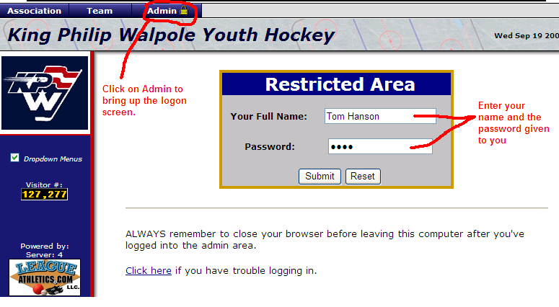

After logging into the website you will be taken to the Admin page as shown below:

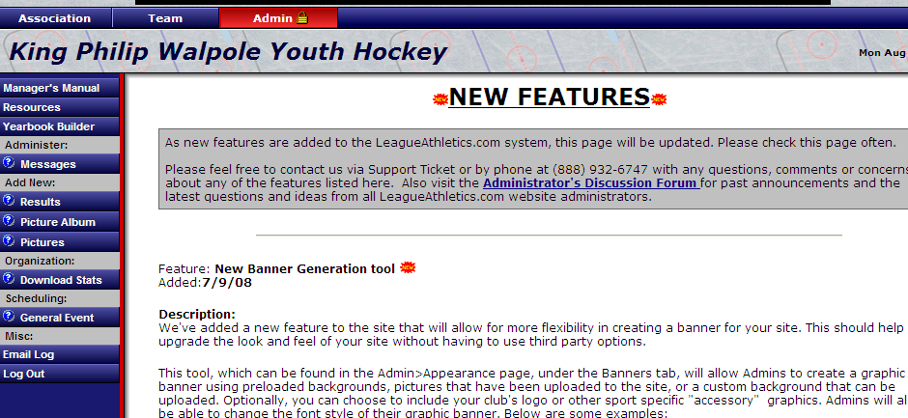

You can switch to your team page by clicking on the Team button at the top of the page and then selecting your correct level and team.

To return back to the Admin page click on the Admin button at the top of the page.

Communicating with your Team

KPW would like all coaches and managers to use the web site as the primary means of communication for your team. By using the web site to send email your email can appear on the team page as a bulletin. If you do not wish to have your message appear on the team page then you have that option also. We recommend posting the emails on your team page as a courtesy to your team. Its sometimes easy for people to forget about an email that they received so by posting it on the team page it is their as a reminder. Plus people like to see things on the team page when they visit it.

Posting a Bulletin and Emailing the Team at the Same time

The bulletin should be the primary way to communicate with your team's players and parents. Bulletins are displayed on your team's home page with the newer bulletins displayed at the top of the page. You can email new bulletins to players and parents using the "Broadcast Email" feature. Here are the steps to sending a bulletin out to your team. Below we walk you through these steps with screen shots of the web pages.

- First make sure you are signed in using your password
- Select "Team" from the menu tabs from the at the top of the page
Note: You may have to select season, league and team at the top of the page
- Click on the "Add a New Bulletin" hyperlink
- Enter information including "Respond To", "Publish Date", and "End Date"
Note: If no "End Date" is entered the bulletin will remain on your team's page indefinitely
- Enter the title and write your bulletin.
- You may choose to have the bulletin emailed by checking the "Email Broadcast" box. Email the bulletin to both parents and players to ensure everyone gets a copy. If the same email address is entered for both the player and the parent only one copy is sent out.
- Click "Submit" to complete.

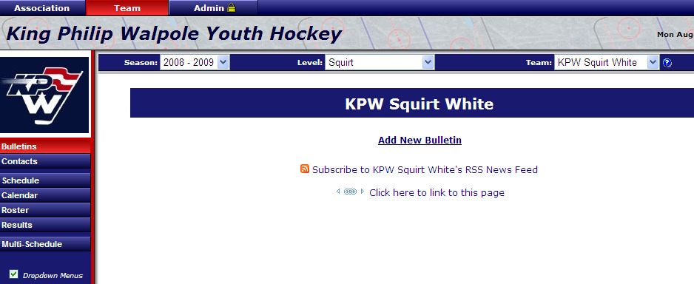

To edit an existing bulletin, just click on the "Edit" icon next to the bulletin on your team's page. To delete an existing bulletin, just click on the "Delete" icon next to the bulletin on you team's page

To send the email from your team page click Add New Bulletin. You may need to click on the Bulletins tab in the left hand menu first.

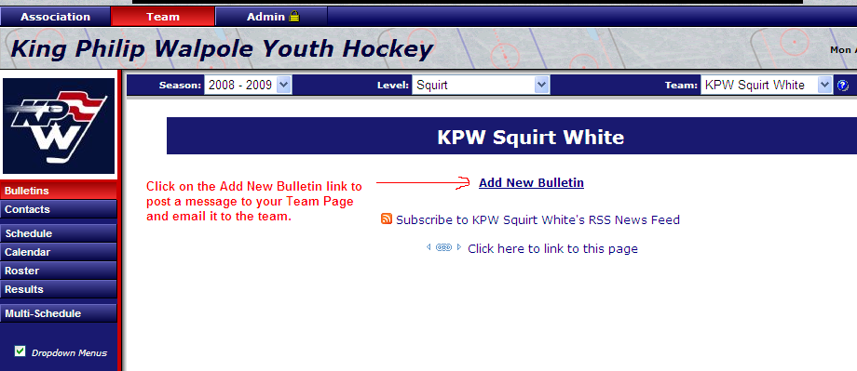

Next you will see the New Bulletin page, Fill in the fields as explained in the picture below:

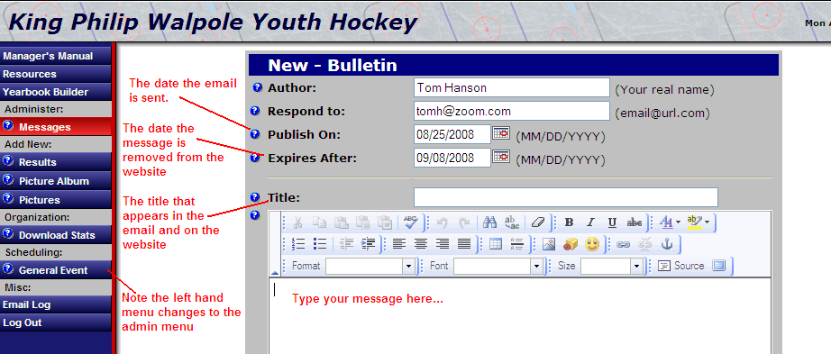

Now complete the rest of the page and click submit to send the email:

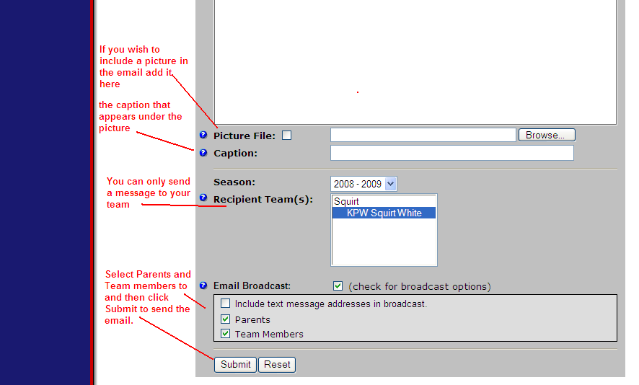

Emailing the Team Without Posting the Message on the Team Page

Sometime you just want to drop a quick note to the team and do not wish for it to appear on the team page. To do this:

- From your team page Select Roster:

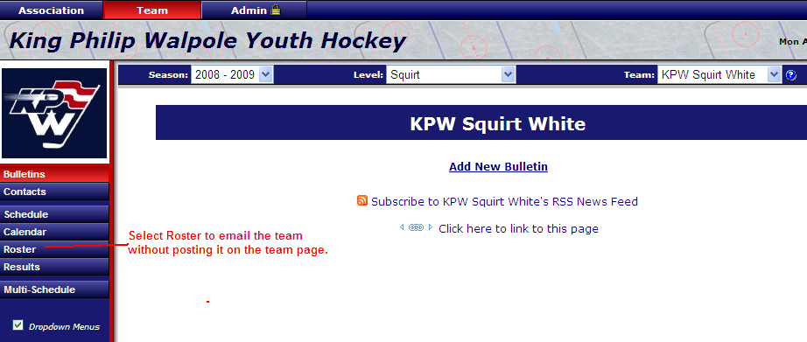

- Next Select Email the Team:

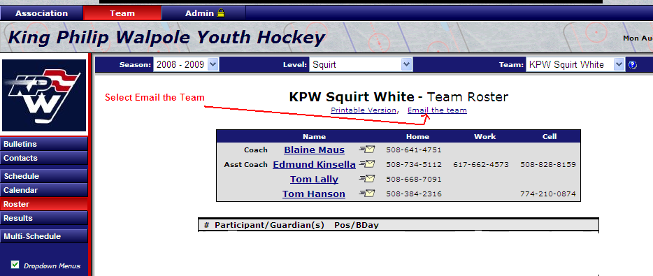

- Now enter your email and click Submit

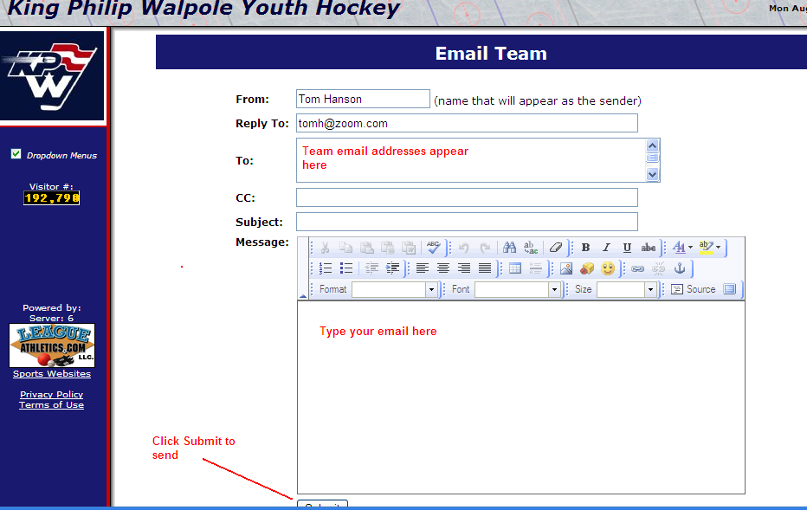

Adding additional Email addresses

Members of your team can now add additional email addresses to their account. Instructions on how to do this can also be found by clicking on the documents tab on the KPW website.

To edit your account settings:

- Select Edit My Account from the left hand menu on the KPW website.
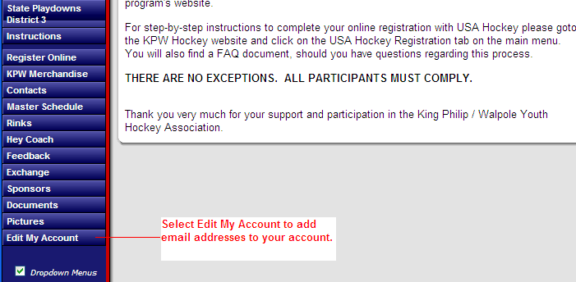
- Sign into your account using the same email and password you did to register your player. If you forgot the email address you used contact KPW’s Technology Coordinator and he can look it up for you. Contact information for all board members is found by clicking on the Contacts tab on the main page.

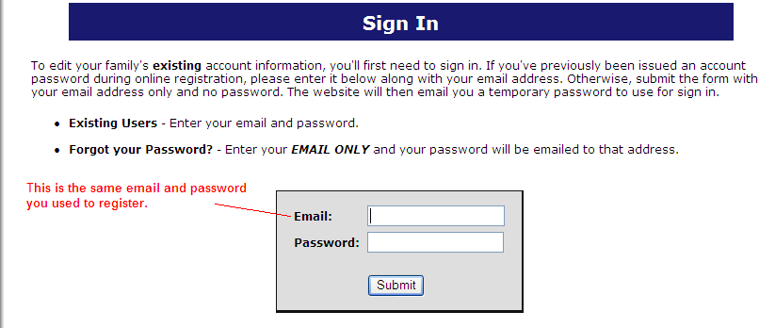

- Select your name to update the email address

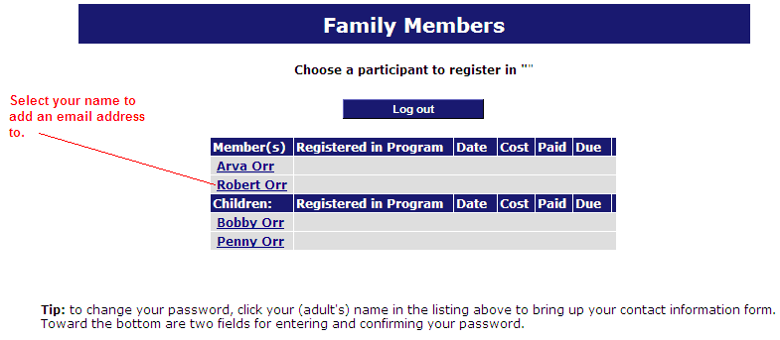

- On the participant information page you can now make any changes you wish such as adding a new email address, setting reminders for practices and games, or receiving changes via text messages. If you are adding a new email address separate the emails by a comma. (e.g b_orr4@verizon.net, orr@bruins.com ). Click submit at the bottom of the page to save your changes.
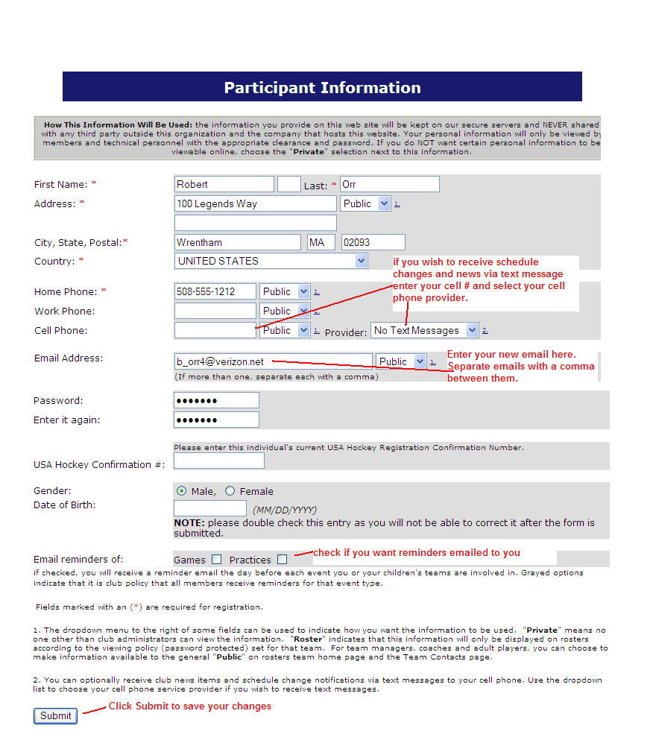

Don’t forget to submit your changes in order to store them.

Viewing your Roster

By selecting Roster from your team page you are able to see contact information including emails and phone numbers for each player on your team.
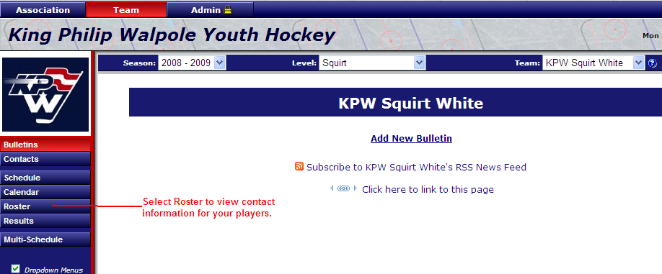

Entering Game Results on your Team Page

You can enter the results for each game your team plays as well as a short summary of the game from your team page. Your games will not appear on the results page until their scheduled time has passed.

If you wish to add the results for Tournament games, State Playdown games, exhibitions, etc. you will need to have the game added to your schedule. To do this send an email to either KPW’s Ice Coordinator, or Technology Director (Webmaster) to add the game to your schedule. Their contact info can be found from the main page by clicking on Contacts.

To Enter the results for a game click on the calendar next to the game:

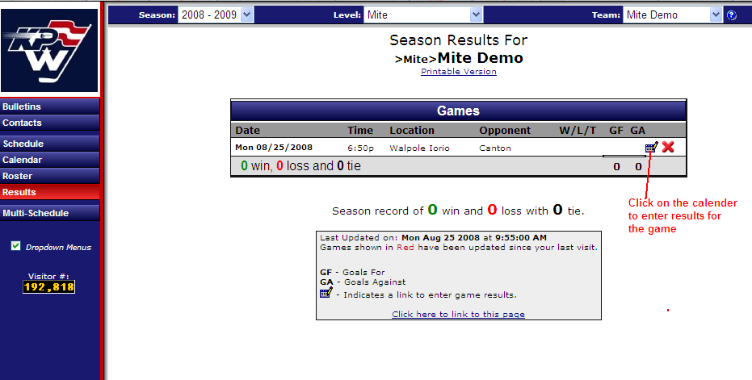

Next enter the score of the game and a short game summary(optional) and click submit:

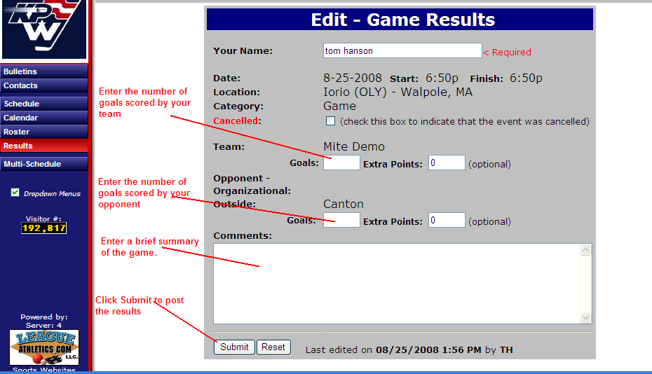

The results should now appear on our team page.

Adding Pictures to your Team page

We strongly encourage coaches and managers to add pictures to your team page. Its a great way to drive traffic to your team page plus players enjoy seeing the photos when they log on. Many teams don’t end up getting pictures posted until they play in a tournament. Encourage your parents to take some pictures during the games or try to get the team together early in the season for a team picture.

If you wish to get your pictures posted on the main KPW web page send it along with a brief description to the KPW Technology Director or another board member to get it posted. Contact information for the board members are available from the Contacts button on the main page.

To post a picture on your team page do the following:

Click on the Pictures button on the Left hand side of the screen, you may need to click on the admin button on the top of the screen to return to the admin page:

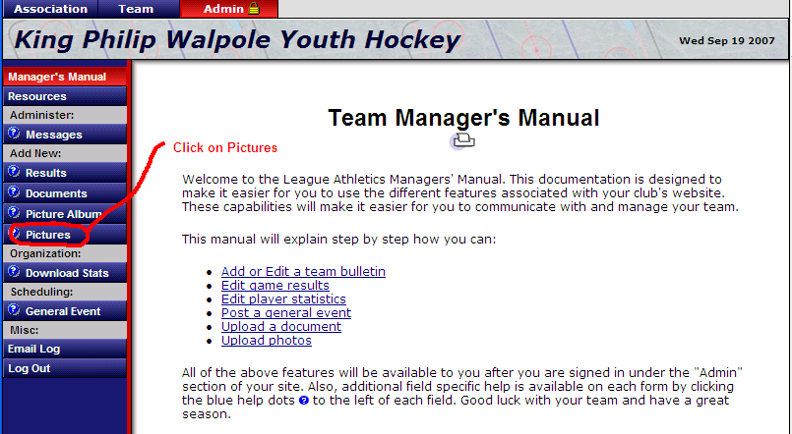

Select the Browse button to find the picture on your PC.

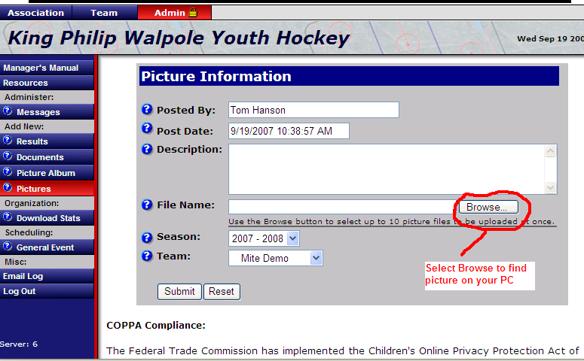

Next enter the description that you want to appear underneath the picture on your team page. Do not use any player’s full names in the description.

Click on Submit to upload the picture to your team page.

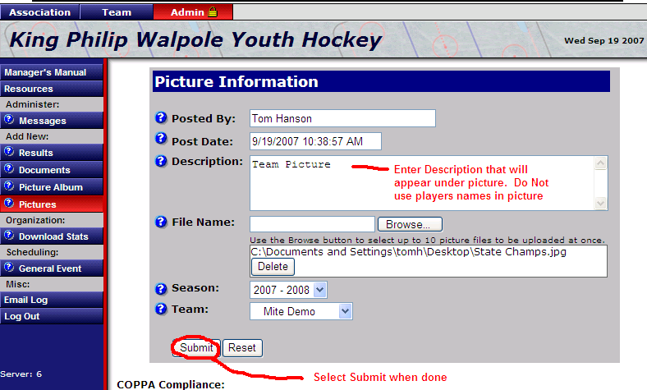

If you make a mistake and wish to delete the picture

- Click on Team at the top of the page to bring you to your Team Page
- On the left side of the page click on Picture. Note that the Picture button only appears in the left hand menu if you have loaded picture(s) onto your Team Page.

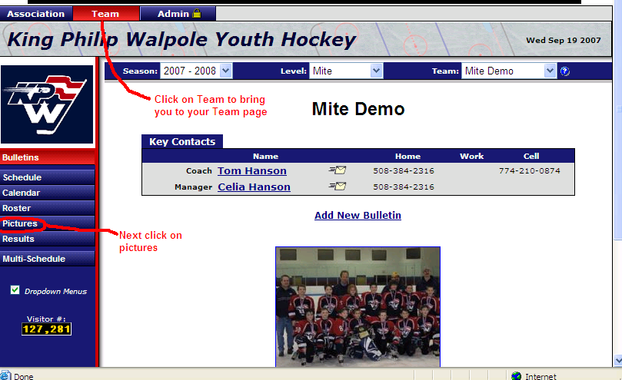

- Next click on the red X to delete the picture on the page. If you have uploaded multiple pictures to your Team Page all the pictures will appear.

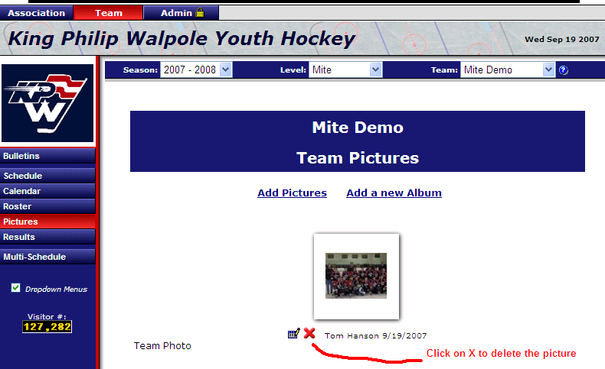

A few other notes:
- If you post multiple pictures then people will see a different picture each time the go to your Team Page
- The edit button next to the red X can be a bit flaky. If you want to make a change to the description it might be easier to delete the picture and upload it again.
- You can use the picture album feature to organize multiple pictures of an event.

Scheduling General Events

You can use the general events button to schedule non game type activities. For example if you are having a team get together you can add it to the team calendar using general events. Any event you wish to show up on your team’s calendar or on your team’s schedule page is added through General Events. For example, you can use it to remind people of upcoming deadlines such as getting money in for an upcoming tournament.

If you want to add a game that is outside of your normal schedule, such as a State Playdown game, a Tournament game etc. you should ask either KPW’s Ice Coordinator, or Technology Director to add the game to your schedule so you can add results.

To schedule a general event:

Click on General Event from the admin page:
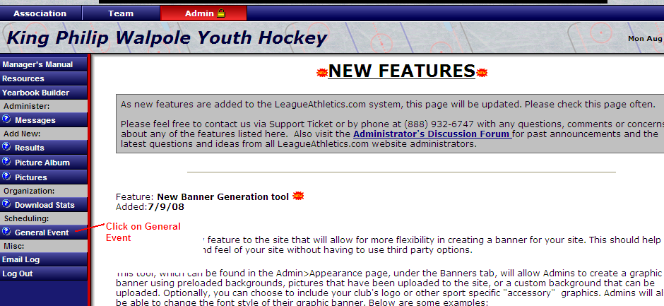

The General Event screen appears. Fill out the information for your event:

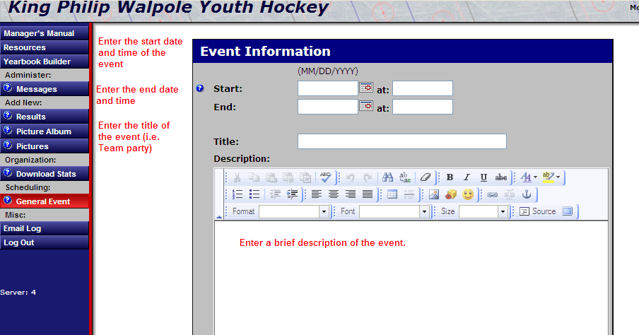

Enter the remaining info:

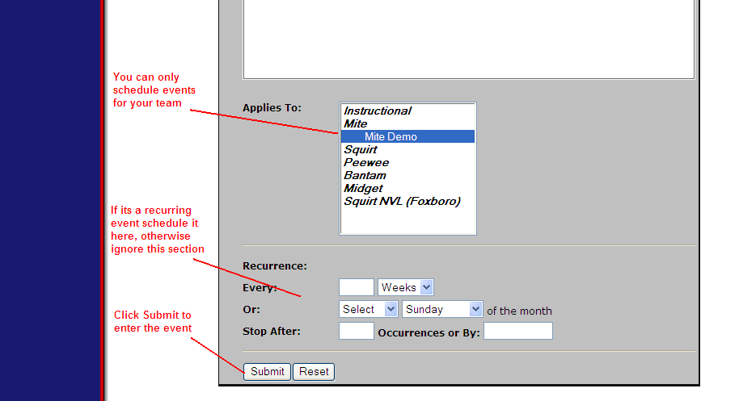

If you wish to change or delete the event after you have entered it click on Schedule to bring up the schedule. From this page you can delete or edit an existing event.

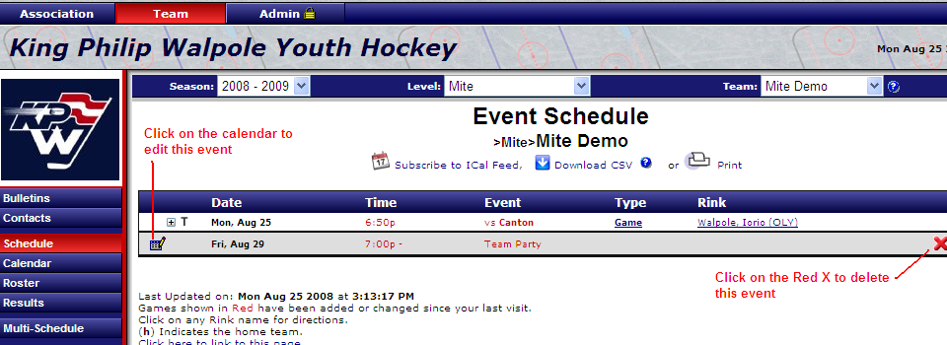

Download Stats

KPW does not support downloading or tracking statistics for each team.

