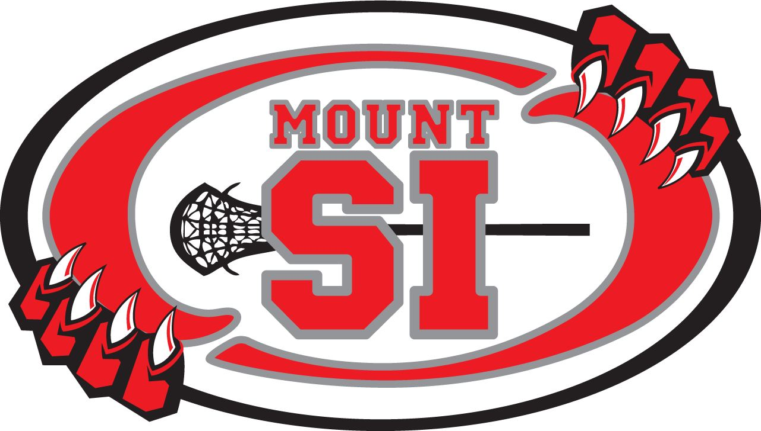
2020 Mount Si Lacrosse Club
OFFICIAL USE ONLY

$200 Deposit Ck#_________ _________
(initial)

Jersey #: ____________

Notes:
Uniform Check Out / Return Form
(Please Print)

_______________________________________________________
Player Name

_______________________________________________________
Parent/Guardian Name

_______________________________________________________
Contact Phone:

Team: (Circle One)

BOYS: GIRLS:

2/3/4 U9
5/6 U11
7/8 U13
HS U15
HS

UNIFORM RECEIVED CHECKLIST:

Jersey Pinnie (n/a for Boys HS) Shorts

Parent/Guardian Agreement:

“I acknowledge that I have received the above noted uniform pieces, will care for the uniform pieces properly and return them at the end of the season in compliance with MSLC check-in procedures at which time my deposit will be returned. I accept financially responsible for the uniform pieces. If ALL pieces are not returned, I will forfeit my $200 deposit.”

________________________________________________________ __________________________
Parent/Guardian Signature Date

Page 1 of 1 MSLC Document created 01292018

