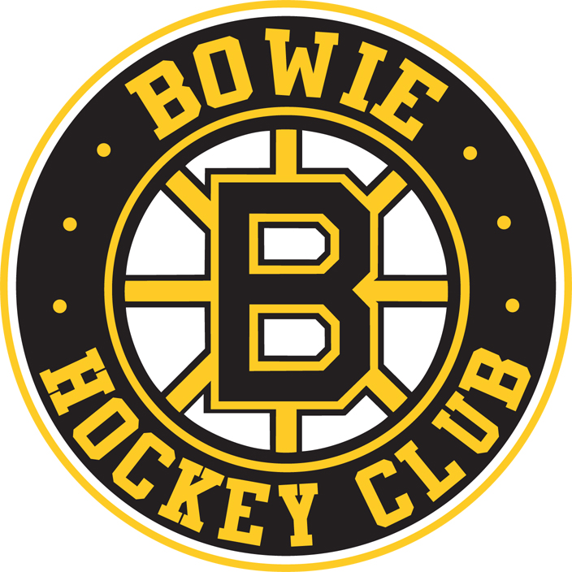

Bowie Hockey Club Board of Directors Meeting
July 2012 Minutes

Present: Carl Ousler, Mike Alfaro, Tabby Chesnick, Scott Pridmore, Janel McFadyen, Amy Richardson

Absent: Joe Loschiavo, Chris Hinkson, , Randy Richardson, Carrie Robertson

Guest: Darren Bruenig

Call to Order: 7:10 PM

Motion to approve June minutes. Mike, Amy second, all in favor.

Board Member Reports:

- President
Supplemental Tryouts – August
No Golf outing for Clun in the Fall.

- Vice President of Travel
USA Hockey Congress Update– *See attachment

- Vice President of Recreational
No Report

- Vice President of Finance
June Financial Report presented

- Director of Membership/Treasurer
Will work on scheduling a concussion review session for Coaches
Working on USA Hockey numbers – In system by August 15

- Director of Special Events
President’s Day Tourney – Should it be changed to a Mite Jamboree to make it a more feasible event for the club?
Open House - September

- Secretary
Manager Books almost completed
Will schedule meeting late July to review
Birth Certificates Organized by year

- Director of Sponsorships
No Report

- Scheduler
Waiting for Tucker and Wells to respond with ice times

- Director of Coaching
No Report

- Equipment Manager
No Report

- Webmaster
No Report

- New Business

- Old Business

Motion to Adjourn: Michelle, 2nd Phil

Meeting Adjourned: 8:29 PM

Note: The next Bowie Hockey Club Board of Directors meeting will be held on August 9th, 2012, at 7:00 PM in the meeting room at the Bowie Ice Arena.

*Attachment below:

The USAH Board formally adopted a legislative proposal to recognize the American Development Model as USA Hockey's model program recommended guidelines. http://usahockey.cachefly.net/Meetings/2012ACYouthCouncil&PlayerDevelopmentCommittee3.pdf

For Mite age hockey the Board unanimously adopted a ByLaw proposal that states that the age appropriate standard playing surface for 8 & under hockey is cross-ice or half-ice. Recognizing that various affiliates are at different stages of adopting Mite ADM guidelines the adopted ByLaw provision went on to state that "Effective for the 2013-14 playing season, but subject to limited exceptions as are approved by the USA Hockey Player Development Committee, all games and scrimmages at the 8U age level shall be played either cross-ice or half-ice, or on a playing surface that is equal to or less than the dimensions of cross-ice or half-ice." Each Affiliate was directed to enact rules and regulations to implement the transition to cross-ice and half-ice for 8 & Under players by September 1, 2013.

I believe our current Affiliate Rules meet the requirement of the newly adopted USA Hockey ByLaw provision. Attached is a copy of the specific Mite ADM ByLaw provision that was adopted at the Annual Congress. Please review your club's plans to make sure that you will comply with the USA Hockey Mite ADM Guidelines.

There was another ByLaw Provision that was adopted that may require some review and discussion at the Affiliate level. As you know the age classifications for youth and girls hockey had been
8 & Under, 10 & Under, 12 & Under, 14 & Under etc. One of the adopted ByLaw provisions (copy attached) changed the wording of the age classification to:

8 & Under - Mite
9 & 10 - Squirt
11 & 12 - Peewee
13 & 14 - Bantam etc

The adopted provision went on to say that "A youth or girls player may play on a team in an older classification only if the applicable Affiliate's rules or decisions, and the applicable local program's rules or decisions, permit that player to do so." The Affiliate has no current rules on playing up. I would recommend that you look at your club's policies on playing up to make sure that it states the policy you are currently following in the club. If you have any thoughts on wording that the Affiliate should consider for an Affiliate rule or policy on playing up an age level please let me know.

USA Hockey in concert with the US Olympic Committee has been reviewing policies regarding background screening and the need for other policies to make sure that our players are safe both on and off the ice. Attached is the USA Hockey Safesport Program Handbook. One change made in the Screening Program is that USA Hockey now requires the Affiliates to re-screen coaches, volunteers and employees with access to youth participants every two (2) years. Those individuals that require screening must be screened prior to having access to youth participants.(page 22).

The listing of Affiliate coaches and volunteers with a current background screening is at http://www.usahockey.com/Screened_Coaches_Volunteers_Database.aspx
You can search by last name, do a search for all coaches whose last names begin with a specific letter of the alphabet (A%), or obtain a complete listing of all currently screened coaches and volunteers by entering % in the search field. Any screenings done from this point forward will be for the 2012/13 season.

I suspect that most clubs have their coaching line up set for the 2012/13 season. Please compare your coaching list for the 2012/13 season to the screened coach/volunteer listing and have any coach without a current screening complete the required background screening before the start of the season. Coaches and volunteers that need to complete a background screening can complete the online application at http://www.usahockey.com/Screening_Consent_Form_-_thru_Dec_31.aspx

Please also review the Safesport Policy on Travel (page 13) and Billeting (page 15). Remember that your teams must have supervision of the team locker rooms (page 11). The Social Media, Mobile and Electronic Communications Policy (page 12-13) should be reviewed and guidelines established within your club on the appropriate methods of communicating with players. Are you able to have a secure method of communication for teams through your club web page? Emails and text messages to a minor player should be copied to the parent. Coaches are prohibited from having minor players join their personal social media page.

There will be Online Education and Awareness Training that will be posted shortly on the USA Hockey web page. Each local program will need to have at least one representative complete this online training. (pages 17-19). Coaches and officials will view training videos through the coaching clinics and officials seminars. There will be online educational and awareness videos available for parents and players on the USA Hockey web page.

If your club uses team drivers (i.e. rent a van and has the coach or team manager drive players on road trips) we will need to discuss how to best do a driving records search for that team driver(page 22). Let me know if your club uses a team driver.

There is a clear statement in the Handbook on a reporting policy in ay situation of suspected abuse(page 25-28).

Some dates to remember:
Welcome Back Week - Sept 17-23
Girls Hockey Weekend - October 13 & 14
Try Hockey for Free - November 3

If you do not receive the USA Hockey Tape to Tape Newsletter you can register to receive the newsletter at
http://usahockey.com/about_usa_hockey/Tape_To_Tape_Archive.aspx

USA Hockey has been working with a supplier to provide discounted hard rink divider dasher boards! These heavy duty dividers are quick and easy to assemble and install on the ice. The hard dividers come with a cart for movement and storage. The hard dividers make cross-ice or half-ice games easier with rounded corners.

The USA Hockey Final Registration Report for the 20011/12 Season can be reviewed at http://usahockey.com/uploadedFiles/USAHockey/Menu_Membership/Menu_Membership_Statistics/11-12%20Final%20Reports.pdf

If you have any questions give me a call.
John Coleman
PVAHA
703-220-5126

