Downloading or Viewing Registration Programs:

STEP 1: How to Download Registrations
1. Go to www.veronalacrosse.com
2. Sign in
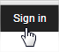
3. Click on Admin
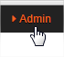
4. Go to Members, Registration
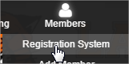

5. Click on the applicable registration program
On the right, click on List or Download
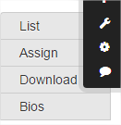
List will provide you a listing of the registrations
Download allows you to download to a CSV file, which can easily be saved to an EXCEL File. The download file will give you all the registration information, including emails, phone numbers, etc. See step 6 for report template for downloading. You can also build your own report data or download ALL data by simply leaving “default” in the Choose Report option below.

6. If Downloading, there will be several preloaded templates that will have “2017” at the front, including 2017_Holiday_Break_Clinic. If there is an applicable template, select it, and then click Save & Download. Alternatively Save & Download will download ALL fields in the registration program. You must click on Save & Download to get the report to generate.

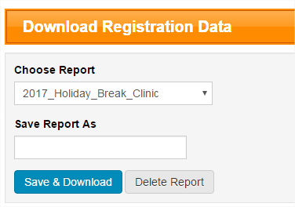

7. Your report will download to a CSV file. Click to open, and you can re-save as an Excel file
8. This report will contain all the player data you need for registrations.

