On the home page, login (found in the top right corner) using the credentials sent to you.
Click or hover over Adminster, then Scheduling, and select Recurring Games as shown below.
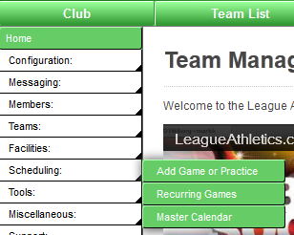
The following picture shows a form that will create a practice for the BU12C team every Friday starting on September 7, 2012 and ending on November 2, 2012. The practice will be held at Russell St A field from 6-7 PM. Once you press submit you should check your team schedule (while logged in) and remove any dates that do not belong, e.g. holidays.
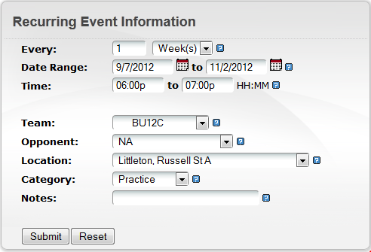
If you need to remove any practices (holidays), simply click the red box with the white x mark to delete the practice. You will need to confirm the deletion and decide if a notice should be sent.
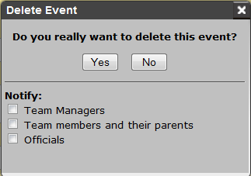
Now your season schedule should be all set.

Sunset Times
As the fall season progresses, the days get shorter. The sunset calendar on the right side of the www.LittletonYouthSoccer.org home page may be useful as you plan your season. There is usually enough light to continue practice about 15 minutes past sunset, but not quite as late as the end of civil twilight. Here is a general guideline:

Week of | End practice by
September 2 | 7:20 pm
September 9 | 7:10 pm
September 16 | 7:00 pm
September 23 | 6:45 pm
September 30 | 6:30 pm
October 7 | 6:20 pm
October 14 | 6:10 pm
October 21 | 6:00 pm
October 28 | 5:50 pm

