All Bats used at Oregon Park must have this USA Baseball Stamp beginning with the 2018 Spring Season.

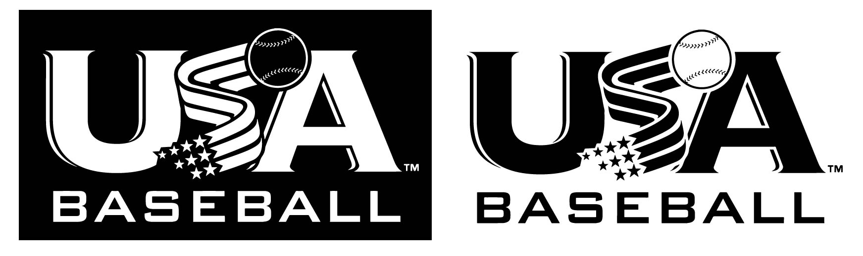

Why the change to a wood-like standard? USA Baseball’s national member organizations believe that a wood-like performance standard will best provide for the long-term integrity of the game. The new standard will not have a drop-weight limit, so young players can use bats made with light-weight materials.

Why not just use wood bats? Wood is a scarce resource. The new bats will be designed to perform much like wood, where its performance will be limited to the highest performing wood.

Why is USA Baseball involved? The national member organizations asked USA Baseball as the national governing body to take the lead in this process to establish a new standard. Many other national governing bodies set and enforce standards for the equipment in their respective sports. To that end, USA Baseball established a Bat Study Committee of leading scientists and conducted theoretical modeling, field testing and lab testing. The committee shared its findings with the national member organizations, who then endorsed the new USABat standard.

How will I know which bat to buy? All new bats that bear the USABat stamp (shown above) will be permissible for play in the leagues and tournaments of the participating youth baseball organizations. A full list of certified bats can be found at usabat.com (Approved Bat List tab). However, you are safe to purchase any bat that has the stamp as shown at the top of this page.

Are wood bats still allowed? Yes. Solid, one piece wood bats are approved for use under USABat with or without the USA Baseball Certification Mark. Multi-piece and composite wood bats must feature the USA Baseball Certification Mark to be approved for play.

Does the standard impact Tee Ball? Yes. Under the USABat standard, certified tee ball bats will feature the USA Baseball mark and text

Can I use a Tee Ball bat that does not feature the USA Baseball mark? All Tee Ball bats must feature the USA Baseball mark and accompanying text. Tee Ball bats that were produced and/or purchased prior to the implementation of the new standard can be certified using an Approved Tee Ball Sticker via the USA Baseball Tee Ball Sticker Program – which can be purchased at usabat.com (Tee Ball Stickers tab).
Where can I purchase a USA stamped bat? You can purchase a bat at many places. Oregon Park encourages you to consider our sponsor partners, DBat West Cobb, or Dicks Sporting Goods. Oregon Park day is scheduled for Sunday January 28th at Dicks where parents will receive a discount on their purchase. More information will come via email about OP Day at Dicks.
How much will I spend? Just like the old bat standards, prices vary. You can find a bat priced anywhere from $50 and up.

