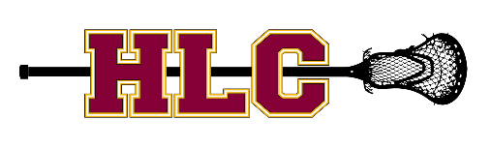
The HLC Program will post pictures of participants on its website, Facebook and Instagram accounts, and in online and print publications. The HLC Program will not intentionally identify the names of minor children participating in the program.
You hereby authorize and consent to the use of your participant’s visual image by the HLC Program for purposes, including but not limited to: photography, videotape, electronic and print publications, websites and social media.
You hereby release and hold harmless the HLC program from any reasonable expectation of privacy or confidentially, from liability for any clams associated with the images mentioned above.
You give permission to the HLC Program to use the image of your participant for the purposes outlined in this photo release.
If you do not want your participant’s picture(s) to be included as part of the outlined use above, you must sign the opt-out form at the bottom of this letter and return it to the HLC Program, by April 1, of this season. If you do not express your preference, you are giving the HLC Program permission.
If you have any questions, please feel free to contact either of us or the Executive Board.
Sincerely,
HLC Board
---------------------------------------------------------------------------------------------------------------------
Opt-Out Form

Do not photograph my child during the lacrosse season for the purposes outlined in the release.
_______________________________ ___________________________________
Participant’s Last Name Participant’s First Name

_________________________________ ___________________________________
Parent’s Last Name Parent’s First Name

