Men's Lacrosse: Defense
AddThis Sharing Buttons
Share to TwitterShare to FacebookShare to Google+Share to More
Grades: 3.0 GPA + 24 ACT + 1000 SAT (out of 1600)
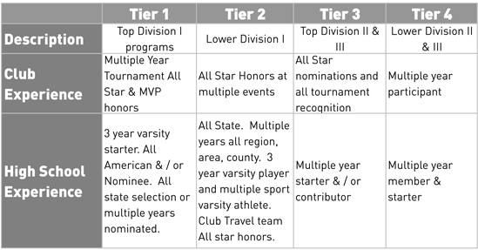
Tier 1 Defense
Physical Measurables:
- 6'2"
- 215 lbs
NCSA Expert Notes:
Can take over a game or the player they're covering. Great on-ball skills and the commander of the defenders around them. Handles the ball often and a threat in the clearing game. Always covering the top offensive player for the other team with great results. A great mix of physical presence and technical skill.

Tier 2 Defense
Physical Measurables:
- 6'1"
- 205 lbs
NCSA Expert Notes:
Steady influence on the player the are covering. Steady mix of GB play and 1 vs. 1 defense. Shows flashes of being the top defensive player on the field. Can cover the top tier offensive threats. Great athletic ability.

Tier 3 Defense
Physical Measurables:
- 6'0"
- 190 lbs
NCSA Expert Notes:
Solid athlete who is a steady contributor. Handles the ball often and fins roles they succeed in. Can cover solid offensive threats and performs well.

Tier 4 Defense
Physical Measurables:
- 5'10"
- 180 lbs
NCSA Expert Notes:
Steady contributor in team concepts. Good athlete and help defense. Uses their advantages very well, and really helps out with communication.

