Chatfield Girls Softball Invites you to our Poker Fundraiser!

August 22, 2015
$40.00 Donation Cash/Check at the Door
$20.00 Additional Re-buys are allowed.
Prizes for the top Four Finishers
Door Prizes and Door Prize Tickets for Sale $1 for one ticket or 7 tickets for $5

Check in from 5-6 pm Cards fly
At 6 pm
Hosted by: The Mirage Sports Bar
8340 W Coal Mine Ave,
Littleton, CO 80123
303-979-9220

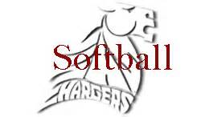

Bring your friends, neighbors, and co-workers!
No Experience necessary. It is a great time all the while supporting the Chatfield Girls Softball program. Food and Drinks are available from the Mirage throughout the night. Hope to see you there!! Dealer/Players Needed

