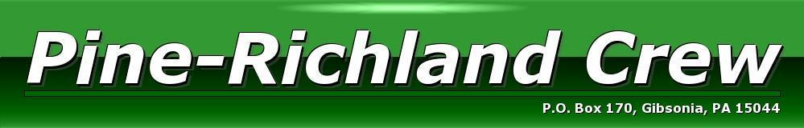

January 1, 2019 EIN#54-2119474

Pine Richland Crew Boosters is a non-profit 501(c)(3) organization supporting the athletes of Pine Richland School District in Gibsonia, PA. The team receives very little financial support from the local school system and solely relies on member dues and fundraising for equipment, uniforms, coaching salaries, and all operating expenses.

Your donation will benefit the team by funding the operational costs while keeping registration costs low to allow more students from the district to join crew.

SPONSOR

________ Friends of PR Crew $200 (Includes name on Crew website, honorable mention at
all fundraising events.)

________ Bronze $500 (Includes name on Crew website, honorable mention at fundraising
events and 1 ½ inch name displayed on t shirts worn on race day.)

________ Silver $1000 (Includes the above and signage on sponsor banner displayed at all
races on our PR Crew tent.)

________ Gold $2,500 (Includes the above, and your logo or name on our travel food wagon.)

Sponsorship payment

- Check payable to “PR Crew” mailed to:
P.O. Box 170
Gibsonia, PA 15044
- Contact Carrie Catalano- ravcarrie@yahoo.com for questions.

Harmony, balance, and rhythm. They’re the three things that stay with you your whole life. Without them civilization is out of whack. And that’s why an oarsman, when he goes out in life, he can fight it, he can handle life. That’s what he gets from rowing.
George Yeoman Pocock

