LEAGUE ATHLETICS USER GUIDE

ALL USER INFORMATION

LOGIN INFORMATION

Go to www.b&bbasketballacademy.org
You must be assigned as a manager/coach to have access
Contact Jacquie Pearson at jacquiepearson@yahoo.com if you are not assigned properly.

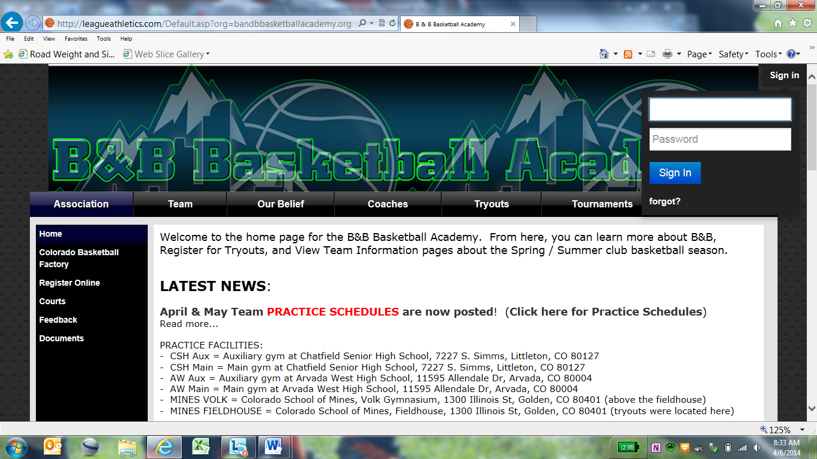
Click Sign In. Enter your account email address in the top box, your account password in the second box.
Click “admin”. Click on “scheduling”. Click on “add game or practice”

ADDING A GAME/PRACTICE

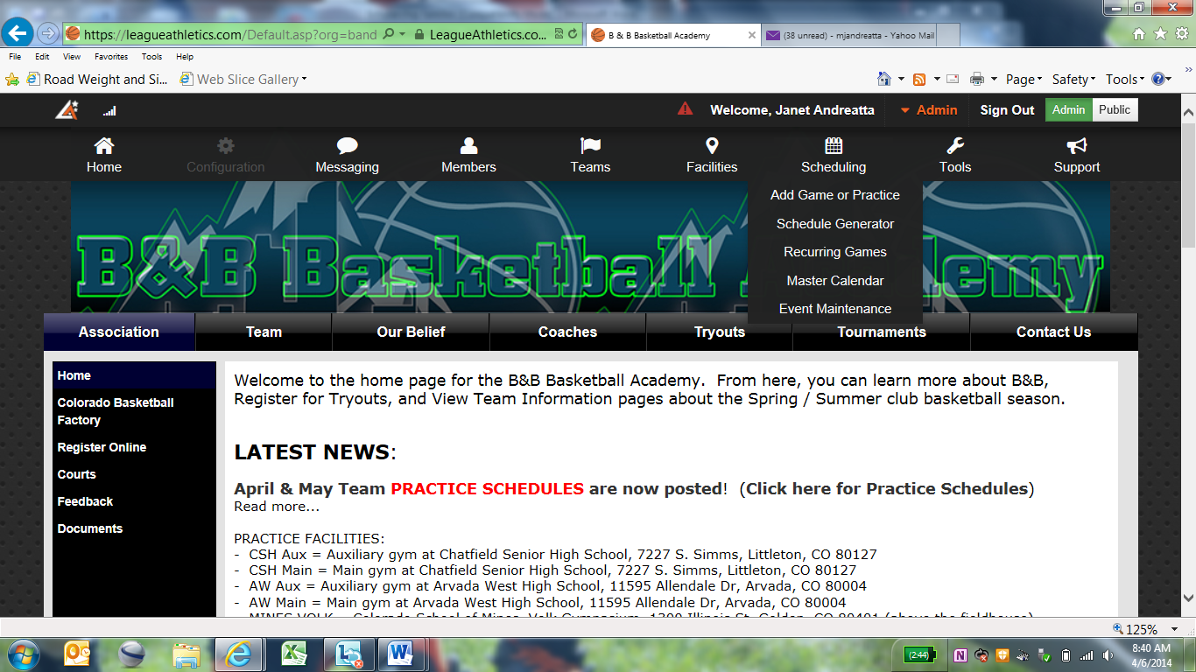

Click “add a game or practice” to add a single event

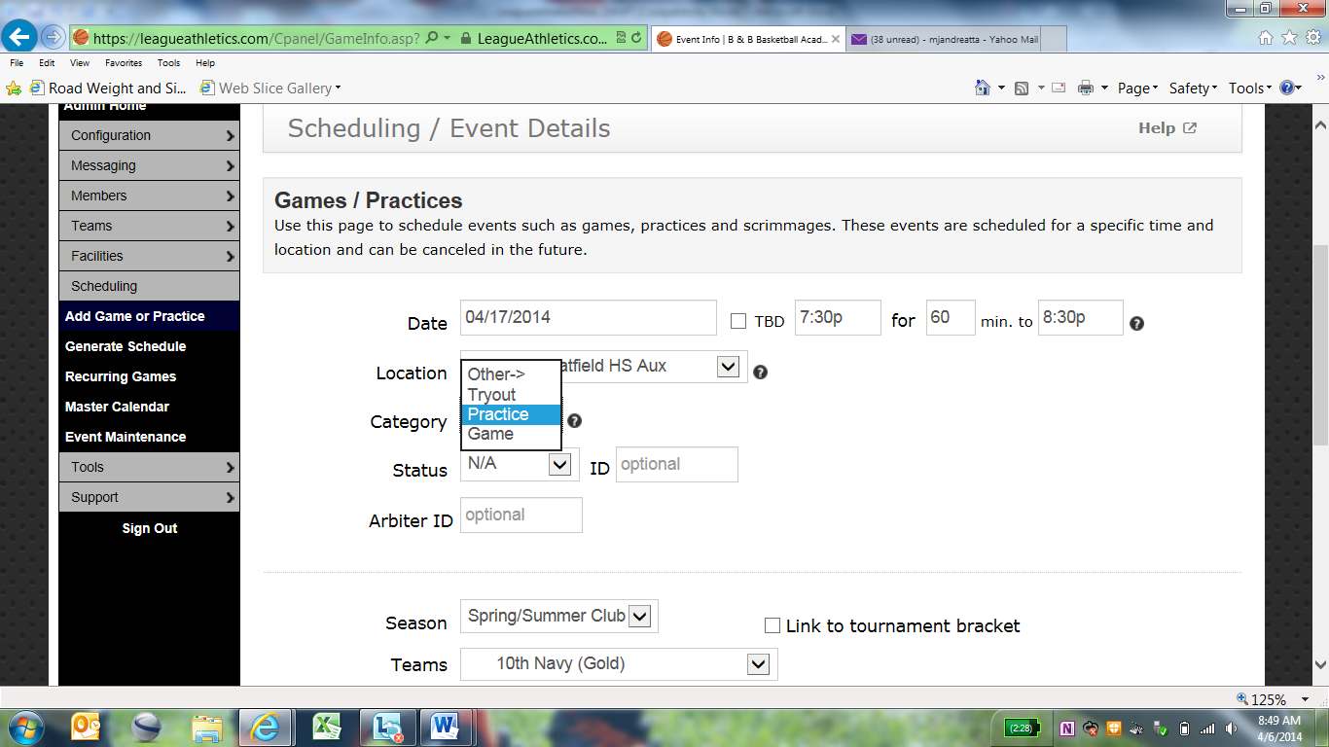
Choose the time and determine the length of event
Choose your team
Choose your event

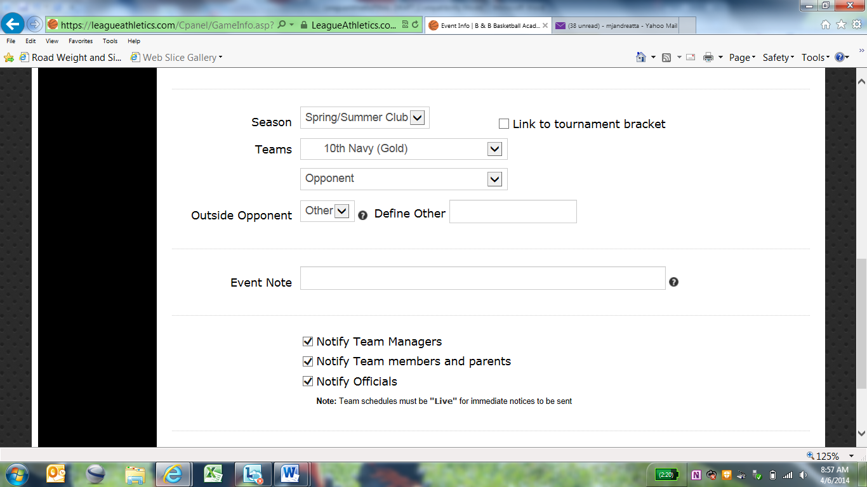
Uncheck the notify boxes. They will still receive the notification 2 days before event occurs.
Choose your opponent if they are listed, or choose “define other” to insert team name. With many outside clubs, they may not be listed until you define them the first time you play them.

Or click “recurring games” if you have a recurring practice or if you would like to block out dates for upcoming tournaments.
Choose frequency of recurring event (i.e. every Monday, choose every 1 week from April 7 to May 26) or (every one day from April 12 to April 14)
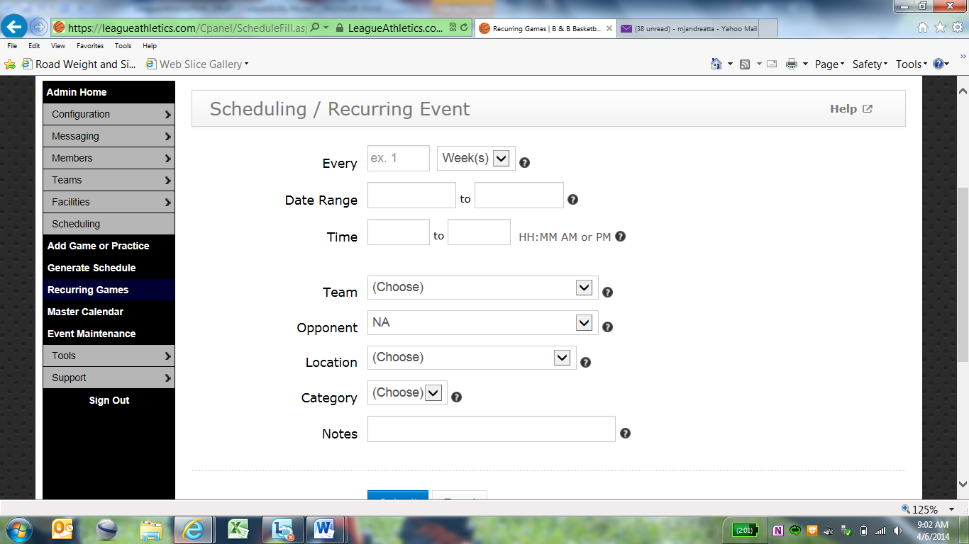
Choose practice (or game for tournaments)
Choose location and category. If your location is not listed, please contact Jacquie Pearson
List start time and end time

POSTING PICTURES
Click the red admin icon. Put cursor on “tools”, click “picture manager”

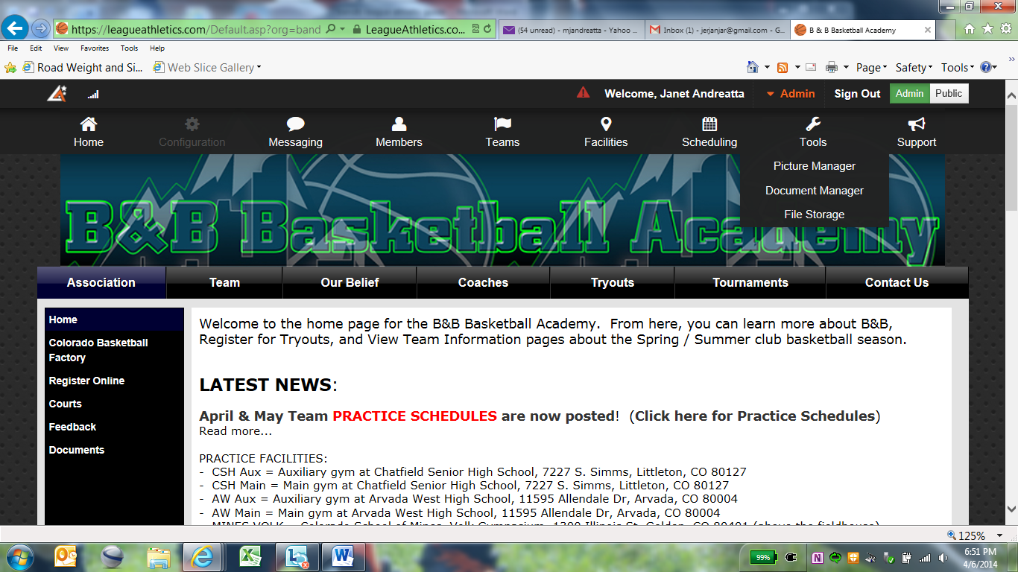

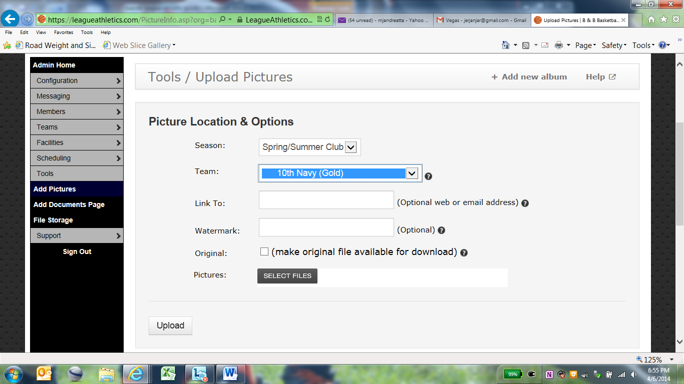
Choose your team
Click “select files”. Select your picture. Hit upload.

Please keep in mind that there are privacy issues if the child’s face or name on the jersey is visible and may require parental approval.

Click the red admin to bring up the menu. Put cursor over “teams”, click “enter results”

POSTING SCORES

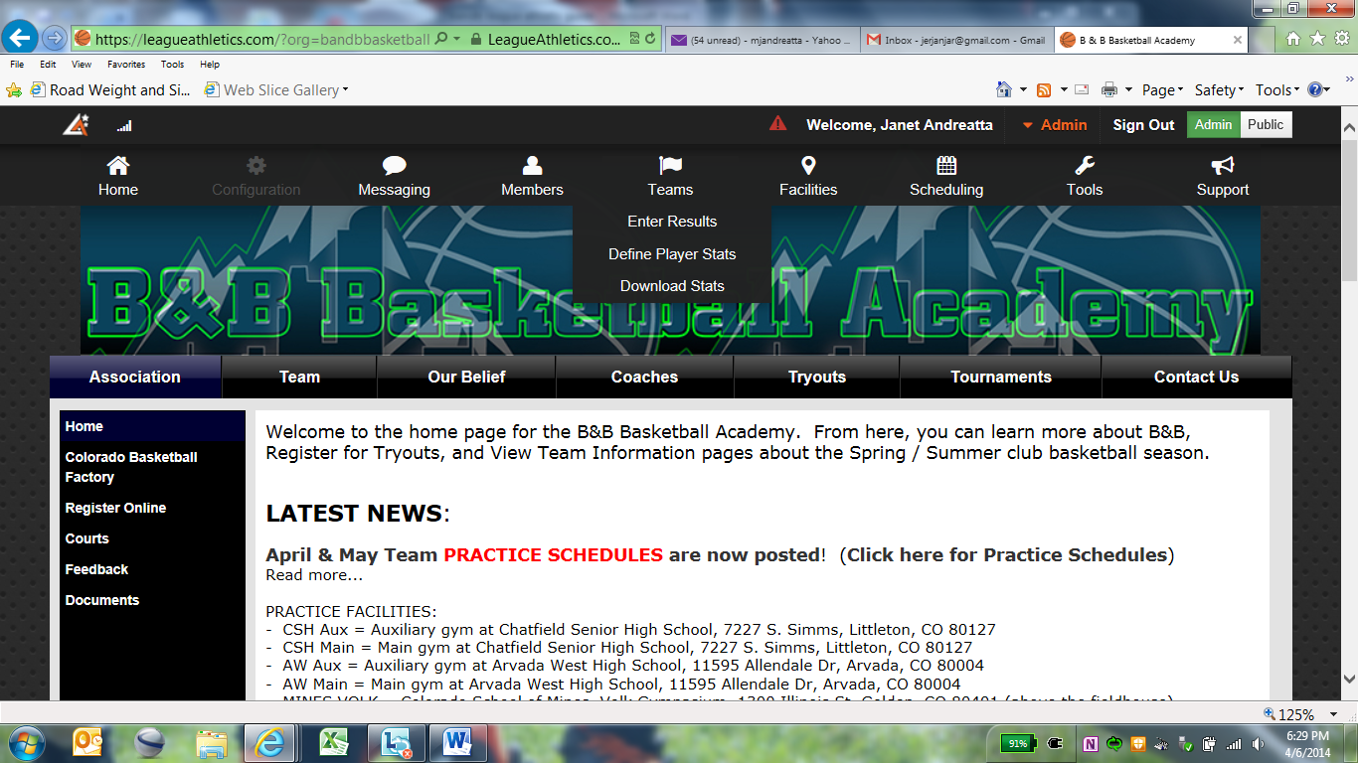

Games played will show on the next screen. Enter your score and opponent score.

POSTING A TEAM BULLETIN

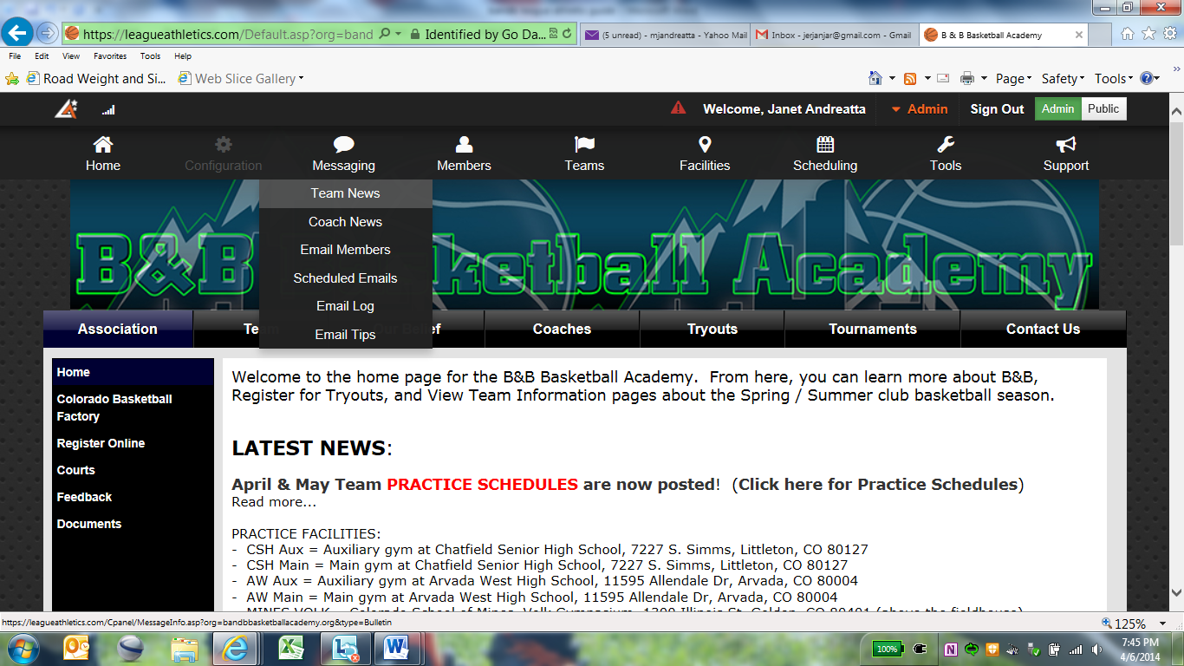
Click the red admin to bring up the menu. Put cursor over “messaging”, click “team news”

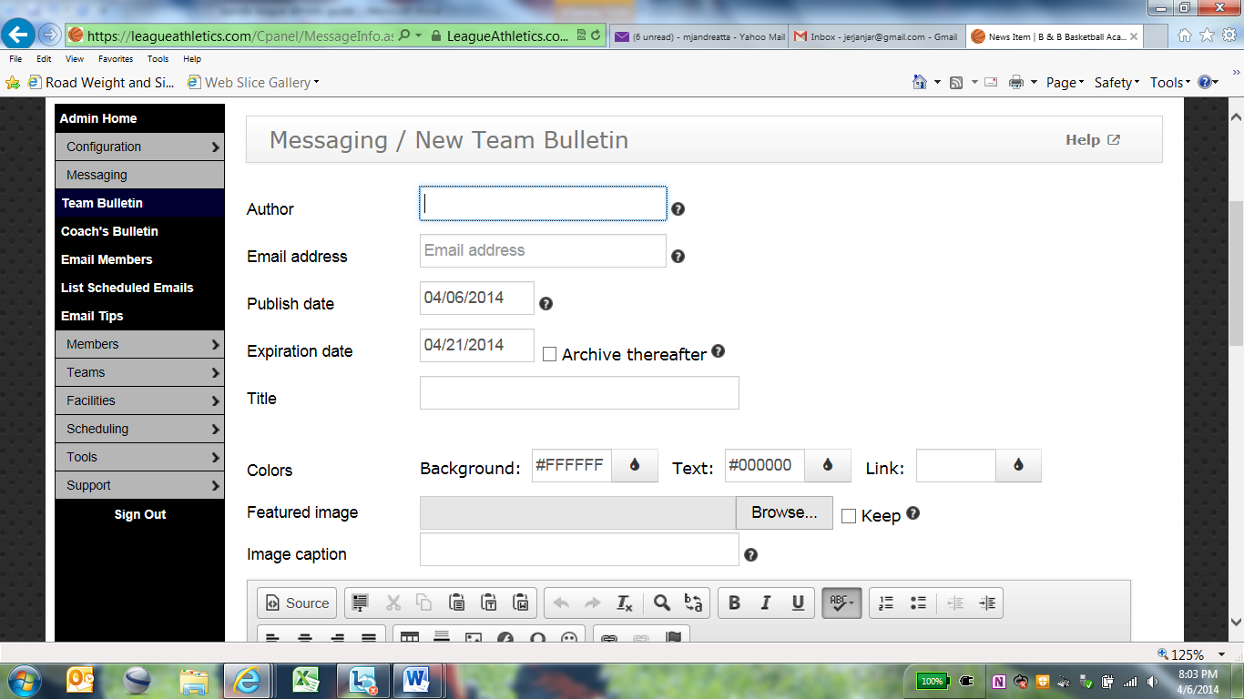
Enter a title that will show as the header for the team bulletin.
Enter “publish date” as the date to begin post, and a date that you would like the posting to be removed from the team’s home page in “expiration date”. If you would like the posting to be available but hidden, click “archive thereafter”
Enter your name as “author” and your email address.
If you have a jpeg file that you would like to show in your bulletin, click here to load image
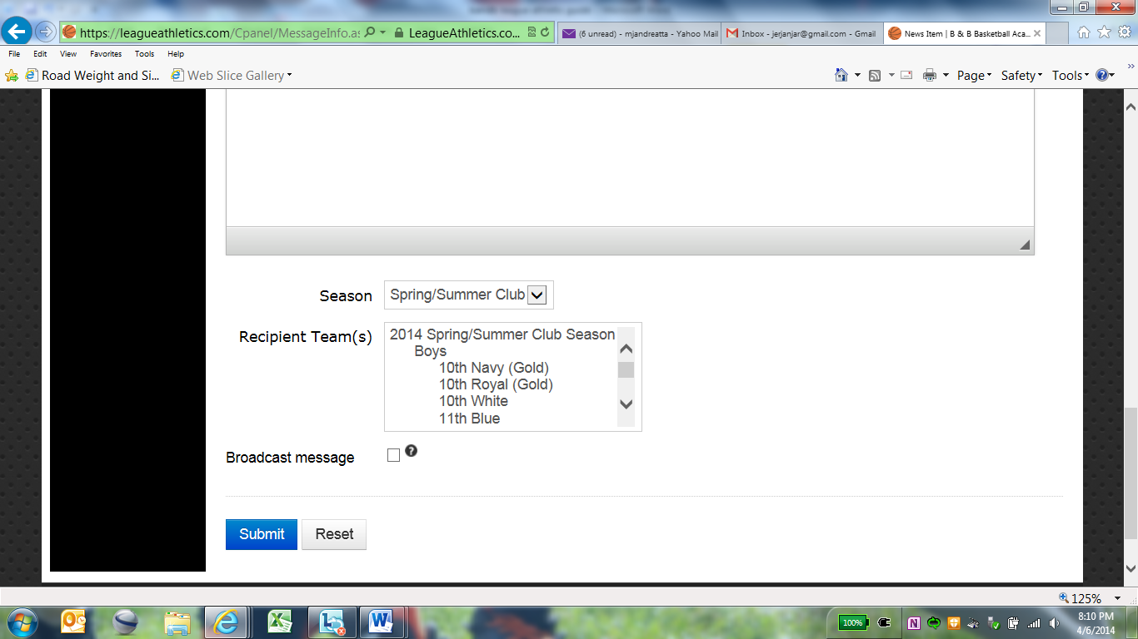
Click to select your team
Enter content of bulletin
If you would like bulletin sent out as a broadcast message, check box.
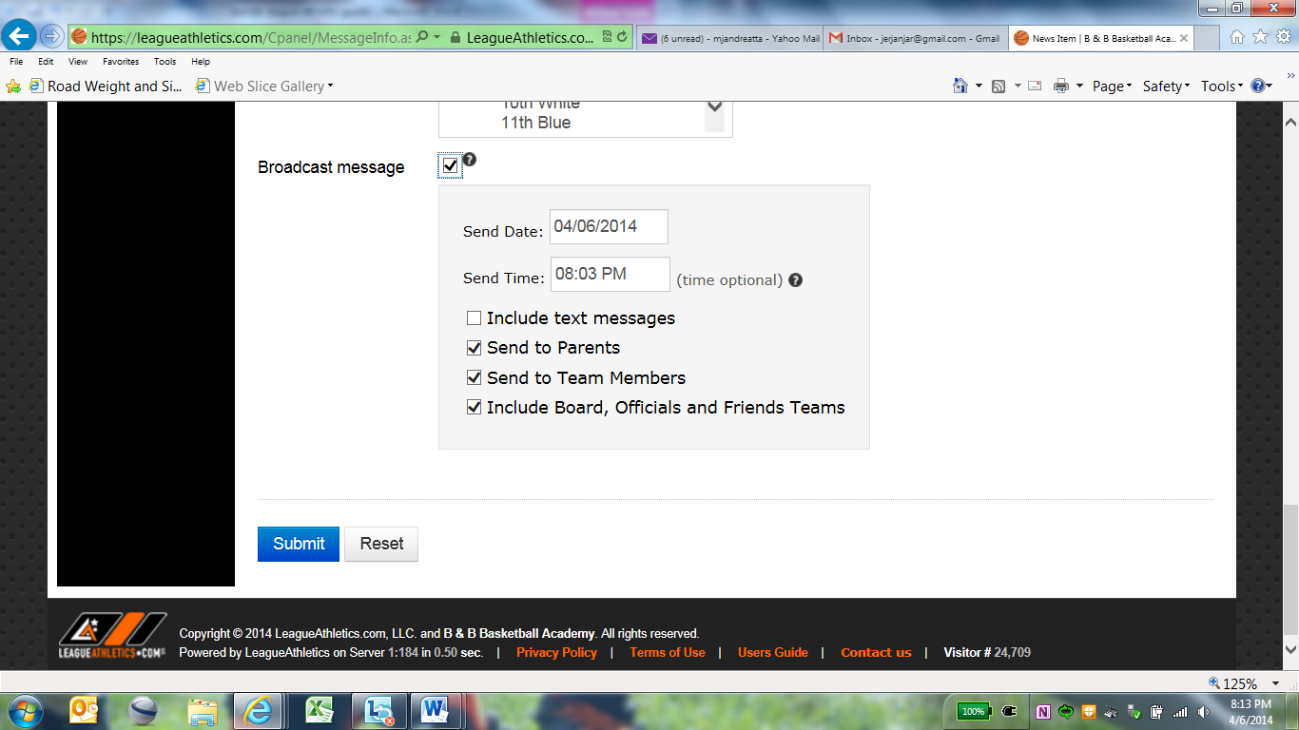
Click submit.
Select message details including date/time and recipients. Text messages will only go to members who have selected a “carrier” in their account profile.

EDITING AN EVENT
To edit a practice/game, go to your team’s page, click “schedule”, and click the orange “edit” box located to the right hand side of the event.

