Coaches Resource & Drill Manual

Table of Contents:

Catching:

Block & Recover with drills Pages 2-6
Receiving & Drills Pages 7-11
Stances & Balance & Drills Page 12-13
Transfer and Throwing & Drills 14-19

Hitting:

Tips & Drills: Pages 20-21

Base Running:

Base running & Drills Overview: Pages 22-24
Majors Pages 25
AAA Pages 25-27
AA Pages 28-32
Rookie Pages 31-33
Tball Pages 31-33

BLOCK AND RECOVER

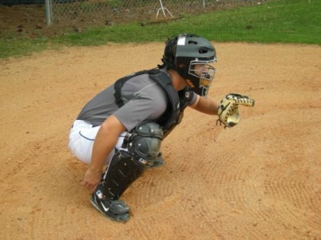
Stance Recap

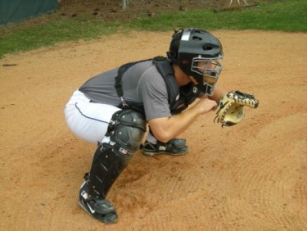
We must create the ability to block out of both the primary (no runners on base) and the secondary (runners on base) stances. We have to put ourselves in a position to be able to get our feet out from under us, allowing gravity to help us get our knees to the ground. The only thing that can slow us down is our feet, but let’s not allow that to happen. Get into a stance that allows you to move your feet when necessary. This stance,
again, should be balanced with a flexed lower-half

and a relaxed upper-half. What this means is your legs should be in a flexed position (strong, but mobile) and the upper-half of your body (chest, shoulders, arms, wrists, hands) should be in a relaxed state to be able to react. Let’s think like a hitter for a minute. How should you feel in your stance? It is very similar. Flexed lower – Relaxed Upper. Create a rhythm to stay loose, just like in your batting stance.

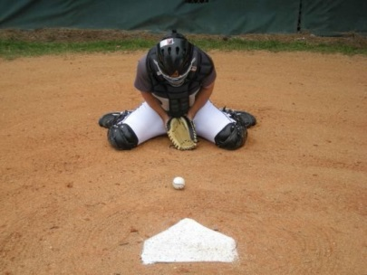
Blocking Positions

As we see here, we are working on the ball that is with-in the width of the plate. We are getting our feet out of the way so the knees can get to the ground in a position where the ball will be centered on our chest. When the ball hits our body, we want it to re-direct back down to the ground, so our chest angle forward and over the ball. Notice, our elbows are back so that our arms have the least amount of exposure to the ball. The glove is on the ground and the bare hand is behind the glove. The reason for this position is

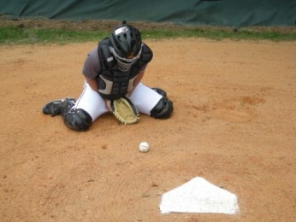
that it keeps us square to the ball. We want to create a trap for the ball so we roll the shoulders slightly forward. This will also create a gap between the chest and the chest protector so that the ball will deaden on the chest protector when it hits. Notice, the feet are wide in the back and the toes are pointed outward for balance and control. We must follow the flight of the
ball all the way to the chest so that we can see the bounce it takes off the dirt. This bounce will tend to be different every time so we have to track the ball. Tracking the ball will also help us find the ball after we block it. Blocking the ball is only half the battle. The other half is to know where the ball kicks off the chest and getting to it quickly so that if the runner tries to advance, we
have a better chance of throwing him out. To the Right: We have to combat the direction the ball is traveling by creating an angle around the ball. As the picture to the right shows, this angle requires the right side of the body to turn while getting into the blocking position. We want every ball we

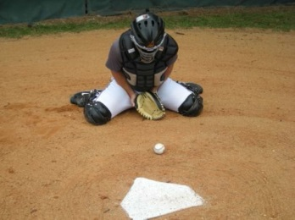
block to land as close to the plate as possible so, again, we roll the shoulders forward to create the space between the chest and the chest protector. One of the biggest problems
we see when blocking to the right and left is that catchers get their lead leg caught underneath their butt. Make sure your lead leg is getting to that kicked-out position so that you have balance to control the ball off your chest. If the lead leg gets caught underneath, the balance is affected and you will lose control and consistency. To the Left: The same applies to the left as it
does to the right, oppositely. The left direction seems to be a little more difficult for some reason, but either way, work on you weak side more, just like any weakness in your game.

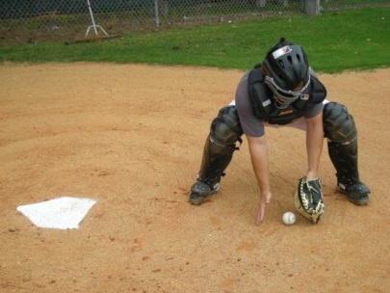
Recover and Scoop

After we block the ball, we have to get up and get it as quickly as possible so if the runner tries to run, we have a chance to throw him out. There are a couple different ways to get to your feet from the blocking stance. One is by using your hands to post on the ground and working your way up to your feet. This is what most young catchers must do. The other requires you to shift the weight backwards on to your feet, swivel your body weight from left to right - then to the up position, without using your hands. This one

requires a lot of practice and athletic ability. If done correctly though, it is much quicker. Either way you do it, it is important to assess the situation on the way to get the ball – not before you start to the ball or after you get there. We have to multi-task here to be quick and efficient. Once you get to the point where you are approaching the ball, we want you to squat down, using your legs, rather than bending at the waist only. We want to see you scoop the ball with two hands and “chest it” to gather yourself, then separate and make a throw if necessary. The biggest mistake we see is a catcher that grabs the ball with one hand, never gathers him-self, makes a throw like he’s never made before, and launches one into centerfield or left-field.

Continue to next pages for Block and Recover drills…

Block and Recover Drills

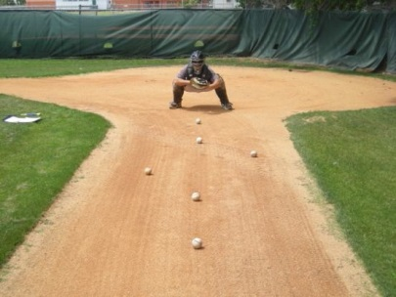
6 Ball Warm-Up

This is a basic blocking warm-up drill to get your catchers loose, while keep their focus on direction and body control. We set 6 baseballs in a pattern like you see in the picture. This pattern can be set up with any combination of directions, as long as there is a change of direction. We focus on gaining a little ground with each block and focusing on body position and control. 3 times through the sequence should give you the warm-up you need to move on to your next drill.

Stick Drill
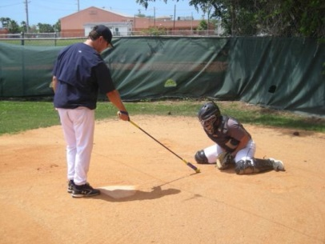

Pointing Drill
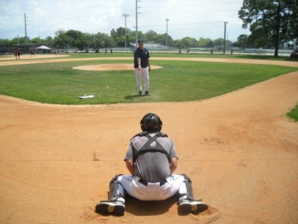

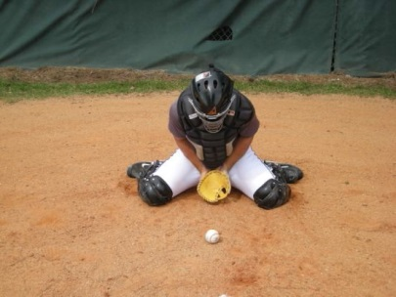
Already Down

The stick drill is another basic warm-up drill that forces the catcher to react to a moving object. We will block to all three positions (middle, right and left). We will start out, telling the catcher the pattern – then we will create a random pattern. It basically trains the brain to begin to see a moving object and interpret which direction to go to get to his blocking stance. You can also use your finger and point to the direction, like the next drill.

As we said above, we can also use this drill to learn to react to a visual and get to our blocking stance. The coach or partner simply points in a direction for the catcher to block and the catcher gets there as quickly as possible. 2-3 sets of 6-8 reps for either the Stick Drill or the Point Drill are great for quickness and movement.

In this drill, we place the catcher in the blocking position to start with. We get about 25 feet away and throw balls in the dirt for him to focus on the upper body only. We want the catcher to get used to seeing the ball all the way to the chest and where it bounces afterwards. We want the catcher to get a feel for adjusting with the upper-body if the ball is going to hit on the left or right side of the chest. This adjustment must come from the shoulders to re-direct the ball back down to the middle. At the same time, we want him

to figure out how to keep the ball off his arms, which hurts and can affect the catcher, mentally. For younger catchers, tennis balls can be used to eliminate the fear of getting hit by a baseball. We use a small glove in this drill so that our catchers aren’t tempted to catch the ball in the dirt. Catching the ball in the dirt creates bad habits and is very inconsistent.

Wall Drill
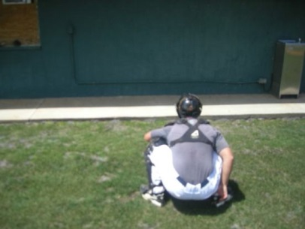

Isolation
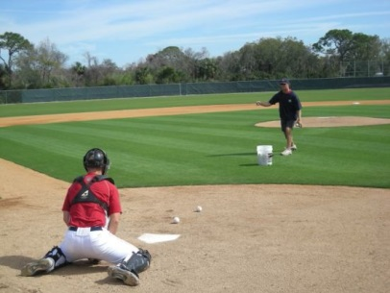

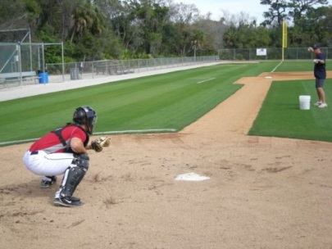
Exaggerated Angles

For the wall drill, find any wall that you aren’t going to ruin by throwing balls against. The coach or partner is behind the catcher and throws the ball so it hits the wall and bounces once on the ground before the catcher has to block it. It takes a while, but the catcher starts to figure out what to look for to get a good read and focuses more and more. This drill helps with quickness and agility because of the limited reaction time.

The isolation drill is when the coach or partner tells the player which direction he is trying to throw the ball. We will throw 4-5 to the middle, then the next catcher goes. When everyone has gone, the first catcher will get 4-5 to the left. Everyone goes through this one and then we will do 4-5 to the right. We usually start slow and increase speed with reps. *Don’t forget that we catchers like to compete so create competitions out of these drills.

We will exaggerate the angles when blocking to isolate the right and left. The catcher knows which way he is going to turn when the ball is thrown in this drill. The only question is how much distance he has to cover to get to the ball. Try to exaggerate the distance you make the catcher travel. Make him work in this drill. If the catcher blocks every ball perfectly, the partner didn’t make it difficult enough on them. We usually keep these reps around 5-6 for 2-3 sets each way.

Random
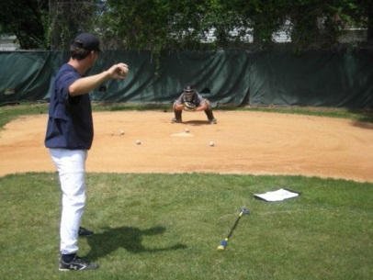

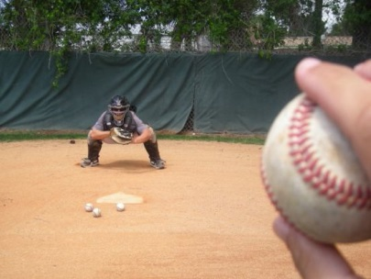
Rapid Fire

Random Blocking is simply the catcher knowing the ball is going to be in the dirt, but not knowing which direction. The coach or partner will mix it up and come up with different combinations each time. We usually keep these sets at 4-6 for 3 sets and we let the catcher have time in between reps to get set in his stance.

In the rapid fire drill, we have 4 baseballs and try to speed the catcher up past his comfort zone. Once the first ball is blocked the catcher must get back up to his stance as quickly as possible because the next ball will be on its way.
If the catcher is able to block every one without trouble, we are not working him hard enough. Make your catchers work!

Block, Recover and Scoop
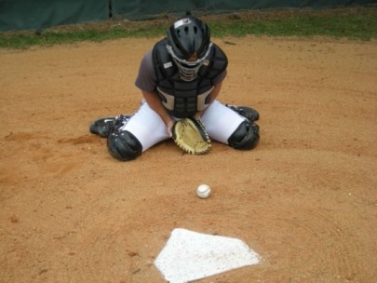
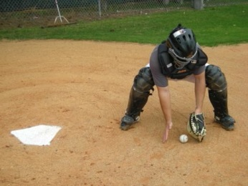
This is where we put it all together. The coach or partner throws the ball anywhere in the blocking range and the catcher must block the ball, get to his feet, get to the ball and scoop it. The catcher finishes
this drill in the throwing stance. Or, you can even incorporate throwing the ball to the bases with another player at that base. Make it a team drill and have your base runners get reads in the dirt while your catchers
work on completing this play.

Reaction
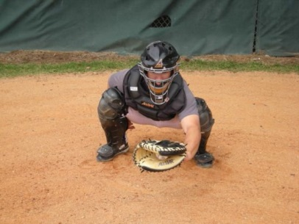

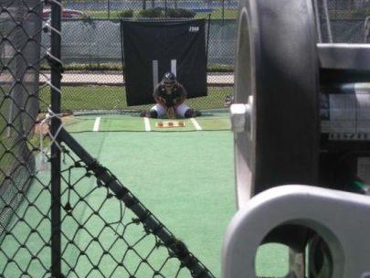
Machine Block

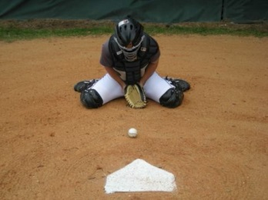
For the reaction drill, the coach or partner does not tell the catcher if he is throwing the ball in the dirt or throwing a strike. This is the most game like drill we have for blocking. The catcher should “think
middle, react left and right.” If the catcher thinks block, he is already beat on the strike. So think catch, react to block. That is why the drill is called Reaction!

Using a Machine to block is very effective, especially for curve balls and sliders. Don’t move the machine for changing location – let the catcher move his starting position to change location. Mix up speeds and pitches by tweaking the machine.

Passed Balls and Wild Pitches
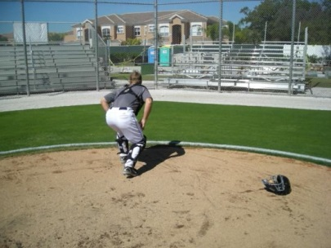
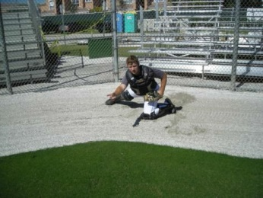
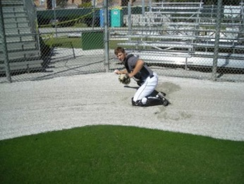
Although we don’t want to let the ball get by us, sometimes it happens. And sometimes it happens when there is a runner on third base. So how do we handle this? First, we find the ball quickly, while pealing the mask off and tossing it aside. Then we sprint to the ball, slide into it, scoop it and throw from one knee to the pitcher, who should be covering the plate.

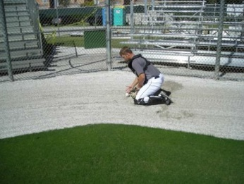

RECEIVING

The Target / Pre-Pitch
The target is one of the most crucial aspects to receiving. To receive the ball well, we have to think about what our hand, wrist and forearm are doing before the pitch. We want to start by giving a nice open-glove target to the pitcher. We want to get him locked in. But when he starts his motion, we want to relax our hand and wrist so that we can adjust to the pitch. This relaxing of the hand and wrist should cause the glove to slightly drop or turn (quarter-turn).

Lower-Middle
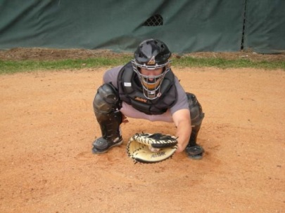
The pitch that is down in the zone has to be caught out in front of the body for a couple of reasons. We want the umpire to be able to see the pitch from his position and we also want to be able to catch and hold the ball. If we catch the ball more towards our body, the ball will have a tendency to continue its path and force the glove down more than we want. So the ball, in this case, looks lower to the umpire. As we get older and pitchers are throwing harder, with more break on their off-speed pitches, the umpire’s job
becomes much more difficult. Our job is to make it easier on the umpire and make the pitcher look better.

Lower-Right
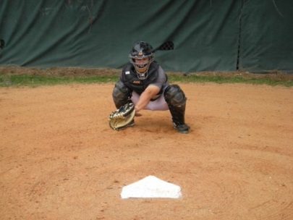
This pitch is down in the zone and to the right of where we originally set up in our stance. To make it look more like a strike, we want to make a slight sway with our weight in that direction. We want to remember to beat the ball to the spot – don’t continue swaying after the ball is caught. This will make the ball appear more outside than it really is. Track the flight of the ball and anticipate the end location. We want the front of the glove to be further from us than the heel of the glove (extend the wrist slightly). Stay
away from snapping the wrist too much when catching this ball. Keep your balance, using your right leg to hold your weight from collapsing. Try not to cave the left leg inward during this sway (stay balanced).

Lower-Left
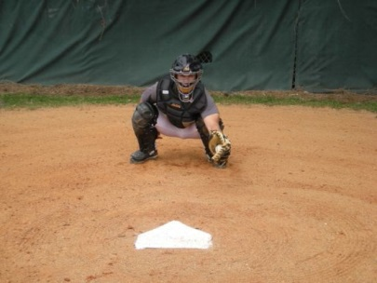
This is perhaps, the toughest pitch to catch, but the most important if you ask your thumb. We have to get from our relaxed, pre-pitch position and rotate our glove upward. We still want to catch the outside of the ball so the web of the glove is facing upward and the heel is obviously underneath the ball. If we catch the ball with the same glove angle as the previous two locations, we risk thumb injury and we can’t present the ball as well to the umpire.

Upper-Middle
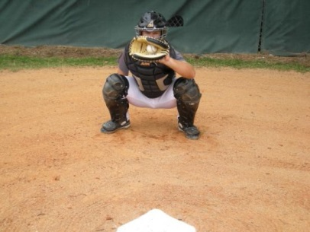

Upper-Right
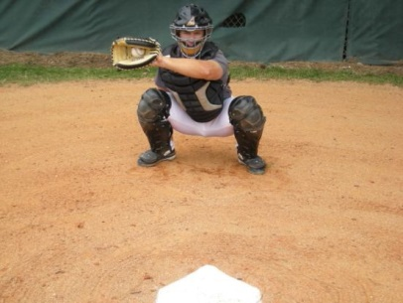

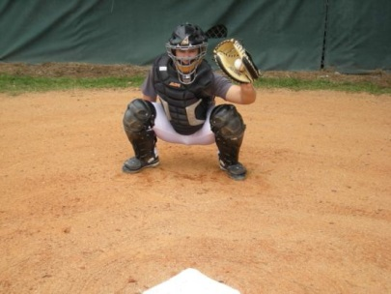
Upper-Left

Because the height of the ball decreases as it travels, we must catch the high pitch deeper in the zone. We need to let it travel to appear as low as possible to the umpire. Here, the elbow must bend as you catch the ball to allow the ball to get deep in the zone and appear lower. This is especially important on off-speed pitches because they tend to have a steeper slope.

Just as we talked about with the Upper-Middle pitch, this pitch must be caught deep in the zone. There is a slight sway, just as we talked about in the Lower-Right pitch. The only difference is we don’t hold the ball as long in one spot like the Lower pitches. We need to catch the ball deep and gradually move the glove to our throwing hand, transfer and throw it back to the pitcher. It is kind of like a mind game with the umpire.

All the same applies to the Upper-Left pitch as the previous two, except the glove angle and the direction of the sway. Just like the Lower-Left pitch, the glove turns upward to catch the outside of the ball. Again, we catch the ball deep and gradually move it to the throwing hand, as not to alarm the umpire that there was any question weather it was a strike or not. This movement should be one of assumption that it was a strike.

Continue to next pages for Receiving Drills…

Receiving Drills

Around the Zone
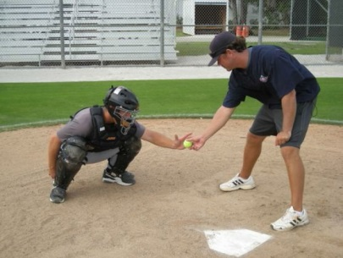

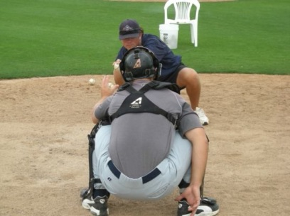
Shadow

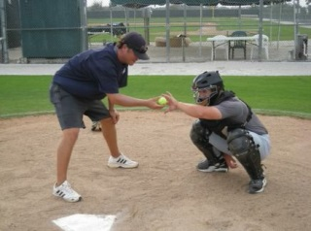
Here, the coach or teammate has a ball and moves it around the strike zone for the catcher to check his hand positioning on each
pitch location. If there is a correction to be made, we stop, make the correction, and continue.

In this drill, the catcher gets with a partner, a coach or even a mirror. If you have a partner, one catcher has to be the leader and one is the follower.
Sway back and forth, checking your balance and positioning for all locations. The follower mirrors the leader, moving slow to check all balance points.
Pretend you are catching the ball by closing the hand. Make sure your eyes are following the hand to each location. (Also good for conditioning legs)

Tennis Ball Under-hand Toss
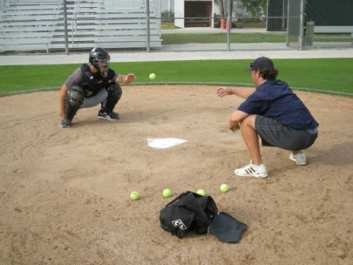
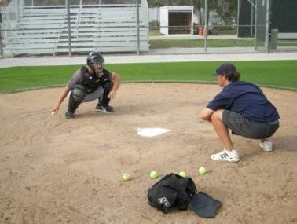
The Tennis Ball Under-hand toss is great for a couple of reasons. It promotes soft hands because the ball is light and takes some coordination to catch. It also promotes a good stance, if done correctly. The key is to be able to toss the ball, passing the outside of the knee with the throwing hand. This will cause you to make sure your knees aren’t too
wide in your stance. If your knees are too wide here, you will either have to throw the ball
around the knee (very wide) or you will have to throw in from the inside. Sometimes, I will catch our guys cheating and throwing it with their glove-hand. There are some good lessons to be learned by doing these drills 100% correct.

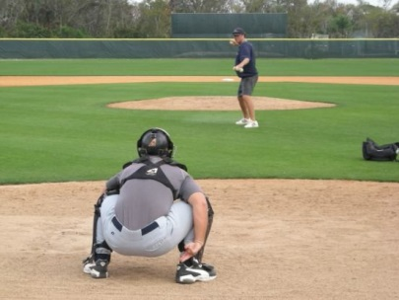
Catch and Hold

This drill is fairly simple. The coach (or a partner) throws the ball to different locations and the catcher basically catches the ball and holds it, as if he were presenting it to the umpire. Now, we’ve talked about the high pitch
– don’t “hold” that one. Your goal is to be the best receiver on the team, in the league, in the area, in the state! Make every drill, every pitch count…be the best drill-guy out there…it’s the only way to become the best!
Mix it Up: Mix in curve balls and change-ups so you can work on receiving

these pitches the right way too. Gradually, make it harder on your partner - make him work!

From Angles
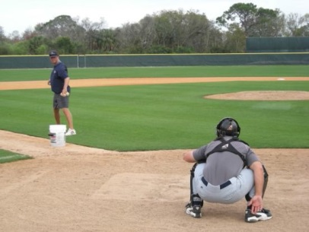

Chair Drill
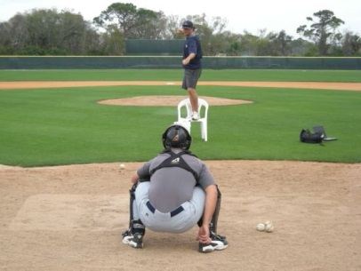

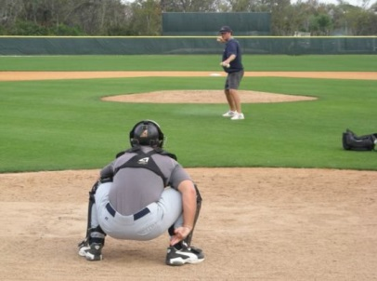
Getting Closer

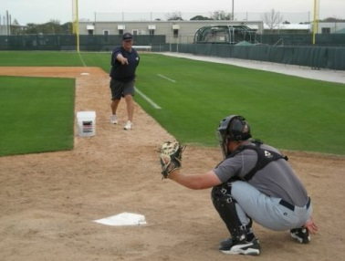
With the coach or partner down the base-line, the catcher is squared up toward the pitcher’s mound. The only thing
facing the coach (thrower) is the head/eyes. When the thrower is down the third-base line, we are working on the pitch to the catcher’s right.
When the thrower is down the first-base line, the catcher is working on the pitch to his left.

The chair drill is used to make the low pitch tougher to catch. It is a different look that can also be used instead of actually throwing curve balls. We mix this in to keep it fun for our guys – to give a different look to receiving. You can use anything that gets you off the ground – preferably something sturdy. Please, no law-suits!

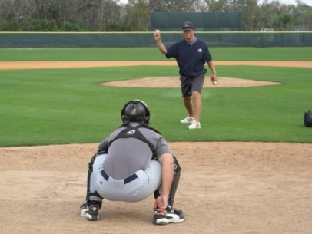
The coach starts back around 45 ft. and moves closer with each throw to make it tougher on the catcher. Coach has 4-6 baseballs and the catcher works on staying relaxed to be able to react quickly. The idea is, the closer the coach gets (or the harder a pitcher is throwing) the more the catcher has to relax, but focus to be quick.

Rapid Fire
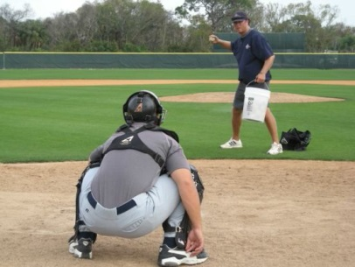

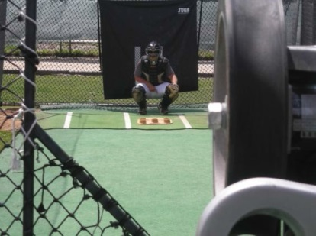
Machine Work

This drill has the same general idea in mind as the Getting Closer drill. But here, we are working on our fast-twitch reaction, one after another. The coach (or partner) has 6-8 baseballs and stands about 20 ft. away from the catcher. Once the first ball hits the catcher’s glove, the second is thrown, then the third, and so-on. We try to get 3-4 sets in during a receiving workout.

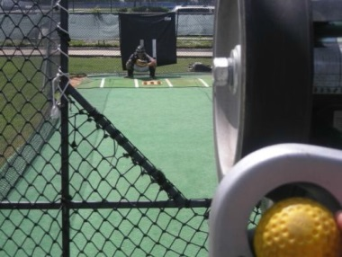
Use a pitching machine as another way to work on receiving. Since it is harder to move the location of the pitch, the catcher sets up in a different location each time. We have our catchers call a pitch, move to a location, receive the ball…then repeat.

Bull-Pens – Every pitcher on the staff will throw bull-pens throughout pre-season and in between outings during the season. As catchers, we need to use these bull-pens as opportunities to work on our receiving with different pitchers. Some pitchers are harder to catch than others. We need to take this as a challenge to make our jobs easier when game-time comes. It is easy to have a negative attitude about bull-pens, especially if you are the back-up catcher, having to catch more of them. Remember, the back-up guy is one pitch away from being the starter. Take time to record some notes on pitchers and what they might need to work on. Maybe it’s a key phrase they need to hear to be able to focus.
Write these things down – it’s no different than taking notes in the class room.

Stances and Balance Positions

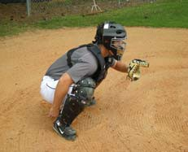
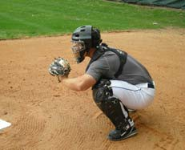
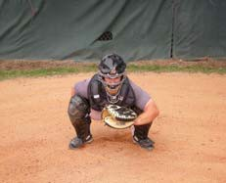

Primary Stance

The most common mis-used term we hear in teaching stances is get to a comfortable position. To receive the ball correctly and give our pitcher the best opportunity to get a strike called, we have to get in a stance that is uncomfortable to learn and get used to. The butt has to be up enough for the 'glove-hand' elbow to be in front of the knee. This will allow the catcher to catch the low ball properly. Notice, the elbows are not inside the knee. This allows for the catcher
to receive the 'glove-hand-side' pitch correctly. The elbow is loose and free and is bent, at the very minimum, a 90 degree angle. See the receiving section for further detail on receiving.

Drill:

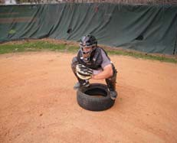
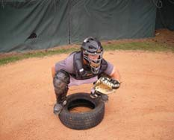
One of the best drills to make it easy for young catchers to feel the correct primary stance without too much explanation is the TIRE DRILL. By putting the arch of the foot on the hard part of the tire where the tread meets the side wall, the catcher, must then squat down and retain a balanced position. To do so, the catcher must have a slight lift in the butt and flatness to his back. See above for the angle of the back in a balanced primary stance.

Secondary Stance

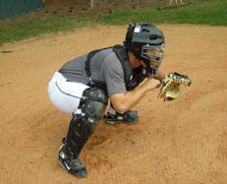
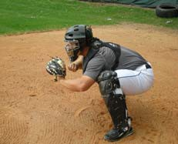
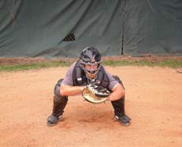

There are many differences in the secondary stance (runners on base or two strikes on the batter). The butt raises slightly because it is more of a flexed position. The back flattens a little and the throwing arm comes in front of the knee.
The throwing arm is still in a relaxed, bent position, ready to frame, block and throw. Don't get into this position and get stiff. Stay loose and ready to react.

Drill:
Get your catchers up in their secondary stance, making sure the positioning is correct, make them hold the stance for certain periods of time. You might start day one with 3 sets of 45 seconds. On day two or three you might increase this
to 3 or 4 sets at 1 minute. Times and sets are all variable. Have a set number of sets and times for each practice, increasing as the season approaches.

You can incorporate the tennis ball and shadow drills into stance training at any time:

***See the Receiving page for the tennis ball and shadow drills***

Transfer and Throwing
Before we get into the transfer and throwing discussion, we must first realize that there are many situations we need to transfer and throw the ball as fast and efficient as we can (When runners steal; when we pick runners off; when we turn double plays from the infield to home to first…and a few more).

Hands
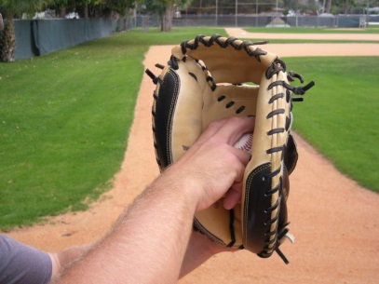

The first thing we must consider in the transfer and throw is the way we want to enter the glove with the bare hand. We want to have both the glove and the bare hand facing upright if possible. The only exception to this is when the ball is thrown to the lower- right of our transfer area. When this happens, the hands will meet with the web of the glove and the finger tips of the bare

hand either pointing sideways or face down. You might have to stop right now and make sense of this.

Ready Stance
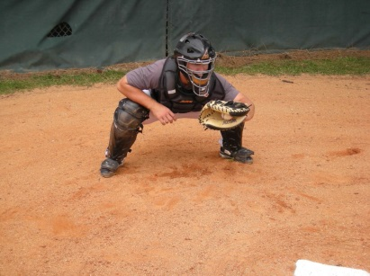

The ready stance is the position we want to be in with runner(s) on base. The butt should be equal height with the knees. The feet should be wider than the knees. Some catchers have to pinch the knees at first and develop the necessary flexibility. It might be something that you have to work to develop comfort.
This is not easy, especially for a young catcher. You might have

to work through the initial burning sensation in your legs but if you want to develop, you will pay the price. Now, moving up to the upper-body, the bare hand should be either resting on the thigh (as pictured) or directly behind the glove for protection (but either way, it is in front of the right knee – this will allow the transfer to take place where we want it to (right in front of the right shoulder as we turn the front side to load to throw).

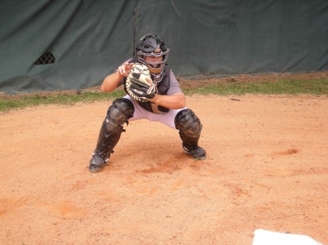
Transfer in Front

To transfer in front of the shoulder, let the ball travel as much as you can, especially if it is thrown to an area within your body. Try not to reach. Slightly turn your glove counter-clockwise as you receive the ball to get the transfer process started. Turn the glove and meet it with the bare hand in front of the shoulder, grab the ball out of the glove with the most similar grip

to how you are going to throw the ball so that you don’t have to adjust your grip too much. Then separate your hands but lead this separation with the elbows.

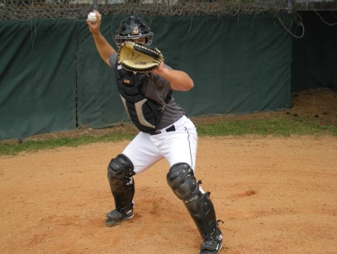
Separation

Again, lead the separation with the elbows. Turn the ball as you start the short circular path around the ear. The glove-hand will extend out in front of your elbow, past 90 degrees and the throwing arm will stay inside 90 degrees. This is commonly described as a bow and arrow position. Line your shoulders up to Try to keep your glove hand stable throughout your throw for

balance. The glove elbow should start with separation from the left side of the body and end up hugging that left side of the body as the catcher throws and rotates. This should cause the glove to face upward through the finish of the throw.

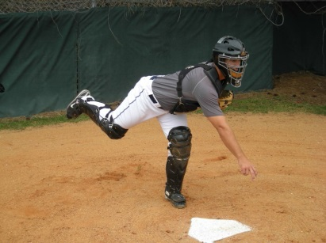
Throw and Finish

As the elbow begins the forward motion from a position of parallel height with the throwing hand, the throwing hand begins to find its index finger and middle finger on top of the ball. This leads up to the finish, where the wrist will snap forward and down, while extending the fingers toward the target. The hand will finish out in front of the left knee, which should be directly

above the foot at this point. We should see a significant ability to balance here with slight bend in the front knee. The back leg and foot should raise up as the arm extends out in front. The leg will eventually come around and down to finish, but you shouldn’t find yourself having to support yourself from falling right away by getting that back leg on the ground. If this is the case, you must be out of control a little with your body.

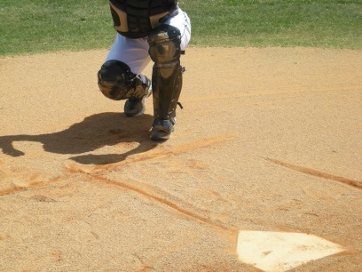
Throwing to Third

The footwork to throw to third depends on where the pitch is thrown. If our catchers can reach the ball without reaching across their body to the right without shifting their weight to the right foot, we want them to go behind
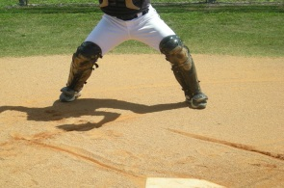
the right handed hitter to throw to third. We must clear the right-handed hitter

enough to make our throw without hitting the batter in the helmet or back. If the pitch is off the plate to the right and we
have to shift our weight to the right foot, we let that shift happen and use it to start the movement to get in front of the hitter, redirect our left foot toward third base and make our throw.

***Transfer and Throwing Drills***

Transfer and Separate

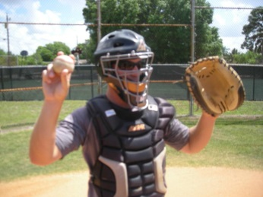
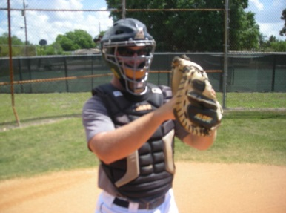
The transfer and separate drill is only for your hands. We build our transfer one step at a time. We start by simplifying things and only using our hands. Start with the ball in the glove. Reach in and grab the ball with a grip similar to the one you will throw with. To be able to get a feel, start this
drill in slow motion. So, grab the ball and pull it out of the glove just like in the Separation Section. Then put the ball back in the glove in exact reverse of how you got it out and separate your hands with out taking the ball out (leave it in your glove). Repeat this action and create muscle memory by
doing it over and over. Build up the speed as you go…when you mishandle the ball, start slow again and gradually get faster again.

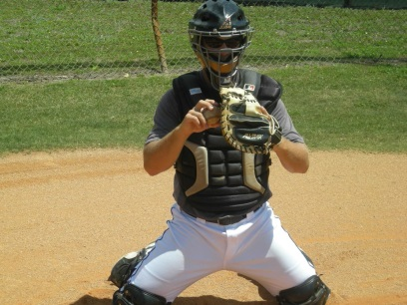
From the knees

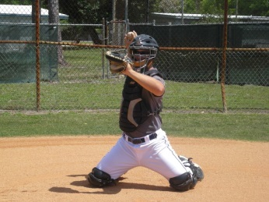
Focusing on the hands only and adding the throwing element to the Transfer and Separate brings us to the Transfer and Throw from the knees. Working with a partner
about 30 feet away, start slow and build the speed up as you go. Going back and forth with your partner creates and

natural challenge to see who muffs/fumbles the transfer first.
This drill helps to train the core muscles to be active and stable during the transfer and throw. This is crucial to your ability to improve or maintain accuracy.

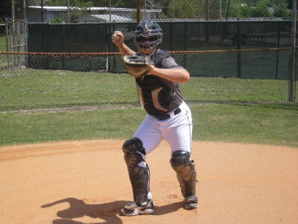
Transfer and Step

This drill is to train the timing between the hands and feet. Receive the ball from your partner. Transfer first and step with the right foot. As the right foot steps forward about 4-5 inches, the angle changes from pointing towards where the 2nd baseman plays (in the stance) to an angle more towards first base.
Practice these one foot step drills before you add the second

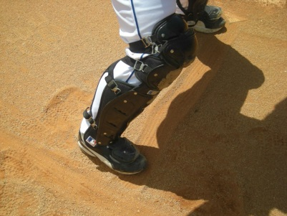
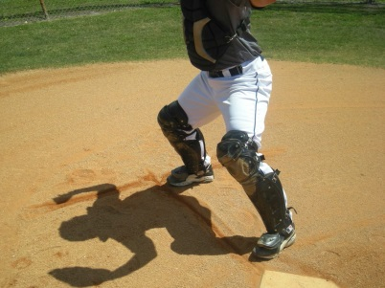
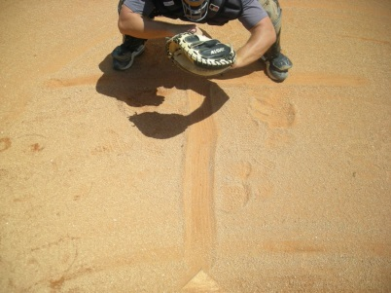
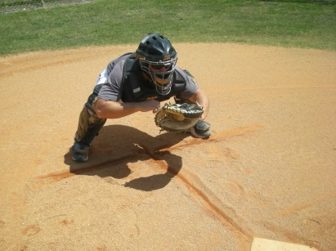
step, creating a shuffle. When you do add the second foot into the sequence, make shore the left foot gets to a position lined up toward your target. Sometimes the foot won’t get all the way to the line we will draw in the “T-Drill.”

T-Drill
First, draw a line from the back corner of the plate to a point where your feet are in your stance. Draw another line perpendicular to that line to form the letter T. The right foot can be slightly behind the line if your left foot is on the line. This will make it a little easier to get the feet lined up, especially on the throw to second base. Catch, transfer, separate and shuffle. Use the line that connects to the back corner of the plate to make sure our left foot is getting as close to that line as the right foot. If the
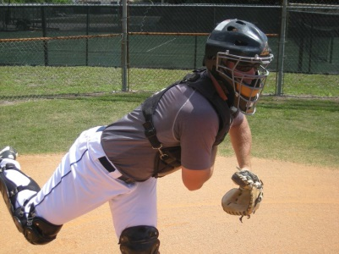
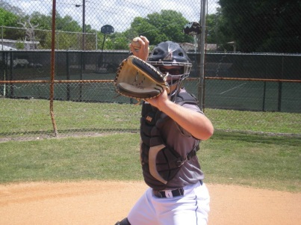
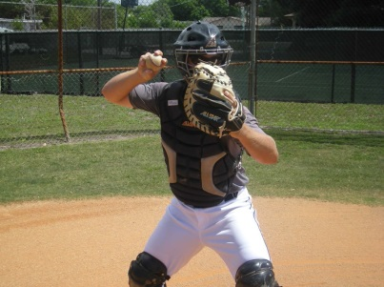
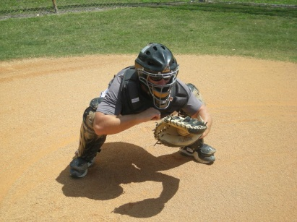
ball is off target, the right foot might shift a little right or left. The left foot should shuffle to a point as far away or near the line as the right foot.

Ball in Glove
Start with the ball in your glove. Transfer, shuffle, separate and throw. Balance on the front leg on the finish for an additional training element.

Throw from Goal Post or Bow and Arrow position

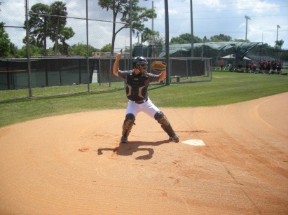
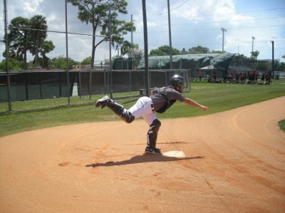
Start with the ball already separated from your glove. Start with your weight 50/50. You should feel out how long you want your stride to be and place your feet there. It should be a powerful position to throw from. Feel a strong connection to the ground with your feet. Rock back to shift about 70% of your weight to your back leg but keep your back knee inside your back foot. Some catchers will shift their weight back but let their knee shift too much (over the back foot). Keep the knee inside the foot to keep constant pressure pushing toward the direction you are throwing. Make your throw and balance on the front leg so we are not falling forward. We must create a brake for our hips to turn quickly so your weight should be restrained by your front foot so you should be able to control your weight enough to balance in the finish.

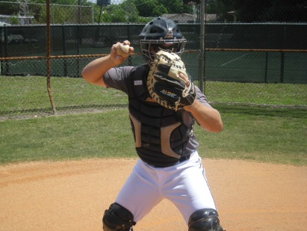
Fast Hands Drills

Work on speeding up your hands as you compete with a partner or teammate. You can play this game from your knees to focus on the hands only or you can go from a slight-
knee-bend position (not squatting but not standing upright). Challenge each other, going back and forth with a partner, focusing

on the transfer, separate and throw techniques discussed earlier.

The front arm might not have time to get out past 90 degrees but everything else will be game like (at least with the upper body).

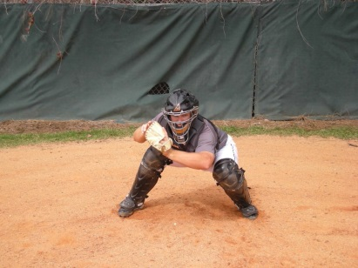
Small Glove

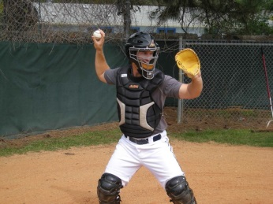
If you are not anticipating the catch and transfer by moving your right hand towards the glove as you catch
the ball, use a small, flat glove to make the hands have to work together more. Your right hand cannot be dormant as the ball is being caught. It must move toward

the transfer position as you prepare to catch the ball. Using the small, flat glove will reinforce this technique and get your hands working together.

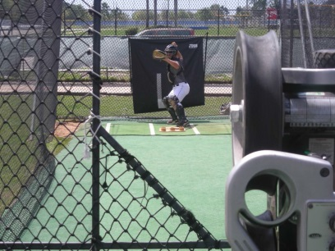
Pitching Machine

When using a pitching machine, we can pinpoint the area we want to work on from a distance more
realistic to where the pitcher will be throwing from. So that we can work on different locations, have the catcher move around instead of moving the pitching machine. Move around to work on different pitches (in and out, up and down).

Hitting

Coaching Points – Mechanics

Coaching Point #1: Grip – Knuckles don’t necessarily have to be lined up! Grip of bat should be aligned with callous portion of hands right before the fingers begin

Coaching Point #2: Stance – Lead arm is parallel to chest, straight up from the ground – Prevents ‘chicken wing’ from occurring. Your back elbow is slightly up, and creates an easy path as your rotate your trunk with your swing.

Coaching Point #3: Start early, don’t get front foot down early! It stops your momentum! Start when the pitcher is at his release point.

Coaching Point #4: After stride, chest is over plate, butt sticking out (in better position to make a strong, rotational move) – Don’t let your kids begin their at-bat in a straight, upright position!

Coaching Point #5: Weight transfer from back knee to front knee, followed by stiff front leg

Coaching Point #6: Swing up or swing down? – The ball is coming downhill from the pitcher at an 8-10 degree angle, so we must meet the ball coming up hill slightly at an 8-10 degree angle. – If you aim to “get on top,” it will result in many weak pop-ups to the infield

Drills

  - Tee Work (always hit to middle)
    - Happy Gilmore – Start at 45 degree angle, left, right, stance, swing
    - 1 (Load and Stride), 2 (Hips come, front shoulder and hands stay back while bottom half moves!), Hitting Box (hit volleyball/basketball in check swing position)
    - Swing Breakdown- 1, 2, hit
  - Check Swing soft toss – partner brings hand back, batter does check swing and brings it back to stance, hits the next ball
  - Happy Gilmore Soft Toss
  - Regular soft toss (inside, middle, outside)
  - Top/Bottom hand soft toss
  - Drop Ball Drill – batter already strides, ball is held at batter’s eyes, dropped when batter puts front heel down and begins torque
  - Tennis ball hip toss – Load, chest over plate, elbow comes with hip, catch tennis ball.

Front Toss:
        - Short bat middle
        - Regular bat in and out

Hitting and Fielding Involving the Entire Team:

  - “Touch ‘Em All” – Group of three hitting – The rest of the players are in the field – After player hits the ball they try to sprint around all of the bases before the fielders get the ball around every base, with the last throw going home.
  - Coach Pitching Live behind L-Screen (Outs Game) – Each group of 3 players get six outs. Players run the bases and field the ball as if it’s a game. After the first 3 outs, clear the bases and play the 2nd 3 outs for the group’s turn to be over. Keep track of score to see which team wins.
  - Pitchers Live
  - Challenge Time
    - Hits (First two swings are free, the third you stay until you make an out)
    - Situations (runner on 1st, 2nd, 3rd, 1st and 3rd, etc)
    - Bunts
    - 2-Strike approach (choke up, let the ball get deep, look for the ball to be away, aim to hit up the middle or opposite field)

Philosophies

- “Get a good pitch to hit!” – Know individual strengths and weaknesses! Talk to your kids…ask them questions…they should know what they are/aren’t good at!
- Be ready for the first pitch, it may be the best pitch you get
- Choke up with 2 strikes – ALWAYS
- With two strikes, think later is better!
- Begin load when pitcher is at his release point

- Every Player Can Be Good At Running The Bases

- Baserunning Techniques (Home to 1st, 1st to 3rd, 2nd to Home)
  - Take good angles
  - Coach’s responsibilities

- Taking a Lead
  - Watch the pitcher
  - Listen to the coaches
  - Weight balanced
  - Don’t cross over
  - Secondary lead
  - Back to the base

Pick Off Attempt
  - Step and a dive
  - Back standing

Advancing on a Passed Ball or Wild Pitch
  - Many scoring opportunities are missed because players don't take an aggressive lead and aren't prepared for the ball to get away from the catcher.
  - Philosophy: We're going on a passed ball until we see that we can't make it.
  - Get your players to expect a passed ball on every pitch. It's much easier to stop a player from going than it is to get them started.
- Coach Players to Take Responsibility in Determining When to Go
- Anticipate!
  - It's important for them to watch the trajectory of the pitch to look for opportunities.
  - When they read the pitch as one that's going to hit the dirt, they can be more aggressive in taking a secondary lead and reading the opportunity.
- Practice Situational Baseball
  - Employ fielders and baserunners with a coach hitting fungos. Fielders and runners play the ball live.
  - Play 6-out game to promote game situations.

- Good Things Can Happen When You Put Pressure on the Defense
  - So even in situations where you can't score on a ball that gets by the catcher, the aggressive nature of your runners will provide a benefit to the hitter.

Baserunning Drills
Burma's
(To develop running skills)
Divide the players equally among the four bases. One at a time from each base will be running, with the others waiting their turn. At 'go' from the coach, the four take off. Proper technique is a must and the goal is to do a certain amount right in a row, before going on to something else.
Player at the plate: Simulates a swing. Takes off as if hitting a double and possibly a triple. Makes a good turn at first. Picks up the 3rd base coach half way to 2nd. Rounds 2nd hard, ‘picks up the ball’ and returns to 2nd quickly.
Player at first: From a lead, goes from 1st to 3rd. Picks up the 3rd base coach half way to 3rd. Makes a hard turn at 3rd then returns quickly.
Player at 2nd: From a lead, goes from 2nd to home. Picks up the 3rd base coach and makes a good turn. Runs hard through the plate.
Player at 3rd: From a lead, goes back to the bag to tag. Takes off for home, rounds it, then takes off for 1st as if beating out a single. Looks inside towards the 1st base dugout as he crosses the bag for possible overthrow.

___________________________________________________________
“Watered down” Burma’s (To develop running skills and stamina)
Proper technique is a must and the goal is to do a certain amount right in a row, before going on to something else. Work on leads and secondary leads also. Drill begins at home plate.
Runners at the plate: Simulates a swing. Takes off as if hitting an infield ground ball - "run through" the bag and look to their right. By looking to their right, they will be able to immediately see if there was an overthrow at first. Coach your players to try to step on the front of the 1st base bag. Do not jump at the bag and do not slide into 1st base. Everyone returns to home plate.
Runners at the plate: Simulates a swing. Takes off as if hitting a ball to the outfield. Take a good, aggressive turn at 1st. Return quickly to the bag. Runners stay at 1st.
Runners at 1st: From a lead, runner goes from 1st to 3rd. Picks up the 3rd base coach two-thirds of the way to 2nd and again after touching the 2nd base bag. Stop right on the 3rd base bag.
Runners at 3rd: Walking lead. Simulate a ball hit to an infielder. Runner must run hard to beat the potential throw.
Runners at the plate: Simulates a hit to the outfield gap…thinking double. Get a good turn and leg out a double stopping on the 2nd base bag.
Players at 2nd: Visualizing a hit to the outfield, from a lead runner goes from 2nd to home. Picks up the 3rd base coach and makes a good turn. Runs hard through the plate.
Runners at the plate: Simulates a hit to the outfield gap…thinking triple. Take a good turn around 1st, pick up 3rd base coach two-thirds of the way to 2nd, pick up 3rd base coach again after touching 2nd, and slides into 3rd base.
Runners at 3rd: Visualize a fly ball to the outfield. Walking lead off 3rd but quickly retreats to tag up. Coach simulates “the catch” by clapping his hands loudly. Upon “clap/catch” runner leaves the bag and runs through home plate.
Runners at the plate: Leg out an inside the park homerun instituting good technique around each bag. By this point, they should be tired. Next, reward their good effort with a fun trip around the bases…out of the park homerun…they can work on their homerun trot.
This is a great baserunning drill to finish every practice with.

___________________________________________________________

Pitch Trajectory (Ball in the Dirt)
Purpose: Develop base runners ability to read the trajectory of the pitch to determine if it will hit the dirt. Allow the defense to work on defense in the same situations.
Equipment: Baseballs, catchers in gear, batting helmets
Setup: Have a complete infield including a couple of catchers in gear. Coach will pitch. Have the rest of the team with helmets on to run the bases. You don't need a hitter.
Execution: Vary the situation by changing how many runners on base. Start with a runner on first, then first and second, first and third, finally bases loaded.
Coach will throw pitches to the catcher. Every few pitches he will throw one in the dirt. Any time a ball is about to bounce the whole team yells "DIRT". This helps you make sure everyone is paying attention.
**NOTE: You can add a dimension to this by running this drill solely for stealing also. The pitcher (coach) comes set and upon delivery to the plate runners focus on getting good jumps. Or if the coach fakes a pick off attempt, runners practice their ‘step and a dive’. To lessen the wait time – have 3 baserunners performing simultaneously at each base (lined up behind one another).
Each runner should be watching the delivery of the pitch and try to read the trajectory to determine if the pitch will be in the dirt. If the runners read that the ball will be in the dirt, he should be more aggressive taking his secondary lead anticipating that he can advance to the next base on a passed or blocked ball.
Baserunners on 1st should automatically go when the ball is in the dirt. If they read it correctly, it should be an easy steal even if the ball is blocked and/or caught on the bounce by the catcher.
When on 2nd and 3rd the runners will be aggressive in taking the secondary lead and determine if they should go or stay. The goal is for runners to get used to reading the pitch and avoiding the hesitation that often happens when a pitch bounces in the dirt.
Defensively this drill gives catchers practice at blocking pitches in the dirt with game situations. Encourage the catchers to throw the ball when runners get too far off. This is a chance for them to learn when to throw the ball and when to run someone back. It also benefits the runners as they learn how far they can get off and how to get back quickly.

___________________________________________________________
Run & Steal
(Develop aggressive baserunning)
Runners start at home plate. Swing and round first properly taking a wide, aggressive, turn and dive back into the bag. Runner gets up quickly, takes an aggressive lead, and takes off to steal 2nd sliding into the bag. Runner then gets up takes an aggressive secondary lead and dives back into the bag. He then steals third repeating the slide, getting up and taking an aggressive lead off third, in foul ground, dives back into the bag, coming back on the foul line. He gets up and sprints home (no slide at plate). The next runner takes off from home when the previous runner completes his dive into first and touches the bag.
The focus of this drill is to make runners very aggressive and not be afraid to get dirty! It also gets players practice in sliding and diving properly, which will hopefully keep them from injuries. It also tends to develop players who want to work hard and get dirty.

___________________________________________________________
Relay Races
(Improves baserunning skills, competition, & stamina)
Split the team in half, with one group of players behind home plate and other half behind second base. Give the first player of each group a ball (this will be the "baton" for the relay race). “Ball/Baton” is optional – can be done without it.
On "GO!", the first player from each team begins running the bases, ball in hand. After making a complete lap around the bases (back to each player's starting point), that player hands the ball off to the next person who continues the relay race. First group of players to finish the race wins.
___________________________________________________________

Baserunning
AAA Division

- Every Player Can Be Good At Running The Bases

- Secondary Leads
  - No leading in AAA (must wait for pitch to cross home plate)

- Baserunning Techniques (Home to 1st, 1st to 3rd, 2nd to Home)
  - Take good angles
  - Coach’s responsibilities

Advancing on a Passed Ball or Wild Pitch
  - Many scoring opportunities are missed because players don't take an aggressive lead and aren't prepared for the ball to get away from the catcher.
  - Philosophy: We're going on a passed ball until we see that we can't make it.
  - Get your players to expect a passed ball on every pitch. It's much easier to stop a player from going than it is to get them started.
- Teach Players to Take Responsibility in Determining When to Go
- Anticipate!
  - It's important for them to watch the trajectory of the pitch to look for opportunities.
  - When they read the pitch as one that's going to hit the dirt, they can be more aggressive in taking a secondary lead and reading the opportunity.
- Practice Situational Baseball
  - Employ fielders and baserunners with a coach hitting fungos. Fielders and runners play the ball live.
  - Play 6-out game to promote game situations.

- Good Things Can Happen When You Put Pressure on the Defense
  - So even in situations where you can't score on a ball that gets by the catcher, the aggressive nature of your runners will provide a benefit to the hitter.
Baserunning Drills
Burma's (To develop running skills)
Divide the players equally among the four bases. One at a time from each base will be running, with the others waiting their turn. At 'go' from the coach, the four take off. Proper technique is a must and the goal is to do a certain amount right in a row, before going on to something else.
Player at the plate: Simulates a swing. Takes off as if hitting a double and possibly a triple. Makes a good turn at first. Picks up the 3rd base coach half way to 2nd. Rounds 2nd hard, ‘picks up the ball’ and returns to 2nd quickly.
Player at first: After secondary lead, goes from 1st to 3rd. Picks up the 3rd base coach half way to 3rd. Makes a hard turn at 3rd then returns quickly.
Player at 2nd: After secondary lead, goes from 2nd to home. Picks up the 3rd base coach and makes a good turn. Runs hard through the plate.
Player at 3rd: From secondary lead, goes back to the bag to tag. Takes off for home, rounds it, then takes off for 1st as if beating out a single. Looks inside towards the 1st base dugout as he crosses the bag for possible overthrow.

___________________________________________________________
“Watered down” Burma’s (To develop running skills and stamina)
Proper technique is a must and the goal is to do a certain amount right in a row, before going on to something else. Baserunners all start at home plate.
Runners at the plate: Simulates a swing. Takes off as if hitting an infield ground ball - "run through" the bag and look to their right. By looking to their right, they will be able to immediately see if there was an overthrow at first. Coach your players to try to step on the front of the 1st base bag. Do not jump at the bag and do not slide into 1st base. Everyone returns to home plate.
Runners at the plate: Simulates a swing. Takes off as if hitting a ball to the outfield. Take a good, aggressive turn at 1st. Return quickly to the bag. Runners stay at 1st.
Runners at 1st: Runner goes from 1st to 3rd. Picks up the 3rd base coach two-thirds of the way to 2nd and again after touching the 2nd base bag. Stop right on the 3rd base bag.
Runners at 3rd: Simulate a ball hit to an infielder. Runner must run hard to beat the potential throw.
Runners at the plate: Simulates a hit to the outfield gap…thinking double. Get a good turn and leg out a double stopping on the 2nd base bag.
Players at 2nd: Visualizing a hit to the outfield, runner goes from 2nd to home. Picks up the 3rd base coach and makes a good turn. Runs hard through the plate.
Runners at the plate: Simulates a hit to the outfield gap…thinking triple. Take a good turn around 1st, pick up 3rd base coach two-thirds of the way to 2nd, pick up 3rd base coach again after touching 2nd, and slides into 3rd base.
Runners at 3rd: Visualize a fly ball to the outfield. Runner jumps off 3rd but quickly retreats to tag up. Coach simulates “the catch” by clapping his hands loudly. Upon “clap/catch” runner leaves the bag and runs through home plate.
Runners at the plate: Leg out an inside the park homerun, instituting good technique around each bag. By this point, they should be tired. Next, reward their good effort with a fun trip around the bases…out of the park homerun…they can work on their homerun trot.
This is a great baserunning drill to finish every practice with.

___________________________________________________________

Pitch Trajectory (In the Dirt Drill)
Purpose: Develop base runners ability to read the trajectory of the pitch to determine if it will hit the dirt. Allow the defense to work on defense in the same situations.
Equipment: Baseballs, catchers in gear, batting helmets
Setup: Have a complete infield including a couple of catchers in gear. Coach will pitch. Have the rest of the team with helmets on to run the bases. You don't need a hitter.
Execution: Vary the situation by changing how many runners on base. Start with a runner on first, then first and second, first and third, finally bases loaded.
Set players up at all three bases. They are independent of each other because each base has different rules for a ball in the dirt. A coach pitches from the mound and mixes in good and bad pitches to the catcher. Any time a ball is about to bounce the whole team yells "DIRT". This helps you make sure everyone is paying attention. Baserunners on first should automatically go when the ball is in the dirt. Runners on second should react to the ball in the dirt by getting a good secondary lead and deciding if they can make third safely. If the ball gets away from the catcher they should go, if the catcher digs the ball out of the dirt, they should return to second. Runners at third should follow the same principles as the runner at second, gets a secondary lead as the ball nears the catcher and then react to whether the catcher digs the ball out of the dirt or not.
**NOTE: You can add a dimension to this by running this drill solely for stealing also. The pitcher (coach) comes set and upon delivery to the plate, runners focus on getting good jumps. To lessen the wait time – have 3 baserunners performing simultaneously at each base (lined up behind one another).

___________________________________________________________
Run & Steal
(Develop aggressive baserunning)
Runners start at home plate. Swing and round first properly taking a wide, aggressive, turn and dive back into the bag. Runner gets up quickly, takes an aggressive lead, and takes off to steal 2nd sliding into the bag. Runner then gets up takes an aggressive secondary lead and dives back into the bag. He then steals third repeating the slide, getting up and taking an aggressive lead off third, in foul ground, dives back into the bag, coming back on the foul line. He gets up and sprints home (no slide at plate). The next runner takes off from home when the previous runner completes his dive into first and touches the bag.
The focus of this drill is to make runners very aggressive and not be afraid to get dirty! It also gets players practice in sliding and diving properly, which will hopefully keep them from injuries. It also tends to develop players who want to work hard and get dirty.

___________________________________________________________
Relay Races
(Improves baserunning skills, competition, & stamina)
Split the team in half, with one group of players behind home plate and other half behind second base. Give the first player of each group a ball (this will be the "baton" for the relay race).
On "GO!", the first player from each team begins running the bases, ball in hand. After making a complete lap around the bases (back to each player's starting point), that player hands the ball off to the next person who continues the relay race. First group of players to finish the race wins.
Players will often beg for rematches and will voluntarily run the race all out
___________________________________________________________
Run Through 1st Base
(Develop player's ability to run through 1st base & recognize coaching signals)
- All players line up single file about 10 feet from home plate.
- One at a time, each player comes to the plate. With imaginary bat in hand, the player swings at an imaginary pitch, and runs full speed to 1st. The base coach at first either gives them the "hold up" sign" or waves them to second.
- If the player is to hold at 1st, make sure they do not slow down, but "run through" the bag and look to their right.
- By looking to their right, they will be able to immediately see if there was an overthrow at first.
- Once the player has finished their run, they return to the end of the line and the next player steps up to the plate.
Tip: Runners should try to step on the front of the 1st base bag. Do not “jump” at the bag and do not slide. Jumping and sliding will slow you down.

Baserunning
AA Division

- Every Player Can Be Good At Running The Bases

- Secondary Leads
  - No leading in AA (must wait for pitch to be hit)

- Baserunning Techniques (Home to 1st, 1st to 3rd, 2nd to Home)
  - Take good angles
  - Coach’s responsibilities

No Stealing or Advancing on a Passed Ball or Wild Pitch
- Teach Players to Take Responsibility in Determining When to Go.
- Anticipate!
  - Expect the ball to be hit every pitch. Be ready to explode off the bag.
- Practice Situational Baseball
  - Employ fielders and baserunners with a coach hitting fungos. Fielders and runners play the ball live.
  - Play 6-out game to promote game situations.

- Good Things Can Happen When You Put Pressure on the Defense.
  - The aggressive nature of your runners will build the foundation of a good, smart baserunner.

Baserunning Drills
“Watered down” Burma’s (To develop running skills and stamina)
Proper technique is a must and the goal is to do a certain amount right in a row, before going on to something else. Baserunners all start at home plate.
Runners at the plate: Simulates a swing. Takes off as if hitting an infield ground ball - "run through" the bag and look to their right. By looking to their right, they will be able to immediately see if there was an overthrow at first. Coach your players to try to step on the front of the 1st base bag. Do not jump at the bag and do not slide into 1st base. Everyone returns to home plate.
Runners at the plate: Simulates a swing. Takes off as if hitting a ball to the outfield. Take a good, aggressive turn at 1st. Return quickly to the bag. Runners stay at 1st.
Runners at 1st: Runner goes from 1st to 3rd. Picks up the 3rd base coach two-thirds of the way to 2nd and again after touching the 2nd base bag. Stop right on the 3rd base bag.
Runners at 3rd: Simulate a ball hit to an infielder. Runner must run hard to beat the potential throw.
Runners at the plate: Simulates a hit to the outfield gap…thinking double. Get a good turn and leg out a double stopping on the 2nd base bag.
Players at 2nd: Visualizing a hit to the outfield, runner goes from 2nd to home. Picks up the 3rd base coach and makes a good turn. Runs hard through the plate.
Runners at the plate: Simulates a hit to the outfield gap…thinking triple. Take a good turn around 1st, pick up 3rd base coach two-thirds of the way to 2nd, pick up 3rd base coach again after touching 2nd, and slides into 3rd base.
Runners at 3rd: Visualize a fly ball to the outfield. Runner jumps off 3rd but quickly retreats to tag up. Coach simulates “the catch” by clapping his hands loudly. Upon “clap/catch” runner leaves the bag and runs through home plate.
Runners at the plate: Leg out an inside the park homerun, instituting good technique around each bag. By this point, they should be tired. Next, reward their good effort with a fun trip around the bases…out of the park homerun…they can work on their homerun trot.
This is a great baserunning drill to finish every practice with.

___________________________________________________________
Run & Slide
(Develop aggressive baserunning)
Runners start at home plate. Swing and round first properly taking a wide, aggressive, turn and dive back into the bag. Runner gets up quickly and takes off to 2nd sliding into the bag feet first. Runner then gets up and takes off for 3rd repeating the feet first slide. He gets up and sprints home (no slide at plate). The next runner takes off from home when the previous runner completes his dive into first and touches the bag.
The focus of this drill is to make runners very aggressive and not be afraid to get dirty! It also gets players practice in sliding and diving properly, which will hopefully keep them from injuries. It also tends to develop players who want to work hard and get dirty.

___________________________________________________________
Relay Races
(Improves baserunning skills, competition, & stamina)
Split the team in half, with one group of players behind home plate and other half behind second base. Give the first player of each group a ball (this will be the "baton" for the relay race).
On "GO!", the first player from each team begins running the bases, ball in hand. After making a complete lap around the bases (back to each player's starting point), that player hands the ball off to the next person who continues the relay race. First group of players to finish the race wins.
Kids will often beg for rematches and will voluntarily run the race all out
___________________________________________________________
Run Through 1st Base
(Develop player's ability to run through 1st base & recognize coaching signals)
- All players line up single file about 10 feet from home plate.
- One at a time, each player comes to the plate. With imaginary bat in hand, the player swings at an imaginary pitch, and runs full speed to 1st. The base coach at first either gives them the "hold up" sign" or waves them to second.
- If the player is to hold at 1st, make sure they do not slow down, but "run through" the bag and look to their right.
- By looking to their right, they will be able to immediately see if there was an overthrow at first.
- Once the player has finished their run, they return to the end of the line and the next player steps up to the plate.
Tip: Runners should try to step on the front of the 1st base bag. Do not “jump” at the bag and do not slide. Jumping and sliding will slow you down.

Baserunning
T-Ball/Instructional and Rookie Divisions

- Every Player Can Be Good At Running The Bases

- Secondary Leads
  - No leading in T-Ball or Rookie (must wait for pitch to be hit)

- Baserunning Techniques (Home to 1st, 1st to 2nd, 2nd to 3rd, 3rd to Home)
  - Take good angles
  - Coach’s responsibilities

No Stealing or Advancing on a Passed Ball or Wild Pitch
- Teach Players to Take Responsibility in Determining When to Go.
  - T-Ball/Instructional: Advancing one base at a time
  - Rookie: Runners can advance 1 base on an infield hit
  - Rookie: Runners can continue to advance until ball is fielded, thrown/carried in, and breaks the plain of the infield.
    - Runners must be at least half way to next base when the ball breaks the plain of the infield and reach the base safely to stay.
- Anticipate!
  - Expect the ball to be hit every pitch. Be ready to explode off the bag.
- Practice Situational Baseball
  - Employ fielders and baserunners with a coach hitting fungos. Fielders and runners play the ball live.
  - Play 6-out game to promote game situations.

- Good Things Can Happen When You Put Pressure on the Defense.
  - The aggressive nature of your runners will build the foundation of a good, smart baserunner.

Baserunning Drills
For both T-ball and Rookie:
Run Through 1st Base
(Develop player's ability to run through 1st base & recognize coaching signals)
- All players line up single file about 10 feet from home plate.
- One at a time, each player comes to the plate. With imaginary bat in hand, the player swings at an imaginary pitch, and runs full speed to 1st. The base coach at first either gives them the "hold up" sign" or waves them to second.
- If the player is to hold at 1st, make sure they do not slow down, but "run through" the bag and look to their right.
- By looking to their right, they will be able to immediately see if there was an overthrow at first.
- Once the player has finished their run, they return to the end of the line and the next player steps up to the plate.
Tip: Runners should try to step on the front of the 1st base bag. Do not “jump” at the bag and do not slide. Jumping and sliding will slow you down.
___________________________________________________________
Relay Races
(Improves baserunning skills, competition, & stamina)
Split the team in half, with one group of players behind home plate and other half behind second base. Give the first player of each group a ball (this will be the "baton" for the relay race).
On "GO!", the first player from each team begins running the bases, ball in hand. After making a complete lap around the bases (back to each player's starting point), that player hands the ball off to the next person who continues the relay race. First group of players to finish the race wins.
Kids will often beg for rematches and will voluntarily run the race all out
___________________________________________________________

For T-Ball:
(may be appropriate for Rookie also)
Runners at the plate: Simulates a swing. Takes off as if hitting an infield ground ball - "run through" the bag and look to their right. By looking to their right, they will be able to immediately see if there was an overthrow at first. Coach your players to try to step on the front of the 1st base bag. Do not jump at the bag and do not slide into 1st base. Everyone returns to home plate.
Runners at the plate: Simulates a swing. Takes off as if hitting a ball to the outfield. Take a good, aggressive turn at 1st. Return quickly to the bag. Runners stay at 1st.
By season’s end, we hope that all players will have:
- Learned to watch the base coach(s) for directions such as: (a) running through the bag at 1st Base, (b) rounding and holding, and (c) rounding and going. Also, when to look for directions from the 3rd Base coach, such as, hold at 2nd Base or continue to run to 3rd Base, or to hold at 3rd Base or to continue home.

___________________________________________________________

Throw Beats the Runner

Set up the defense and a hitter gets one soft toss from plate to put the ball in play, the harder the better, no bunting. It is the job of the defense to field it and throw to first, second, third, and home plate in succession before the runner gets around the bases.

___________________________________________________________

Track Meet
Track meet is one of the fun t-ball drills that begin with two players at home plate. At the start, one runs to third base, the other runs to first base. They continue running in opposite directions around the bases, and the first player to return to home plate wins. In order to avoid collisions, instruct the runner that begins at first base to touch second base from the outside corner, and the runner coming from third base to touch the inside corner of second base.
___________________________________________________________

For Rookie:
“Watered down” Burma’s (To develop running skills and stamina)
Proper technique is a must and the goal is to do a certain amount right in a row, before going on to something else. Baserunners all start at home plate.
Runners at the plate: Simulates a swing. Takes off as if hitting an infield ground ball - "run through" the bag and look to their right. By looking to their right, they will be able to immediately see if there was an overthrow at first. Coach your players to try to step on the front of the 1st base bag. Do not jump at the bag and do not slide into 1st base. Everyone returns to home plate.
Runners at the plate: Simulates a swing. Takes off as if hitting a ball to the outfield. Take a good, aggressive turn at 1st. Return quickly to the bag. Runners stay at 1st.
Runners at 1st: Runner goes from 1st to 3rd. Picks up the 3rd base coach two-thirds of the way to 2nd and again after touching the 2nd base bag. Stop right on the 3rd base bag.
Runners at 3rd: Simulate a ball hit to an infielder. Runner must run hard to beat the potential throw.
Runners at the plate: Simulates a hit to the outfield gap…thinking double. Get a good turn and leg out a double stopping on the 2nd base bag.
Players at 2nd: Visualizing a hit to the outfield, runner goes from 2nd to home. Picks up the 3rd base coach and makes a good turn. Runs hard through the plate.
Runners at the plate: Simulates a hit to the outfield gap…thinking triple. Take a good turn around 1st, pick up 3rd base coach two-thirds of the way to 2nd, pick up 3rd base coach again after touching 2nd, and slides into 3rd base.
Runners at 3rd: Visualize a fly ball to the outfield. Runner jumps off 3rd but quickly retreats to tag up. Coach simulates “the catch” by clapping his hands loudly. Upon “clap/catch” runner leaves the bag and runs through home plate.
Runners at the plate: Leg out an inside the park homerun, instituting good technique around each bag. By this point, they should be tired. Next, reward their good effort with a fun trip around the bases…out of the park homerun…they can work on their homerun trot.
This is a great baserunning drill to finish every practice with.

___________________________________________________________

