CHAFFEE COUNTY UNITED
SOCCER CLUB

PLAYER/PARENT HANDBOOK

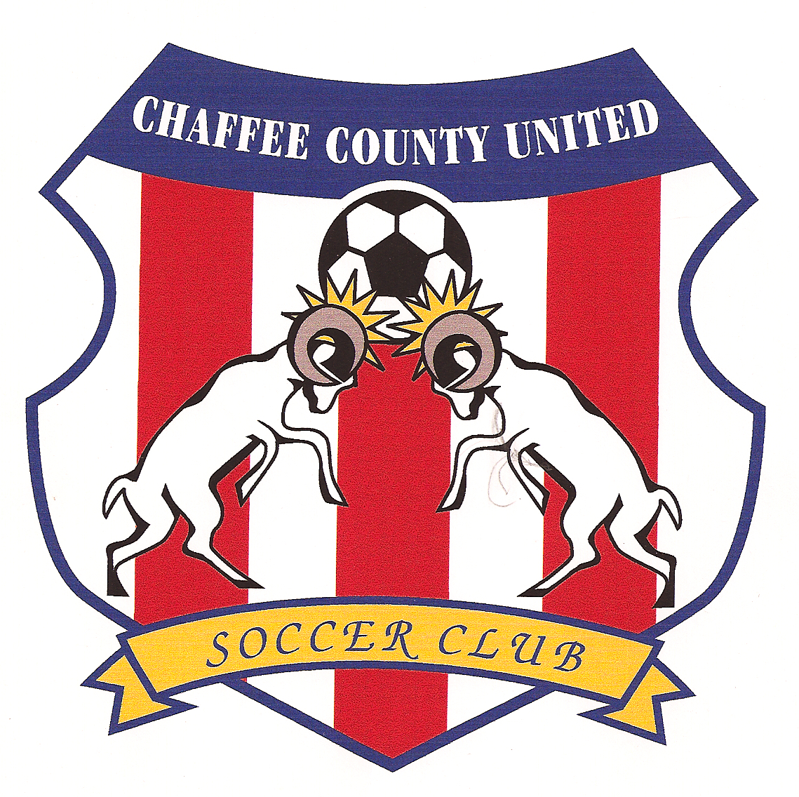

“SOCCER WITH ALTITUDE”

About the Club
Chaffee County United Soccer Club was founded in 2000, with the intent to provide competitive opportunities to male and female soccer players in chaffee county as well as the surrounding area. The successes that our teams have realized are a result of the club’s emphasis on developing skillful players. Our development as a club is ongoing as we continue to expand programming and opportunity for our players.

Some Basic Information
Being a part of this club means a commitment to your teammates. Players are expected to attend all practices and games unless clearly communicated in advance to the head coach.
In this packet you will find registration information and forms as well as fee structure.
We allow our families to make fee payments in two steps if necessary. It is very important that fees be paid when required and that any concerns about financial issues be communicated to the head coach as early as possible. see policies and procedures player fees. CCU offers a scholarship program (form attached).
With regard to uniforms, the club, through sponsorship, provides jerseys, which are returned to the club at the end of each season. It is the responsibility of the players to provide their own shorts and socks---we will do a team order for those items prior to the start of the season so that uniforms are matching as is required by league rules.
the club’s main source of communication is email. Families are encouraged to regularly check their email during season for team information.

Board of Directors
Joel Schaler Molly Pitts
Chad Gorby Darrell Pratt
Jeff Keidel Vicki Schehrer

Director of Coaching/player development
Ben OSWALD 719-539-2494

USEFUL PHONE NUMBERS/WEBSITES

Salida Soccer
www.salidasoccer.org ccu tab
colorado youth soccer
toll free phone 1-877-542-7972
www.coyouthsoccer.org (league standings, schedules, etc)
directory of colorado soccer fields
www.soccerfieldsofcolorado.com

CCU SEASONAL CLUB FEES

your fees this season are: $ 250

REGISTRATION FEES MUST accompany registration form. Fees may be paid in 2 payments if necessary.

registration fees are due: JUNE 1ST for the FALL season AND DECEMBER 1ST for the SPRING season.
coaching fees are due: AUGUST 1^{ST FOR} the FALL season and FEBRUARY 1st for the SPRING season.

ATTACH CHECK MADE PAYABLE AND RETURNED TO:
CC UNITED
c/o Vicki Schehrer
8825 CR 160, SALIDA, CO 81201

ccu scholarship program
ccu has a scholarship program available. the board of directors will review application and make an eligibility determination. (See page 7)

ccu tournament travel
in the event of tournament travel, the players are responsible for head coaches tournament expenses (travel and lodging). all players on roster will divide coaches expenses equally. tournament fees are in addition to club registration fees

transportation
ccu encourages carpooling for all practices, games, and tournaments. historically parents have coordinated the carpools.

