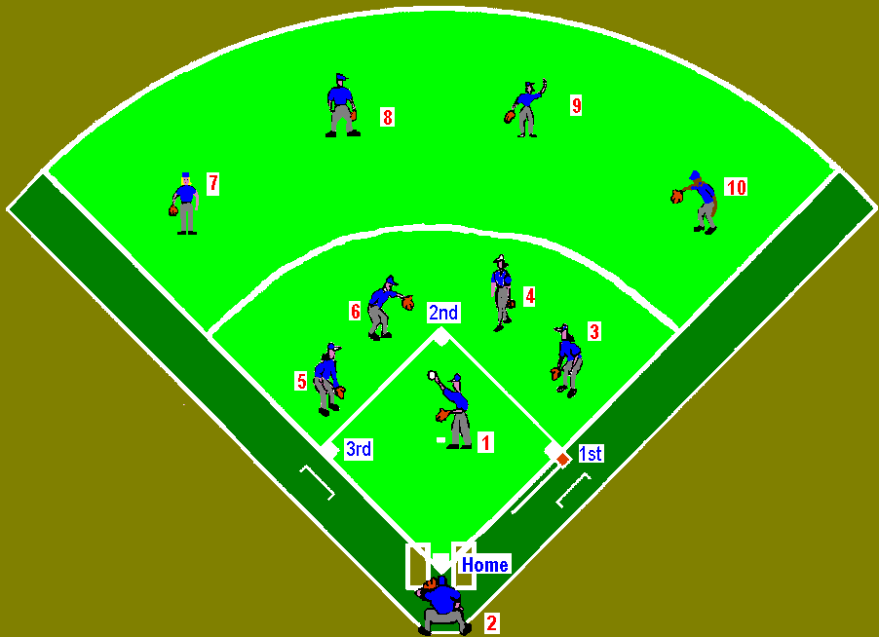

1. Pitcher (P)
2. Catcher (C)
3. First Base (1B)
4. Second Base (2B)
5. Third Base (3B)
6. Shortstop (SS)
7. Left Field (LF)
8. Left Center (LC)
9. Right Center (RC)
10. Right Field (RF)

