Gaining Good or Better Arm Action
By Dave Miramontes and Rich Taylor, MVP Band
In baseball and for pitchers, the term arm action is the movement of a players arm when making a natural throwing motion toward the plate. When referring to arm motion, many coaches generally refer to the terminology of arm angles, arm slots, or release points. Quite frankly, these terms sound foreign to a parent, new coach and most importantly a young player that just wants to get out and play. To have an understanding of these terms, a brief description is provided:
Arm Angles
This is the angle of the upper arm as it passes by one’s head in route to the plate. Many individuals refer to arm angles similar to the hands of a clock. Moving from highest release point to the lowest, the arm angles range from 12-3 with 12 being an overhand throw and 3 being completely sidearm. If you refer to a left-hander, you would use the 12-9 terminology with 9 being sidearm.
Arm slot
The set angle/position of the arm before a player throws the ball toward the plate. Just before you throw the ball, your cbbody opens up toward the plate and your arm drops into a cocking phase or Arm Slot. Many times this is a consistent location, but can change depending on certain pitches.
Release Point
The point at which the ball actually leaves one’s hand before it makes its way to home plate. Coaches generally look at the cbbody position during the release point to determine what needs to be adjusted.
While each player possesses their own personal arm action/angles through their genetic make-up and/or how they have been taught, we find it best to adjust any imperfections or concerns (if needed) at an early age. As a coach or parent, it is important to understand what proper mechanics and arm angles are before you become overzealous in your attempt to correct them. Since all individuals are unique, any adjustments made should be done in small increments so that a player is not discouraged from the sport itself. Our rule of thumb is to keep things in perspective and keep things balanced (literally). In discussing Arm Action we realize there are many opinions, scientific terms and degrees of measurements that can become quite overwhelming. For the sake of simplicity, we will keep things basic and to the point.
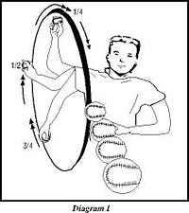
Generally speaking, baseball players possess three types of arm actions: Short, Full or Long. If you can place an imaginary circle over a pitcher with the axis point located at the waist/hip area, and the starting point of a pitch beginning at the initial hand break in the wind-up phase, you can determine what type of arm action a pitcher has (see diagram 1). Our measurement begins where the initial hand break of the throwing hand begins to the actual release point of the ball. When a player uses a Short arm action (referred to as short arming the ball) one typically uses 1/4 of his desired throwing motion. Most kids possess a Full motion, which relates to about 1/2 of the desired rotation. Long arm action, in which the ball travels in a 3/4+ circle, is most desirable. As you can imagine, it is ideal to possess a Long Arm action so that a player builds up maximum momentum before throwing to the plate.
Good arm action simply means that your arm takes a wider arc before the release point. In order to do so, your wind-up must allow your arms to get in the proper positions through certain phases. When we teach arm action and what we deem a “Proper Arm Angle” to kids, we use the visual of a throwing through a doorway (see Diagram 2). If you can picture a doorway and place a pitcher just in front of it, you will find that a player will figure out the best arm angle in which to: 1) get the ball through the door and 2) have enough distance to reach the plate. Again, if the doorway is set up like a clock and 12:00 o’clock rests at the top and center of it’s opening, it will be optimal to throw the ball at a 1:00 o’clock angle (right-handed) or an 11:00 o’clock angle (if left-handed). In teaching a player to reach for the top corner of the doorway at the height of their delivery, we explain that there is little room for error should their arm drop below the 2 o’clock position. If it does, they risk hitting the doorway with both the lead glove and ball.
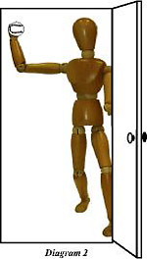
While arm action and arm angles play a critical role in velocity, a player truly has to gain as much of the arc of the circle as possible. In order to maximize this arc, we suggest a simple way to position your throwing hand once it breaks apart from the glove in the wind-up position.
After the initial leg lift and when your hands separate from one another:
- Your throwing hand should reach back towards the 2B position without enabling the arm to become totally straight.
- Your hand/fingers should dominate the ball keeping your knuckles toward the sky.
- At this point your glove hand is pointing directly at home plate at a slightly higher plane than your throwing arm.
Upon initial momentum towards the plate, several actions take place simultaneously
- Your trunk and torso will rotate to open up your cbbody toward home plate.
- Front foot strikes with knee slightly bent (cocking phase begins)
- Glove elbow pulls back to tuck glove at hip (glove in position to field a ground ball)
- Throwing hand should reach back to its apex (highest point) with your elbow cocked and bent in less than a 90-degree angle.
- As the weight transfers from your back leg to your front leg, your elbow will lead the way toward the plate leaving your forearm parallel to the ground.
You are now in position to reach for the top of the doorway
- Once you have reached this point and your hips are facing the plate, your ball hand should now have reached its highest point (hopefully at the 11:00 o’clock or 1:00 o’clock position depending which arm you throw with). You are now in position to release the ball. After release point (which should be at full arm extension at eye level), it will be critical to continue your follow-through by extending your arm beyond the release point finishing in a palm up position outside the plant leg.
- After release, be sure your cbbody is squared, your glove is tucked at your waist, and your head and eyes level with the ground and still focused on the target. Note: If your shoulders remain level after follow through, chances are your eyes and head will as well, thus forcing your cbbody to remain balanced.

Below is a good example of a player with Long Arm Action. Notice his arc from start to finish.
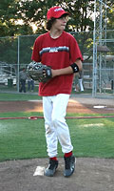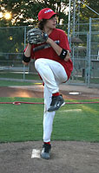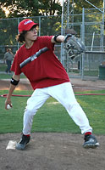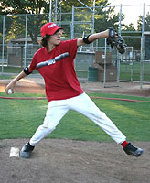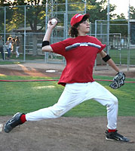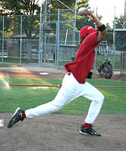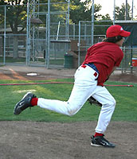
Please keep in mind that developing a young pitcher starts with good balance (see last article). Regardless if a player obtains a short, full or long arm action, one’s cbbody mechanics, proper lead foot plant and follow through must remain in check. If your arm action does not match up to proper cbbody positioning, a player most likely will experience control problems, improper release point and repeated stress on the arm, especially the elbow area. Most often a young pitcher who has acquired poor arm action may have learned his throwing technique due to compensation for an underdeveloped shoulder and/or simply being trained to toss a ball in a motion similar to throwing darts for accuracy. Getting one’s arm/shoulder stronger by extending their arm can be done by performing exercises such as long toss and exercises specifically designed for strength and range of motion.

